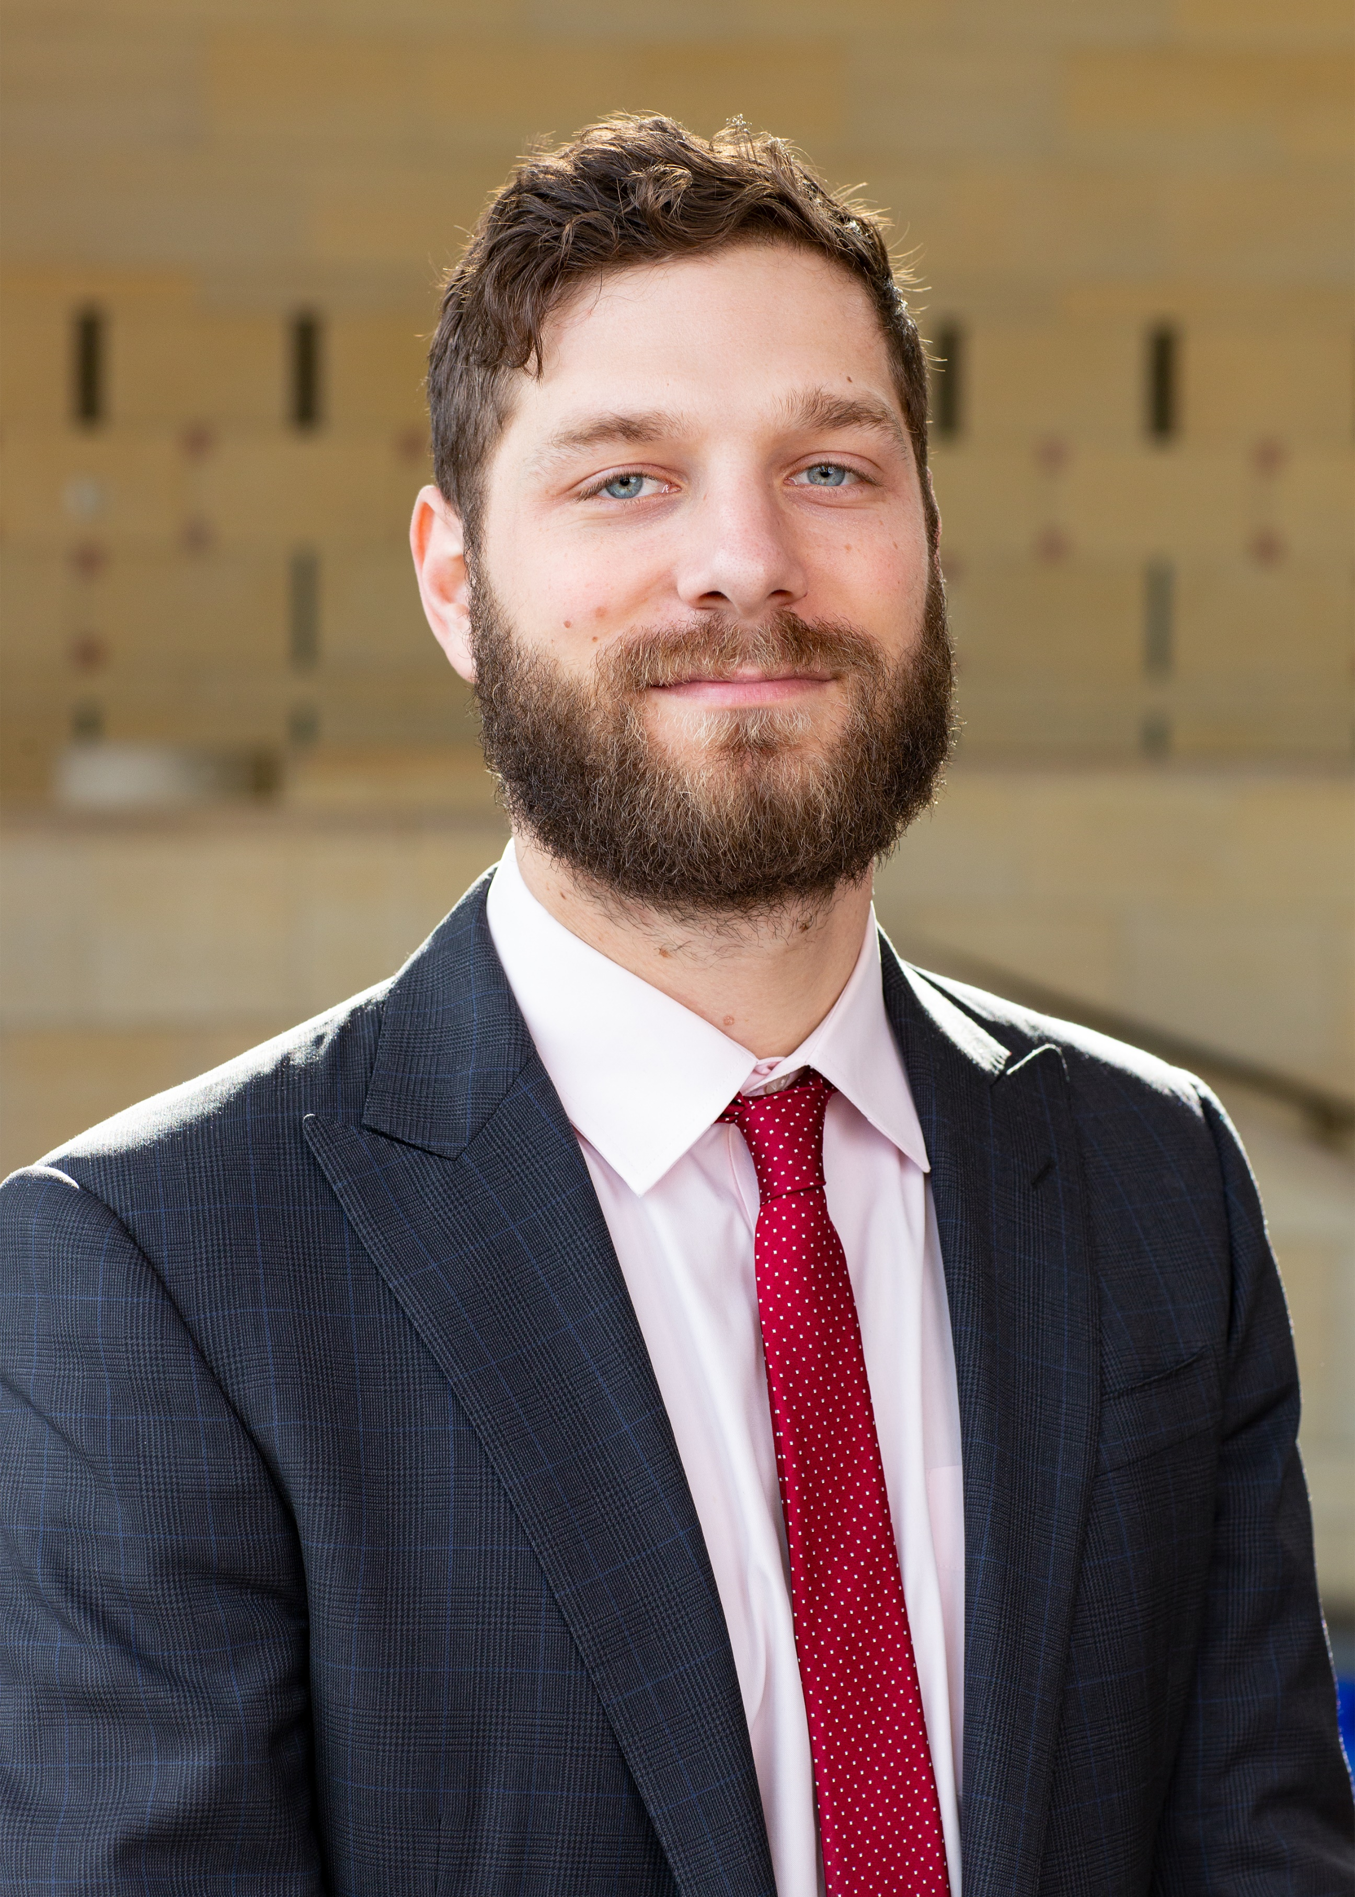 |  | nolan borgman  Los Angeles County Metropolitan Transportation Authority  Senior Transportation Planner
PROFILE  Nolan is a Senior Transportation Planner in the OEI responsible for managing the Unsolicited Proposals Policy and process. He has worked with the private sector and Metro Departments to develop a range of low-cost, high impact innovation pilots and proofs of concept. Several projects leverage new technology to improve the customer experience across transit, biking and tolling, others explore non-traditional project delivery approaches. In 2019 he received Metro’s Innovation Award for his work on using drones for data collection and was a member of the inaugural Women and Girls Governing Council that received Metro's CEO Award for recommendations to improve transportation outcomes for women.  Nolan was a Transportation Planner in the Office of the CEO/ Board Relations prior to OEI. He joined Metro in 2013 as a Trainee with Management Audit Services after completing the Coro Fellowship in Public Affairs in Los Angeles. He graduated cum laude from Occidental College with a Bachelor's degree in Urban and Environmental Policy and minor in French Literature. He studied abroad in Senegal and played two seasons of varsity soccer. He loves traveling, music, games, cats, and Philadelphia sports teams. Finally, Nolan tries to always have at least a few dollars in his pocket for street tacos.  Contact  PHONE:  (213) 922-4117  CELL PHONE:  (213) 842-2037  EMAIL:  borgmann@metro.net |  | department  The Office of Extraordinary Innovation (OEI)  position description  Manage Metro's Unsolicited Proposal projects and the development and incubation of projects that come through it. Run Metro's Ride Along program. Work with businesses to align their offerings with transportation related challenges facing Metro and the region.  business project  Most transit agencies lose money on every ride, which creates a subtle disincentive to offer excellent customer service. I hope to examine customer service cultural artifacts and trainings across the MAX agencies with the hope of highlighting best practices and exploring areas for improvement in putting the customer at the heart of the journey.  My project will examine best practices in training and culture building that have succeeded in improving the customer experience.  People have a choice of how they travel. In order for Metro to be that choice, it must put the customer at the heart of the journey. This not only means working as a total team to offer an excellent customer service to all passengers, at all touch points, across all services, it also means removing systemic barriers to customer success.  Looking across the many departments and service offerings of the EnoMAX West Coast agencies, I will examine the ways in which agencies equip their employees to provide customer service and seek to assess the broader culture with respect to customer experience.

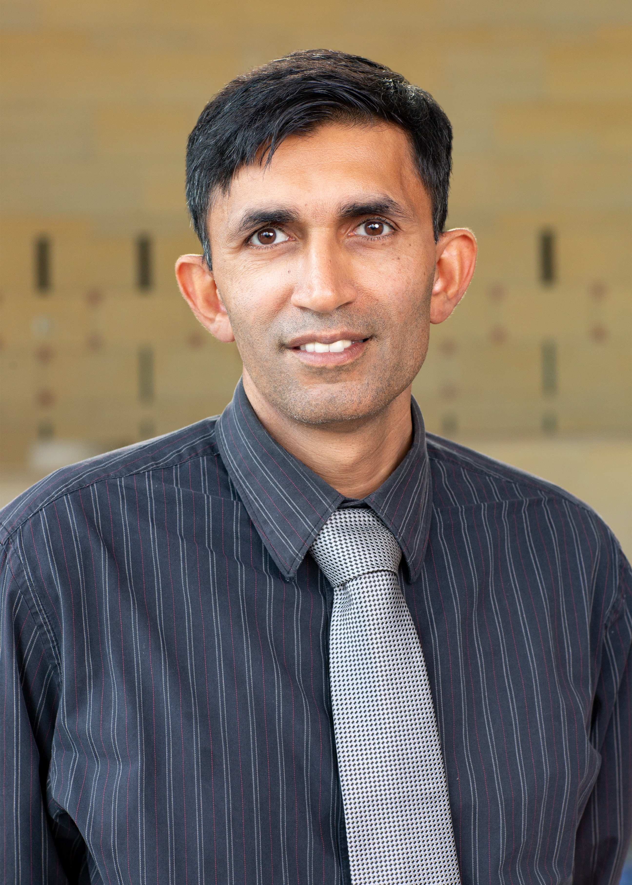 |  | BahraM chaudhry  Los Angeles County Metropolitan Transportation Authority  Director, Systems Project
PROFILE  I am an IT professional with more than 15 years of experience working in information technology. I started my career with JPL (NASA) and worked in various private companies including IBM and Warner Brothers before joining Los Angeles Metro as a software developer. I am a native Los Angelino and love living in Los Angeles. I am grateful to be part of Metro because it gives me an opportunity to improve public transportation in Los Angeles. I love working on projects that have a positive impact on our patrons.  Outside work I enjoy spending time with my family. I am also a passionate college sports fan. I travel to different states to watch football games whenever I get an opportunity. I also enjoy surfing and hiking.  Contact  PHONE:  (213) 922-6441  CELL PHONE:  (818) 414-0170  EMAIL:  chaudhryb@metro.net |  | department  Information Technology Services (ITS)  position description  Supervise Advanced Transportation Management System (ATMS) for CAD/AVL. This includes 24/7 support for Bus Operations Control, ATMS data center and Bus Operations. Also responsible for supporting all Bus related technology enhancements.  Supervise development of internal web applications to support various business units. Web applications team is responsible for creating internal and external facing web applications for Metro to enhance and streamline business process.  business project  Provide consistent and accurate real-time arrival information for our transit system.  Metro is rapidly growing with more rail lines. Along with the new rail lines, Metro is also working on enhancing our bus system. As we enhance our services, it is important to help our patrons ride the new system. Goal of this project is to figure out the best method for providing consistent and accurate real-time arrival information for our transit system.  Providing real-time arrival information will make it easier for our patrons to use our transit system. It will help us integrate our services with other ride share options. For example, patron may choose to use Uber to get to our transit line for the longer ride, if he/she knows what time the next bus/rail is arriving. This information can also be used to integrate first/last miles options that Metro is exploring.

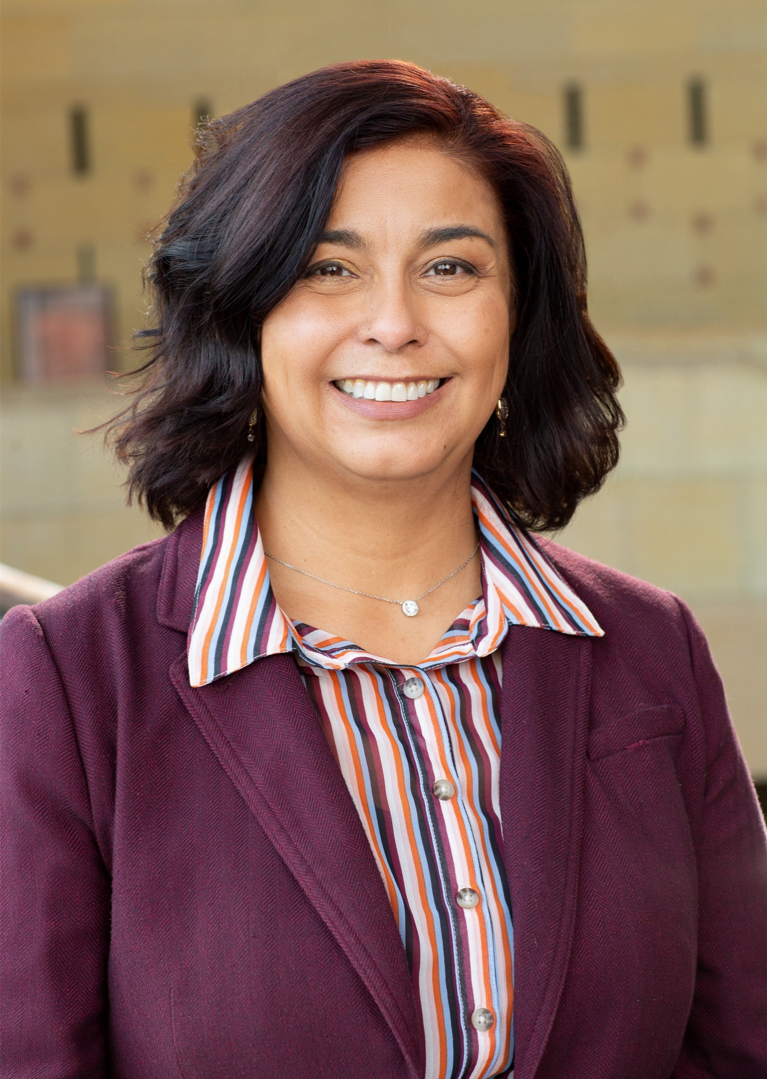 |  | lilian De Loza-Gutierrez  Los Angeles County Metropolitan Transportation Authority  Community Relations Manager
PROFILE  Over my 25-year career in community relations, I have implemented numerous successful community engagement programs for transportation, housing, public facilities, retail and environmental remediation projects at the federal, state and local levels. Currently, I serve as the San Gabriel Valley Area Deputy for Los Angeles County Metro where I work with 31 cities on various projects, programs and initiatives to help improve mobility options for LA County residents.  I hold a Bachelor of Arts degree in Sociology from Occidental College and over the years I have had the pleasure of serving my community as a planning, transportation, housing and environmental commissioner in the City of Alhambra where I reside with my husband of 22 years and three daughters. In my (very little) spare time, I enjoy crocheting and playing word games.  Contact  PHONE:  (213) 922-7479  CELL PHONE:  (213) 922-7479  EMAIL:  delozagutierrezl@metro.net |  | department  Communications Department, Community Relations Unit, Local Government and External Affairs Team  position description  - Represent Metro as area deputy for the San Gabriel Valley region of Los Angeles County.  - Manage public participation efforts for various Metro Projects that are currently being planned.  - Organize and represent Metro at numerous community meetings, presentations and events to share project and relevant information regarding Metro projects, programs and initiatives.  - Manage project related social media pages to support environmental review efforts.  - Serve as a liaison between Metro executive management, local public elected officials, public and private agencies, community groups and stakeholders to build relationships that could further Metro's programs, policies, operations and initiatives.  - Oversee community outreach consultant's deliverables and budget for work.  - Maintain regular communications with key elected officials, staff members, community leaders and groups regarding Metro activities.  - Respond to and keep directors and executive management apprised of internal/external community relations issues of interest to Metro.  - Develop outreach programs and strategies for projects undergoing environmental clearance.  business project  I would like to explore communications strategies and activities that other agencies have implemented that are specifically targeted to Limited English Proficiency stakeholders.  These communication activities include best practices and lessons learned when involving stakeholders to participate in dialogue regarding fare right sizing, bus restructuring, and/or other potential issues that have a profound impact on this largely transit-dependent population.

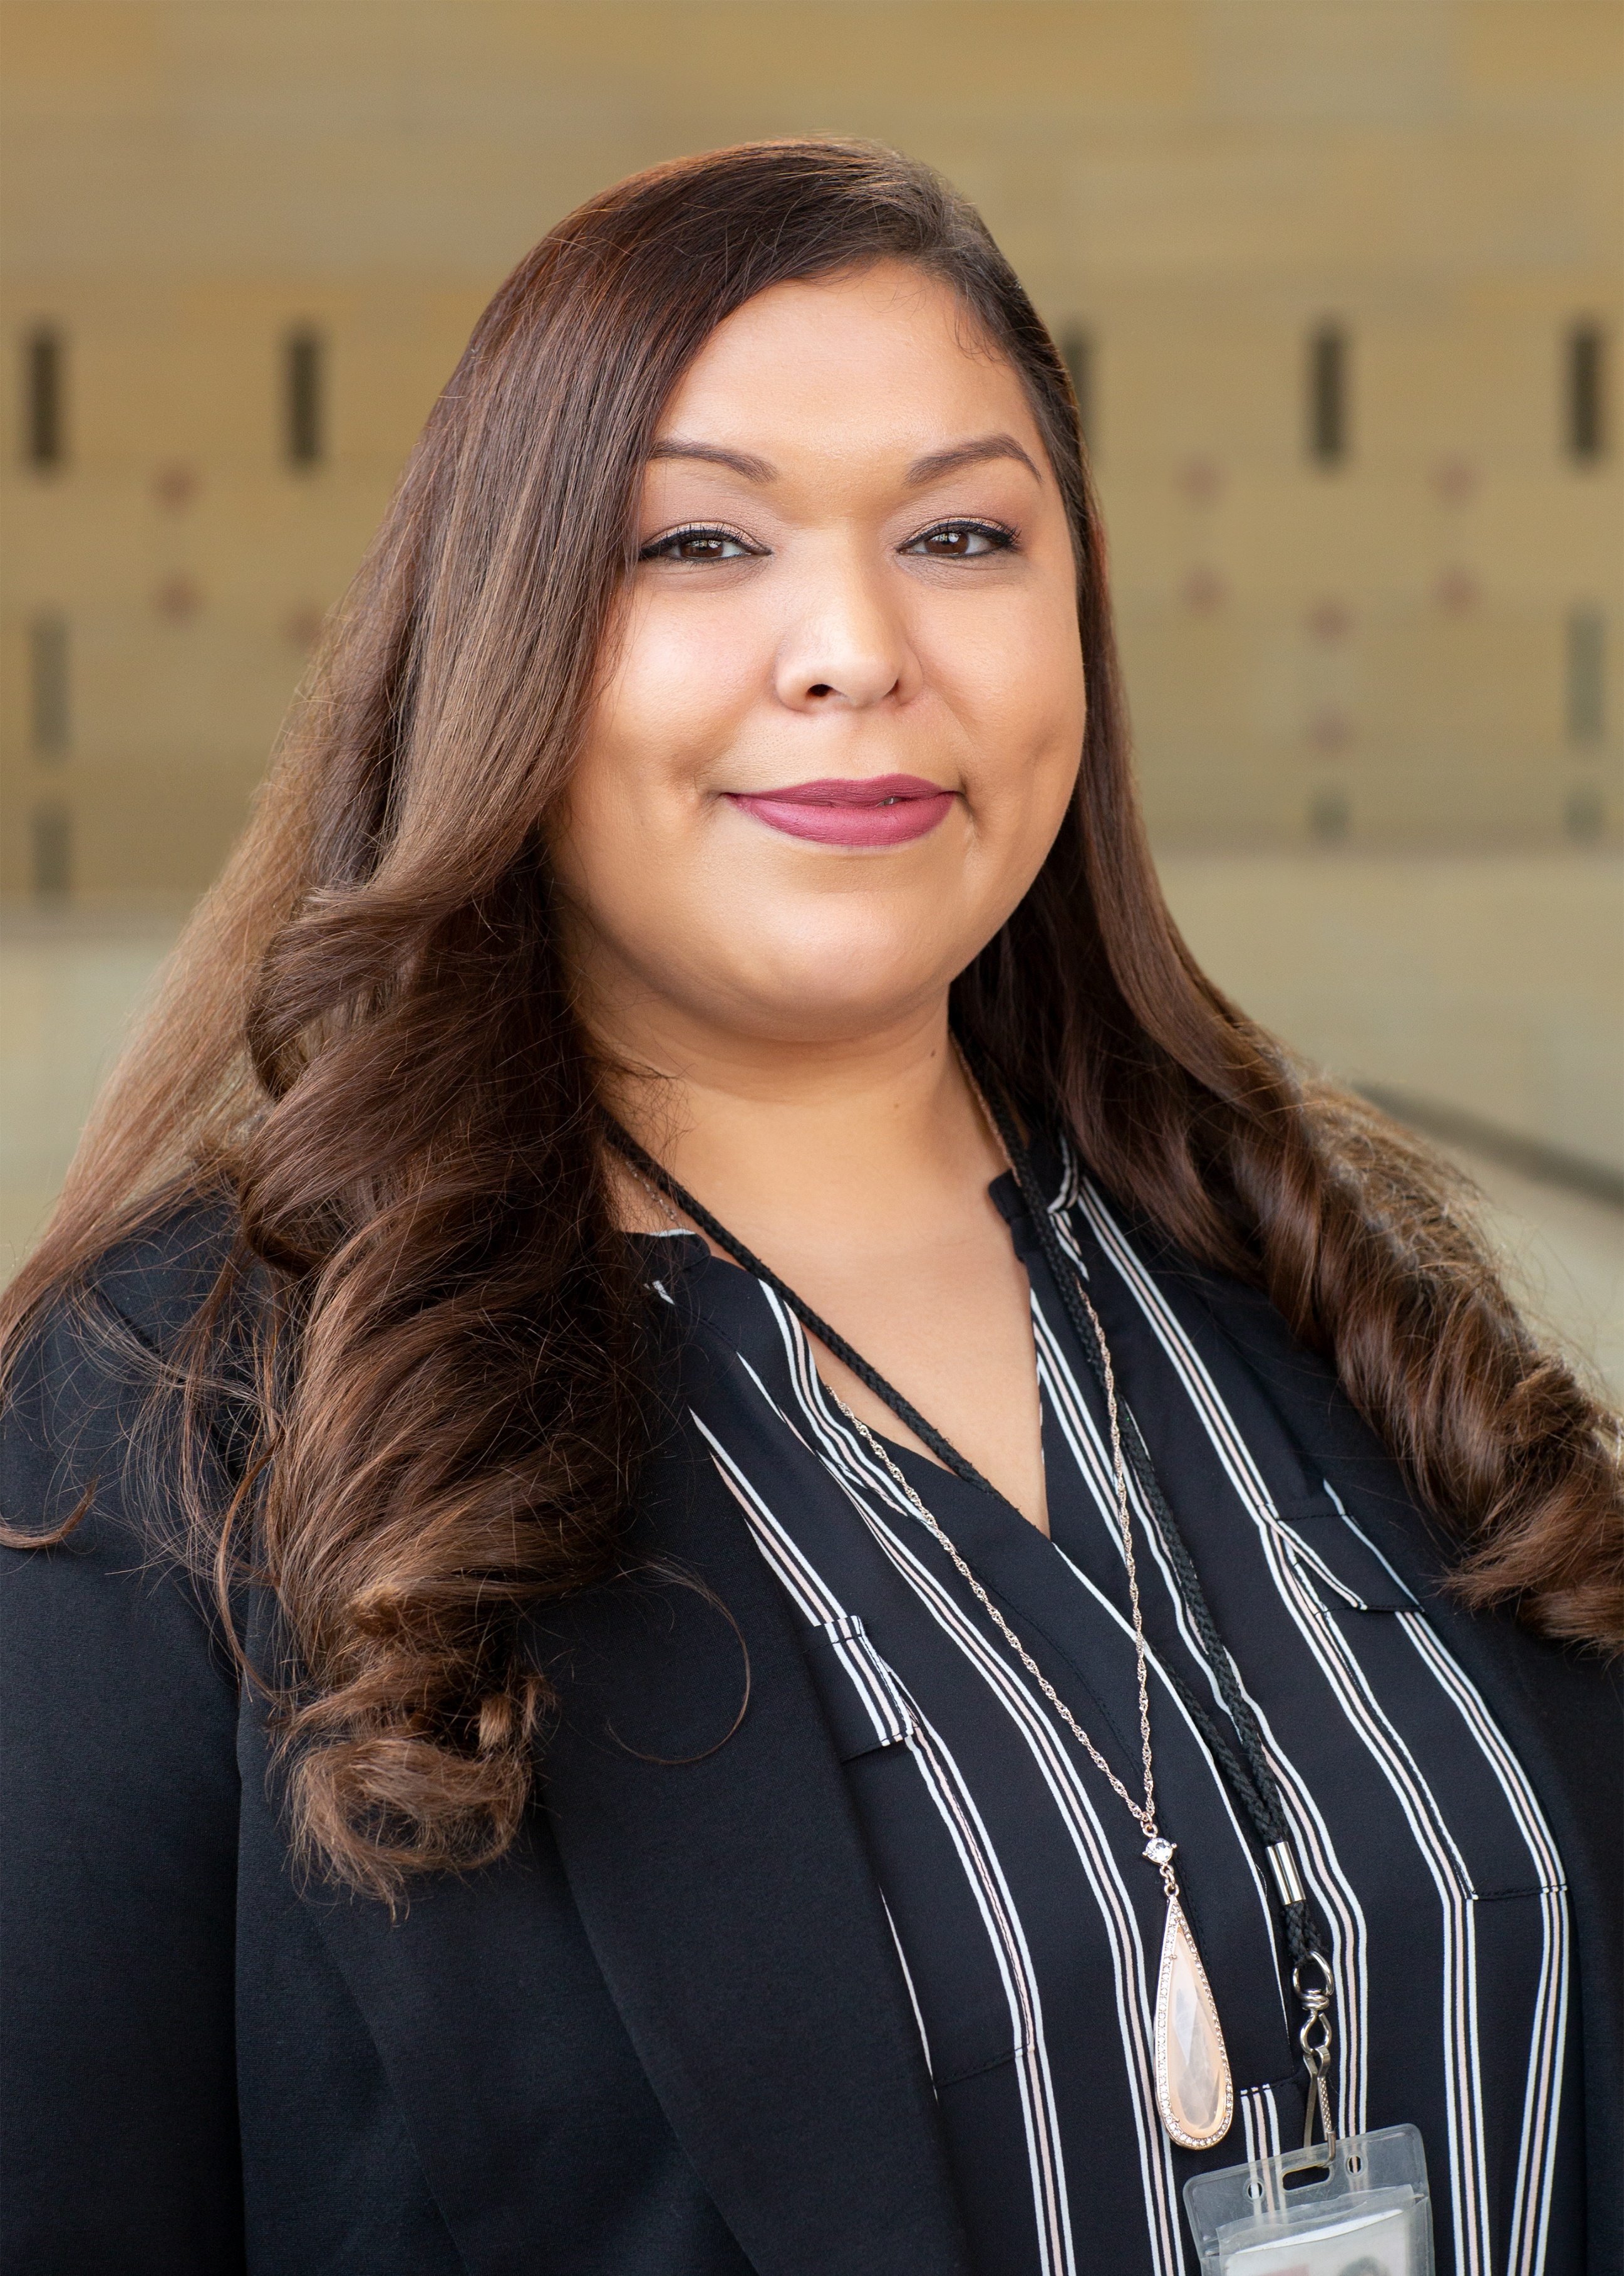 |  | Nancy Hinojosa  Los Angeles County Metropolitan Transportation Authority  senior admin analyst
PROFILE  Nancy began her career with LA Metro in 2012 in the Executive Office of Communications. In 2014 she promoted into the Risk, Safety & Asset Management department. She has held 4 positions during tenure, currently serving as Senior Admin Analyst supporting the Chief Risk, Safety & Asset Management Officer. She wears many hats in her department from administration management, handling the department's board relations activities and manages various special projects directed from LA Metro's CEO.  Nancy obtained her Bachelor's degree from California State University-Los Angeles and in 2015 earned her Masters' degree with Distinction from California State University-Northridge, majoring in Public Sector Management and Leadership. Nancy’s involvement in LA Metro Leadership programs and initiatives including graduating from LA Metro's Leadership Academy in 2016 and serving on the Women and Girls Governing Council whose mission is to promote the advancement of women in non-traditional transportation careers. She continues to develop and expand her skills in the transportation industry and is excited to be a part of the 2019 MAX cohort. In her free-time Nancy enjoys hiking and traveling with her husband of 15 years.  Contact  PHONE:  (213) 922-3482  CELL PHONE:  (213) 841-3828  EMAIL:  hinojosan@metro.net |  | department  Risk, Safety, and Asset Management  position description  - Provide support to the Chief Risk, Safety and Asset Management Officer and reporting departments with development of transportation projects in the areas of risk, safety, emergency and asset management.  - Prepare and present reports, presentations, scopes of work, letters, and performance measure updates to senior management and the OCEO.  - Plan and organize administrative functions and tasks relative to the activities and operations of the department.  - Design, develop and implement projects that are defined by agency goals and objectives, policies and procedures, work requirements, and performance measures.  - Recommends strategies for process improvement and prepare justifications for staffing, facilities, equipment, production, and policy.  - Confer with and represents LA Metro in meetings and conduct on-site meetings to comply with agency policies and procedures and maintain interface with public agencies, community organizations, contractors, vendors, consultants, and the public on various matters as assigned.  - Conduct data analysis and research and implement problem-solving methods.  business project  Metro is dedicated to increasing the safety of our Bus Operators and customers. Assaults on Operators continue to be a problem, causing worker absence, productivity issues and increased levels of stress for both the assaulted Operators and their coworkers. LA Metro has installed Operator barriers on some busses to determine their effectiveness in reducing Operator assaults. However, most Operators choose not to use the barriers. For their own protection, we are considering mandating Operators to use the barriers. To fully determine the effectiveness of using barriers to decrease assaults on Operators, a pilot program mandating their use must be implemented and evaluated including the reduction in Workers’ Compensation claims.  With a successful pilot program of mandatory use of Operator barriers Metro can implement a permanent program to enforce the use of these safety enhancements, helping promote a safer work environment and potentially providing large cost savings to our agency by reducing Workers' Compensation claims.

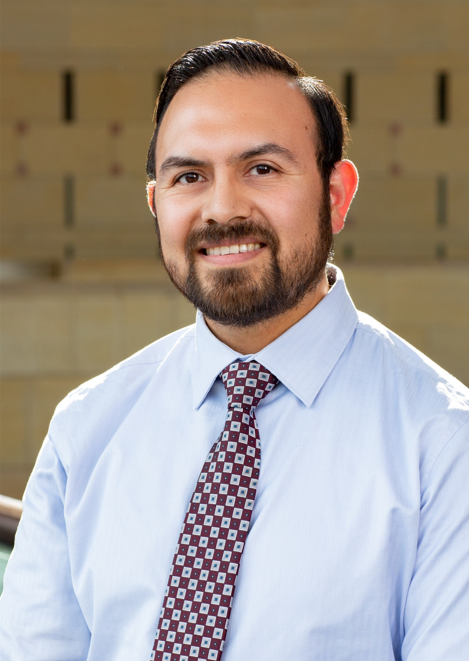 |  | jose paz  Los Angeles County Metropolitan Transportation Authority  Schedule Checking Supervisor
PROFILE  Jose Paz joined Metro in 2015 as a supervisor in the Data Checking department. In this position he oversees the collection of rail patronage data for government reporting. Prior to public transit, Jose was involved in the education sector for ten years; scheduling and coordinating field trips for 27 schools and managing the routing software for a school district. With a degree in Information Systems, Jose is excited about the application of data as a solution to business needs.  In his spare time, Jose enjoys learning about science with his three children. He also enjoys making and listening to music. Jose is excited about working at Metro and about being a part of future transit service developments.  Contact  PHONE:  (213) 922-4849  CELL PHONE:  (909) 841-3182  EMAIL:  pazjos@metro.net |  | department  Service Performance Analysis, Data Collection  position description  Oversee and supervise a group of subordinate staff in the collection of patronage data for internal statistical analysis and service adjustments, federal reporting, and to ensure departmental objectives are met.  business project  In order to promote and maximize the future leadership potential at all levels of the workforce, I want to research the feasibility of expanding on the current training and development offered to employees. A portion of this plan involves keeping all employees abreast and engaged with respect to agency endeavors, both current and future. I envision internal and external certificate programs and training opportunities made available in order to enhance employee skills and make them better-qualified for promotion within the Agency. Some of the primary points of research include the feasibility of implementing such recommendations in light of stakeholders involved such as union or employee opposition and the time and human capital demand required in order to minimize interference with daily operations. In the process I plan to identify best practices at other agencies, evaluate the potential applicability of such in my own agency and develop the steps and processes to implement an achievable solution to my proposal.  I see the potential of encouraging promotion within the agency as a great benefit. Employees who have the ambition to serve, have a good grasp of the Agency's culture and regional needs may be lacking some of the hard skills to serve in a greater capacity. Providing the educational outlets and focused skill-building through the agency and external partners promise to provide ideal and qualified candidates to move forward Metro's vision for the future.

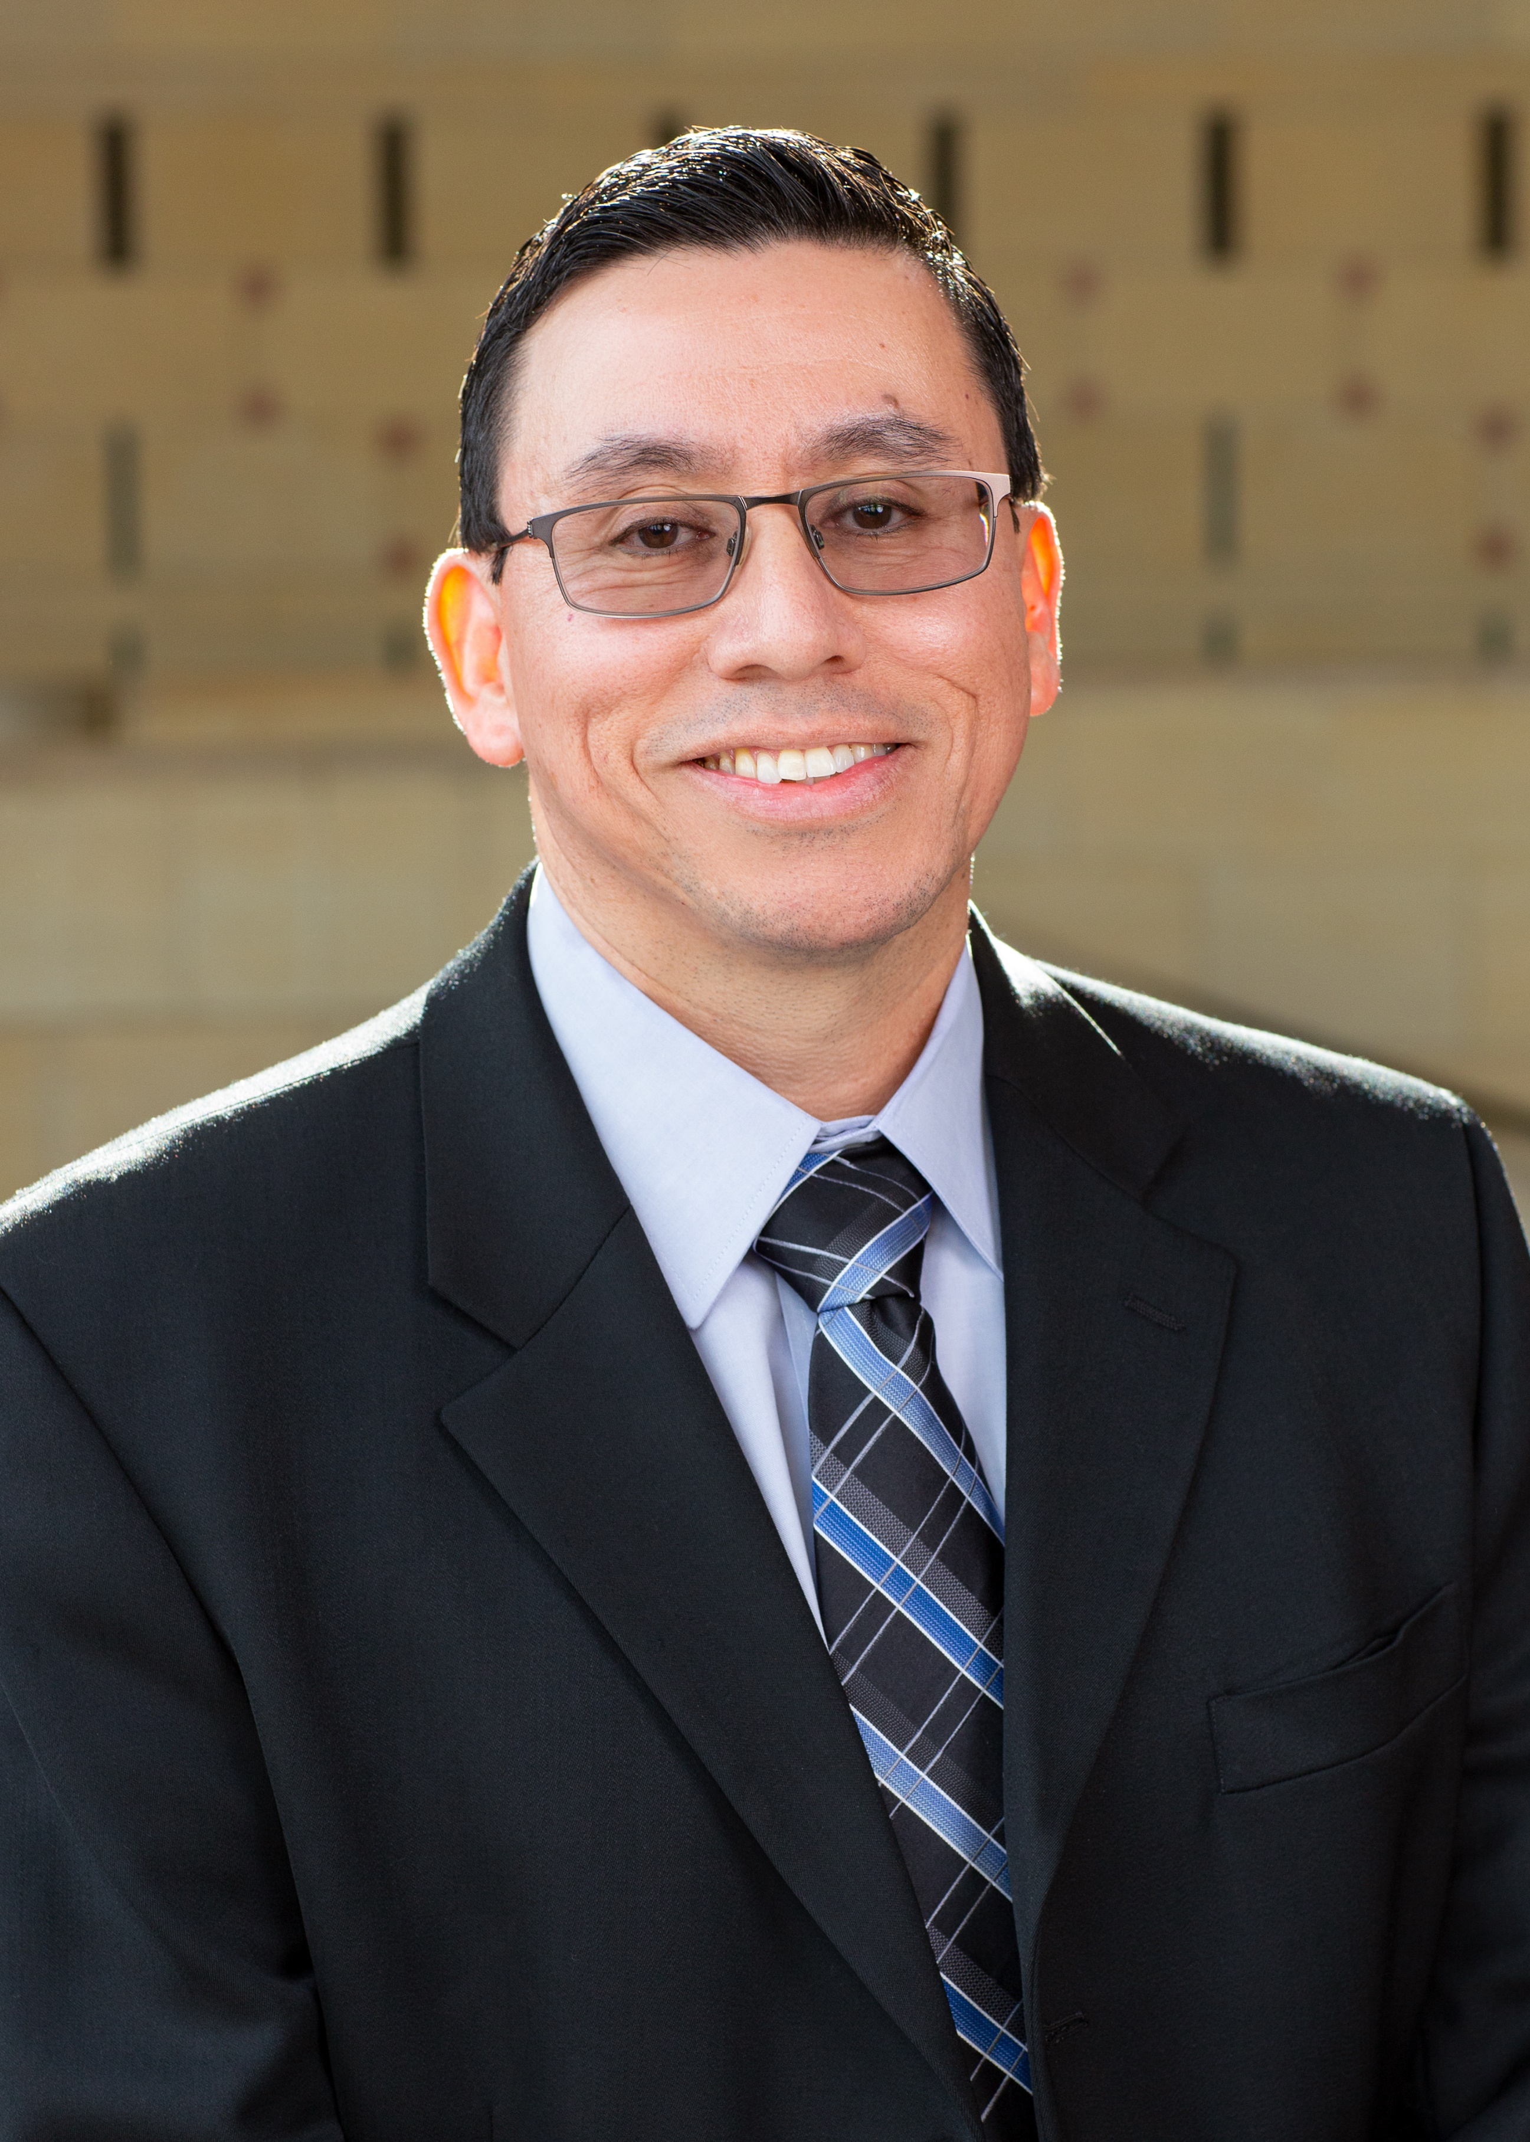 |  | arturo ramirez  Los Angeles County Metropolitan Transportation Authority  Senior Manager, Systems Projects
PROFILE  I am a UCLA graduate with a degree in economics. I have worked at LA Metro for 18 years, specifically in Bus Transit Operations. Career highlights include: participating in Metro's Emerging Leaders Program, graduating from the Metro Leadership Academy, acceptance into the MAX program, and recieving a recognition award at the 2018 Operations Department annual retreat. Prior to my working career I was awarded a California Pre-Doctoral Scholarship.  On a personal level, I am an avid reader, a baseball fan, and a soccer fan. I am the first in my family to graduate from a university. I have been married for twenty years and am a father of three children. Our middle child was diagnosed with autism at the age of three. My wife and I have spent the last 14 years (he is now 17) making sure he gets all the services he needs to succeed.  Contact  PHONE:  (213) 922-4434  CELL PHONE:  (323) 552-3328  EMAIL:  ramirezar@metro.net |  | department  Workforce Staffing  position description  I am responsible for coordinating the distribution and promotion of our primary unionized labor group so that all our locations have the human capital necessary to implement public transportation. I collect and analyze data which is used to adjust hiring patterns. I work with other departments (HR, Instruction, Scheduling) to ensure we have proper staffing levels across all our work locations.  business project  Implementing a two-tier salary proposal: base salary for absences and bonus salary for work.  One current business problem we have is an increase in revenue service either paid at an overtime rate or cancelled. One creates a fiscal problem the other a customer experience problem.  Two reasons for this problem are not having enough employees to begin with but also having employees who are absent. Our state has a generous protected leave policy which allows our employees to be absent at their current rate of pay, forcing our work locations to find an alternate employee to drive the bus or train that the absent employee left vacant.  I want to investigate whether it is viable to have a two-wage structure where the employee is paid their contractual wage when absent but paid a higher wage (bonus) for working. I am curious if other agencies are looking into different pay structures to curb absence rates, lower OT and reduce cancellations.

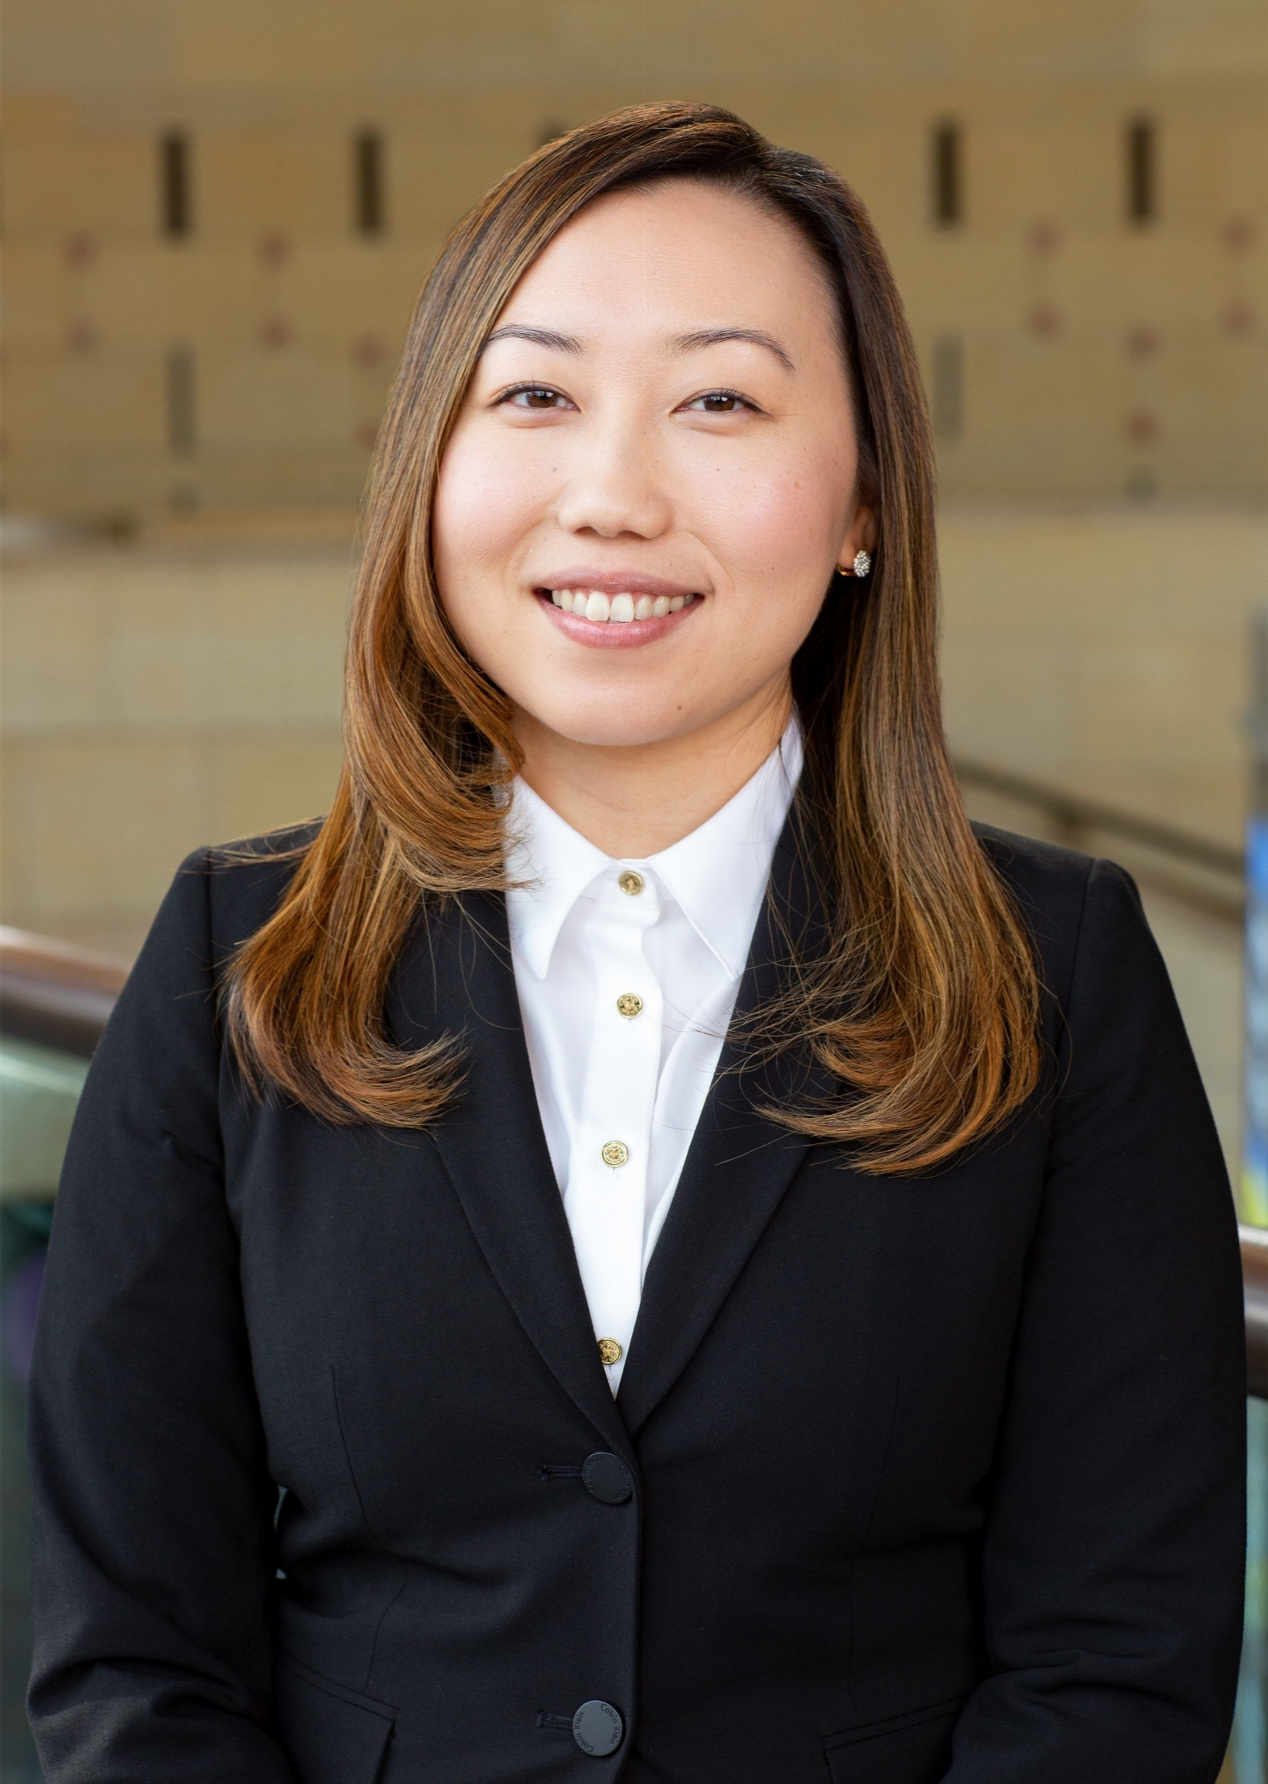 |  | elezanbee vue  Los Angeles County Metropolitan Transportation Authority  Employment Processing Specialist
PROFILE  Raised in Sacramento, CA, Elezanbee participated in the pioneer class of the International Baccalaureate Programme at Luther Burbank High School. She earned her undergraduate degree in English with a concentration in Teaching English to Speakers of Other Languages from CSU Sacramento, and is the first of nine siblings to earn her Master's degree in Public Administration from CSU Long Beach. She was the Executive Secretary for the Hmong Student Intercollegiate Coalition planning successful state-wide conferences for Hmong-American University Student Associations. She contributed to the editing, and publicizing of How Do I Begin?: A Hmong American Literary Anthology with the Hmong American Writers' Circle. She also facilitated creative writing workshops for Hmong National Development in 2013 before relocating to Los Angeles.  Prior to joining Talent Acquisition, Elezanbee excelled as a Division Stenographer at Division 18 assisting them in achieving Division of the Year in 2017 and 2019. She is passionate about Leadership, Communication, and Team Building. She plays volleyball, likes rap, hip hop and R&B, and loves breakfast.  Contact  PHONE:  (213) 922-7147  CELL PHONE:  (916) 803-9590  EMAIL:  vuee@metro.net |  | department  Human Resources, Talent Acquisition  position description  - Interact professionally with diverse backgrounds and various levels of Metro employees and external representatives regarding job vacancies, operating procedures, and other employment related issues  - Receive and process employment verification  - Schedule appointments, pre-employment and re-instatement physical examinations  - Review and verify sensitive information provided by employees and new hires  - Conduct new hire processing, assigning employee identification numbers  - Confirm and process termination paperwork for separating employees  - Process Human Resource related information such as personnel action forms  business project  Currently, Metro offers two forms of employment verification: basic verbal confirmation of information through a dedicated phone line and a more detailed verification through a dedicated fax line. Employment Processing Specialists (EPS) who process employment verification requests are only able to provide confirmation of information to other agencies with a verbal verification. Paper requests received through the fax line can be filled out accordingly with proper authorization from the employee. However, faxed requests are subjected to be misplaced and sometimes need to be physically tracked down. Improvements to this employment verification process can also benefit other departments to respond to time-sensitive requests (i.e. mortgage requests) with a faster turn-around time to benefit our employees.  With this project, I hope to address two questions: 1) How have other large transit agencies successfully implement technology into their employment verification request process and 2) How have these agencies been able to get buy in from other stakeholders?

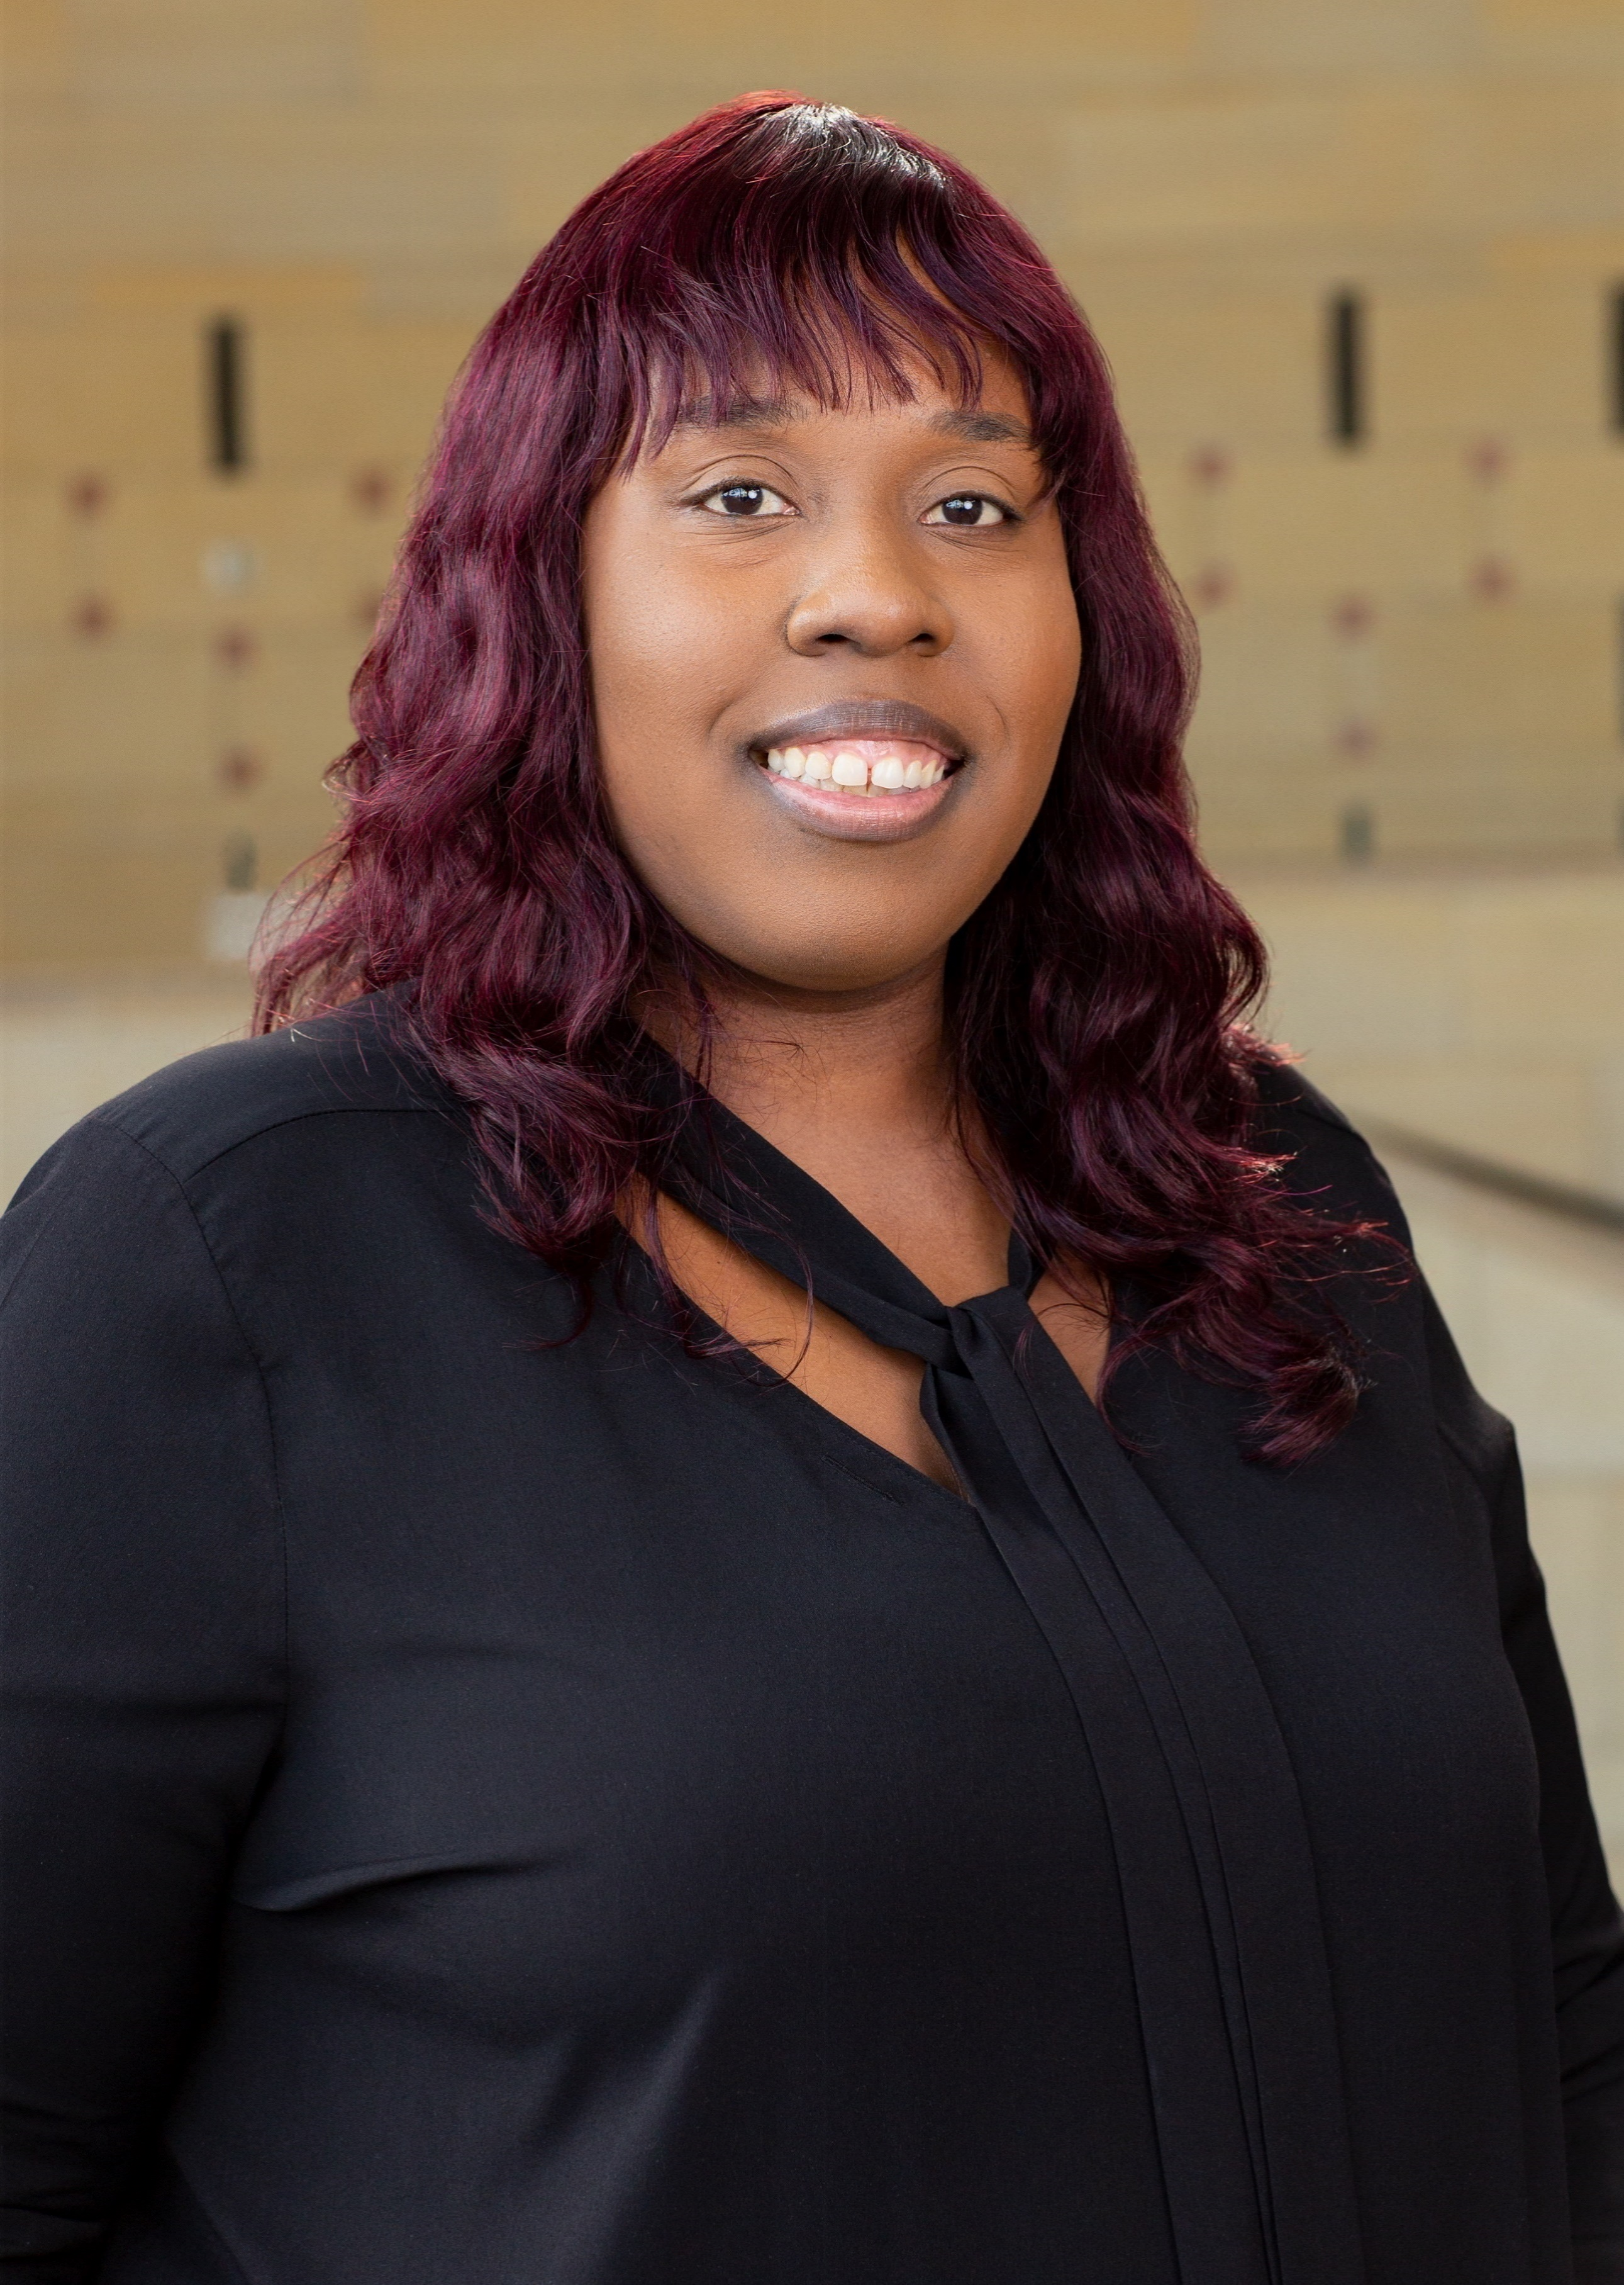 |  | raven wilson  Los Angeles County Metropolitan Transportation Authority  Transit Operations Manager
PROFILE  My name is Raven Wilson. I have been with Metro for over 12 years. I started as a Transit Operations Supervisor, working at Division 8, Vehicle Operations and at Bus Operations Control. I am now working as a Transportation Operations Manager at Division 7 in West Hollywood.  I have had the pleasure of participating in the 2017 Leadership Academy, in addition to this year's EnoMAX program and this year's Southern California Leadership Program.  I like to read, watch movies, spend time with friends and family in my spare time. Fun fact: some people find me funny.  Contact  PHONE:  (310) 854-3103  CELL PHONE:  (310) 405-5882  EMAIL:  wilsonrav@metro.net |  | department  Bus Operations, Transportation, West Hollywood Division 7  position description  I share responsibility for dealing and handling operations/service in a bus division. I am in charge of the administration side of the division; attendance, protected leaves of absence, tardiness, hearings, accident reviews, termination.  business project  My project would be researching Operations-Bus Maintenance in regard to our bus shortage, Maintenance issues that affect our daily service such as cancellations and out late assignments. Procurement is involved in regard to the quality of our bus purchases and how we can maximize our value in vehicle service and fiscal spending.  Ideal Outcome-would be improving the duration and quality of our bus fleet; to increase our population of buses to assist with equipment shortages and special events which include rail closures/bus bridges etc.

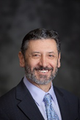 |  | Ignacio Correa-Ortiz  Regional Transportation District  SENIOR Architect/Urban Designer
Profile  Ignacio Correa-Ortiz made the decision to actively participate in the healthy evolution of cities thirty years ago; he believes that the future of humanity and ecology depends largely on the sustainability of the urban environment. He made the decision to actively participate in the healthy evolution of cities thirty years ago. He believes that the future of humanity and ecology depends largely on the sustainability of the urban environment.  Ignacio is a licensed architect, certified urban designer and urban planner, and an accredited LEED professional. He serves in several boards including the AIA Colorado, the Denver Planning Board and the Denver Architecture Foundation.  Ignacio graduated from the University of Wisconsin-Milwaukee with masters' degrees in architecture and in urban planning and has a professional degree in architecture from Universidad Santo Tomas in Colombia, South America. He is a Senior Architect, Urban Designer, and Urban Planner at the Regional Transportation District in Denver.  Contact  PHONE:  (303) 299-6937  CELL PHONE:  (303) 335-7085  EMAIL:  ignacio.correa-ortiz@rtd-denver.com |  | department  Capital Programs  position description  Perform reviews and coordinate all architectural, landscape and urban design and field construction management efforts for FasTracks and base system related projects, including buildings, passenger stations, park-n-Rides, joint development projects, sidewalk and paving treatments, and landscape treatments.  Assist in the interpretation of architectural design standards established by local jurisdictions and in the establishment of formal agreements with various outside agencies.  Review and evaluate the design prepared by other agencies and consultants, as well as that of other staff engineers to ensure adequacy, completeness, economy and compliance with design criteria, design standards, ADA requirements and maintainability.  Assist in the development of criteria for evaluating joint development proposals related to architectural elements and land use considerations. Supports RTD staff in promoting Transit Oriented Development and coordinate joint development tasks related to design and construction within each FasTracks Corridor.  business project  I want to explore the issue of how transit agencies plan to cultivate minority youth for transit professions. I want to explore also how different agencies are preventing an equity, diversity and inclusion chasm. I want to explore how professions are distributed across the board and determine if there is a disproportionate distribution of pay-grades by gender and ethnicity.  RTD like any other agencies is making great advances towards a more integrated and equitable working place. But we are not there yet. Typically, one area that is still underrepresented in transit agencies is the participation of female professionals.  I am proposing to look at current Utilization Analyses by the participating agencies and observe whether there are any trends. I also will study the different agencies EEO programs and their achievements. The thesis is that by including youth, in particular minorities, a transit agency can improve minority utilization in the professional categories.

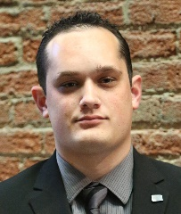 |  | charles eberling  Regional Transportation District  electronics technician
Profile  I have an associate degree in Electronics technology. I started working part time for a company that designed system recorders for private companies including the air force. I worked for them during college and a few years after while I was searching for a job. Which I eventually found at RTD as a member of the mobile technologies group for the last 5 years.  I am a graduate of RTD's leadership academy. I was also a member of a group called Royal Rangers where I earned an equivalent of the Eagle Scout award called the Gold Medal of achievement. I also earned another award called the Saber where the requirements are to pass four leadership training classes under different environments for different purposes. Interesting facts for me are I have a black belt in judo and am an anime fan.  Contact  PHONE:  (303) 299-3085  CELL PHONE:  (575) 202-2861  EMAIL:  charles.eberling@rtd-denver.com |  | department  Mobile Technologies Group  position description  I maintain all physical CAD/AVL equipment on buses and trains. This equipment includes automatic people counter's (APC), On board electronic fair equipment, Digital and Networked video recorders, Destination Sign board level repair's, on board networking equipment both cellular and WIFI, Radio Transmission equipment, vehicle health monitoring equipment, on board ticket printing systems, and INIT based CAD/AVL products.  business project  RTD's current smart fare collection system (bar code scanner, tap cards, Smart pay such as apple or google pay) will soon be up for replacement. As a maintainer for that equipment I want to look at other systems and bring back ideas for what RTD should have as requirements for our next system. I also want to look into how other properties use their automatic people counting systems, what types they have, and what features they use or find useful. These ideas will be brought back to RTD so it can make better use of its ever-expanding APC fleet and increase its functionality.  The main outcome I will be looking for is increasing customer satisfaction by making payments more user friendly. I will follow by combining both smart fare and people counting to better align route usage. This will also lead into tracking fare evasion more aggressively and allow all agencies to be more reactive to it.

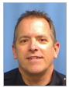 |  | stephen johnson  Regional Transportation District  transit police officer
Profile  I have been with RTD for 6 years. Started as contract security officer. Then drove bus for 6 months, light rail operator for 18 months and transit police officer for a little over 3 years. 15 years law enforcement experience elsewhere. Currently working for my M.B.A. at an online school. Would like to continue growth within RTD using all my skillset.  Most proud of my three college educated daughters to be productive members of society. Currently all in the Seattle area for separate reasons. I love to travel and visit new places.  In the summer, my wife and I like to spend time at her family cabin in the mountains. Also, I enjoy bicycling (mountain and road) and hiking in the beautiful Colorado Rocky Mountains.  Contact  PHONE:  (303) 299-2345  CELL PHONE:  (303) 594-3629  EMAIL:  Stephen.johnson@rtd-denver.com |  | department  RTD Transit Police  position description  Patrol 2400 square miles of our district. Primarily focused in the Denver metro area. Enforce RTD code of conduct violations, fare violations, and criminal activity. Work with our 280+ armed security officers and assist them when needed. Also follow up on abandoned vehicle in our 80 park and rides.  business project  I am interested in how other agencies handle homeless and drug use at their facilities. Specifically, in the bathrooms. We recently changed doors at our main hub, Union Station and still having problems with people sleeping in stalls and using illegal drugs. Unfortunately, this is an inconvenience for our regular passengers who need to use the facility quickly. This is also a safety concern for illegal drug activity including users and dealers. Currently our contracted security officers monitor the restrooms by periodically checking the bathrooms for these activities, but not there all the time. Once the security officers remove the parties out of the restroom and they leave, the homeless and drug crowd returns.

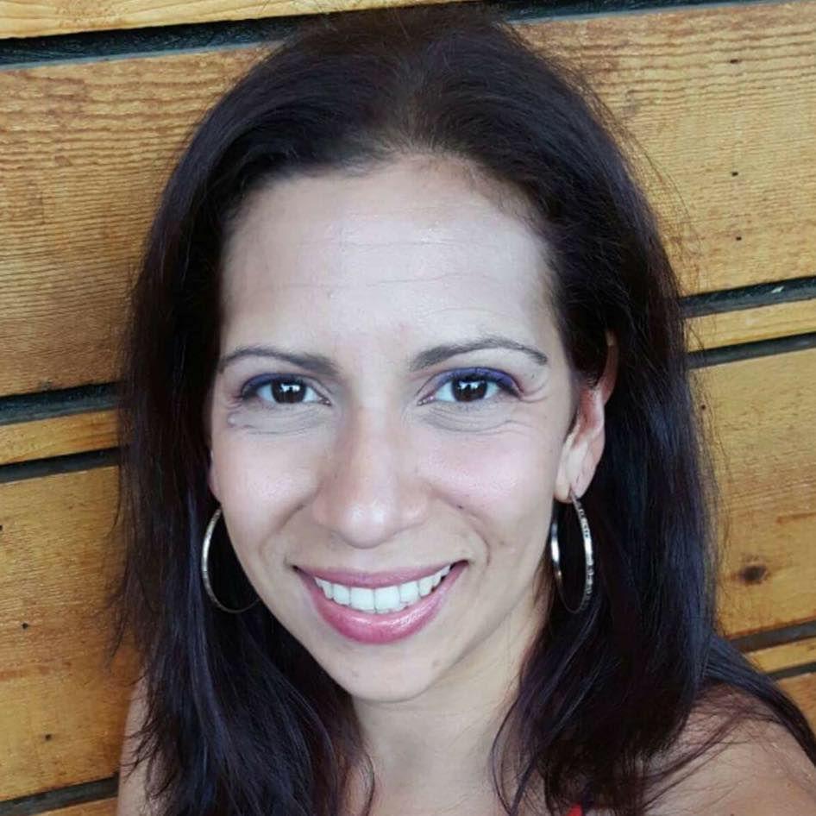 |  | VIVIAN MORALES  Regional Transportation District  civil rights outreach Specialist
PROFILE  Born and raised in Puerto Rico, Vivian found her way to Denver via Chicago. She started her RTD career in 2014 and joined the Civil Rights Division in 2018. Her background is in non-profits concentrating in outreach, communications, curriculum development, volunteer recruitment/development and operations. Outside of RTD she is an improv actor, director, and instructor. She also serves as a board member at Escuela Valdez.  Vivian holds a Certificate in Paralegal Studies, an M.A. in Transformational Leadership and B.A.s in Theater and History of the Americas. She is indeed a nerd at heart who loves a glass of Malbec, an IPA, a well-written historical fiction and cheese flan. Vivian lives in the Denver metro area with her husband Tony and grade school daughter Aliyah.  Contact  PHONE:  (303) 299-2126  CELL PHONE:  (720) 212-3417  EMAIL:  vivian.morales@rtd-denver.com |  | department  Civil Rights Division  position description  Community liaison for the Civil Rights Divisions with external and internal stakeholders including elected officials, organizations that represent people with disabilities, small and minority businesses, and community leaders.  Develops civil rights strategies and activities as part of the annual and quarterly public outreach planning processes.  Data collection and production of division related reports as mandated by the FTA and the organization’s Board of Directors.  business project  Identifying first and last mile equivalency for the ADA community.  Approximately 1 in 5 of the population qualify as Americans with Disabilities Act (ADA) passengers. As agencies explore different options for first and last mile, specifically partnering with Transportation Network Companies (TNC) such as Uber, Lyft, and taxis, the ADA community has not experienced equivalency in these options.  RTD's ADA and Paratransit are exploring different options on how to find this equivalency while complying with FTA regulations. Ideally this project will find concrete solutions and at the least will collect best practices across the participating agencies while creating a network for discussion and further discovery.

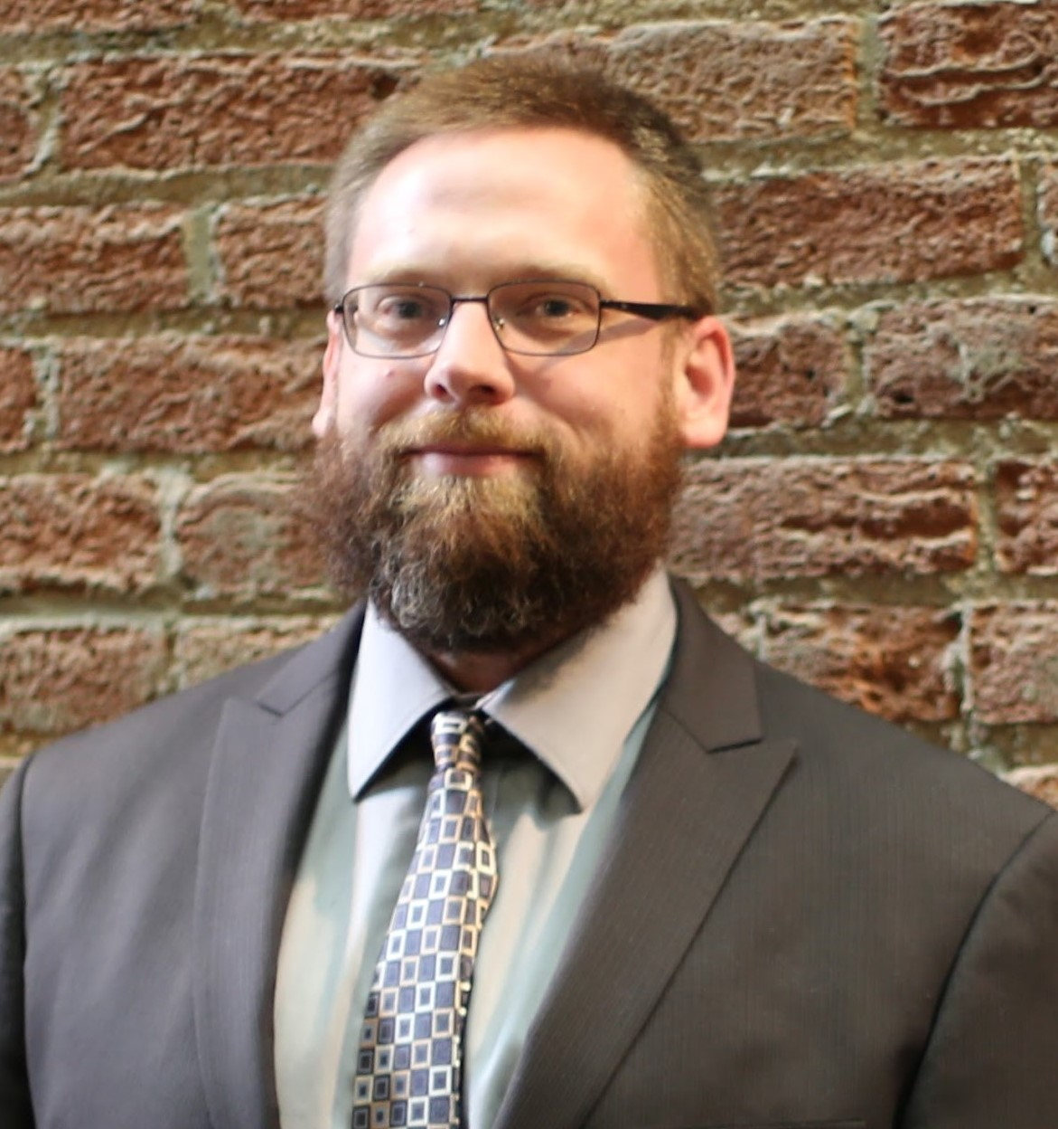 |  | karl shoemaker  Regional Transportation District  General Superintendent, Infrastructure
PROFILE  I started my career in railroading with the Union Pacific in track maintenance. I left there to come and work with RTD in training. I moved up to track engineer and now find myself in my current position as General Superintendent.  I enjoy working at RTD due in part to its cross functional aspects. I get exposure to various functions, from IT, HR, Signal, OCS, and track. It’s been quite an experience.  Contact  PHONE:  (303) 299-3386  CELL PHONE:  (970) 584-0132  EMAIL:  karl.shoeomaker@rtd-denver.com |  | department  Rail Operations Infrastructure, MOW and SCADA  position description  Oversee the infrastructure maintenance department. This involves, strategic planning, budgets, union issues, manpower, emergency response.  business project  How to best integrate new inspection technologies into existing maintenance processes.  RTD is in the process of implementing new automated inspections. RTD is also starting up new analytic software. What I'm trying to put together is how best to align existing inspections and maintenance processes with new data and analytics with the goal of more efficiently using our resources.

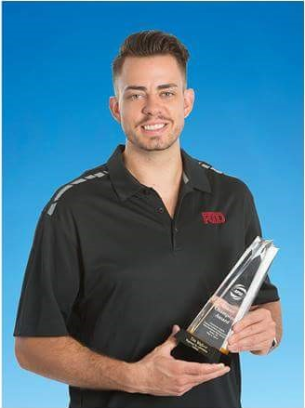 |  | tim wallace  Regional Transportation District  technical trainer
PROFILE  Starting out in my career, I worked at a small garage in Westminster, CO, while attending Lincoln College of Technology receiving my Associate’s Degree in Diesel and Truck technology and a minor in accounting. After graduating, I came to RTD as a general repair mechanic where I became a Certified Mechanic and a Master ASE Certified Transit Bus Technician. From 2014 to 2017 with two other mechanics I competed in the APTA International Roadeos. At the 2017 Roadeo in Reno, NV, our team won first place in Electrical, HVAC, Highest Scoring Maintenance Team, and Overall Grand National Champion. It was an amazing honor to take a national title back to RTD and share the experience with some great people.  Shortly after the Roadeo, I was promoted to Technical Trainer facilitating mechanics training courses, providing shop floor technical support, and assisting in hiring processes. I really enjoy the transit industry and am looking forward to visiting other agencies during MAX to learn what other buses are being utilized and about their maintenance programs and procedures.  Contact  PHONE:  (303) 299-6303  CELL PHONE:  (720) 290-2665  EMAIL:  tim.walllace@rtd-denver.com |  | department  Bus Operations, Maintenance  position description  As a technical trainer, I train mechanics in a variety of zones on transit buses, give technical support to mechanics on the shop floor, facilitate interviews and hiring mechanics, recruit employees from high schools and colleges, instruct mechanics for class A CDL testing and many other tasks that are assigned in various parts of RTD.  business project  I am interested in learning how other transit agencies perform new hire on boarding processes, recruitment and retention and how other maintenance training departments operate. At RTD, we are really focusing on hiring mechanics and are looking for new ideas or innovative programs that might assist in the process, observing other companies could be beneficial and some brainstorming could strike up some really good ideas. Currently we are struggling to get experienced mechanics and some applicants do not have much experience and many do not pass the new hire test. We have recently reconstructed our entire testing and on boarding process and are waiting for new mechanics to apply and begin the new program. I understand from trends that trade jobs are declining but, there are many ideas from great people out there.  I am also interested in observing how other maintenance training departments operate, I have heard there are not too many training departments at transit agencies. Being able to look over the department could bring up some good pros and cons for both RTD and the participating agencies. This is the main objective I would like to focus on but, I would like to learn as much as possible and take any beneficial information back to RTD.

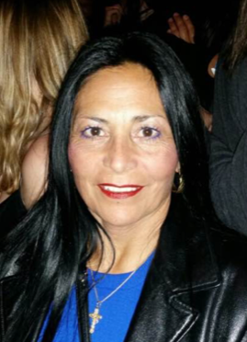 |  | hazel wing  Regional Transportation District  station starter
PROFILE  I have been employed with RTD for 15 years. I drove 12 years and Station Starter for 3. Due to Civic Center renovation, all transactions were moved to the street. A highlight as an everyday challenge.  Completing the Leadership Academy gave me great insight to a large part of how bus operations work. I have completed a Citizens Fire Academy and have completed a Transit Alliance Class.  I am very outgoing and love to ride bicycles. I love learning, meeting new people and helping people with transportation needs.  Contact  PHONE:  (303) 299-2774  CELL PHONE:  (720) 300-3223  EMAIL:  hazel.wing@rtd-denver.com |  | department  Bus Operations, Dispatch  position description  Responsible for tracking and logging in buses. Responsible for the safety of passengers boarding and de boarding buses at gates. Resolve any driver issues in the station. Monitoring Union Station for safety issues, hazards and working monitors, elevators, escalators and doors etc.  business project  Safe evacuation of masses of people in Union Station, and RTD offices in an emergency. Location of first responders, medical personnel, command center and holding area. Keeping order to evacuate all peoples.  I am interested in how other agencies conduct drills for safe evacuations of masses of people from public buildings and who are the first responders, call list order of the employees working in said building, where the safe area is located, and where the command post located.

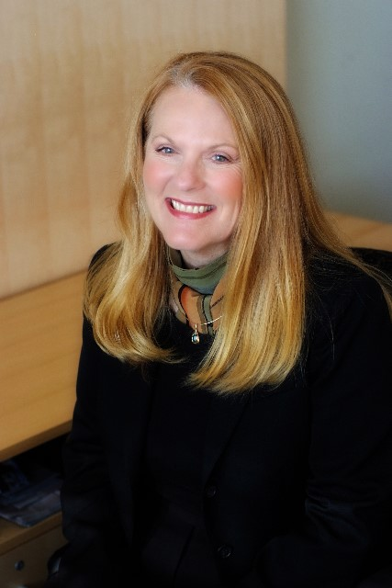 |  | susan wood  Regional Transportation District  Planning Project Manager II
PROFILE  Susan is a Planning Project Manager, Environmental, for the Regional Transportation District, where she oversees environmental documentation and compliance, consistent with the National Environmental Policy Act, for a variety of projects. Prior to transit planning, she worked in land use for several municipalities and counties in the Denver Metro Region.  She holds a MURP degree from the University of Colorado at Denver and a B.S. degree in Geology from Baylor University. She is active in the American Planning Association, and in particular, she serves on the Legislative and Policy Committee at the national level and as the Legislative Committee Chair at the State level.  Contact  PHONE:  (303) 299-2467  CELL PHONE:  (303) 968-7574  EMAIL:  susan.wood@rtd-denver.com |  | department  Systems Planning  position description  Oversee environmental process and compliance (National Environmental Policy Act [NEPA]) for RTD. Conduct studies consistent with NEPA and ensure compliance with environmental mitigation commitments for projects in construction.  business project  Communicating Transit's Positive Role in Addressing Climate Change  I would like to explore how agencies are communicating the importance of transit in addressing the global issue of climate change. Certainly, transportation is a primary contributor of greenhouse gas emissions (GHG) and transit through its capability to move many people per vehicle (approx. 80/bus) as opposed one per car has the ability to reduce GHG. Coupled with zero emissions technology, the positive effects are multiplied. It would be interesting to find out how and if other agencies are messaging the importance of transit and its link to climate change. Beyond that, I would like to explore various changes and technologies that are feasible and cost-effective that agencies could implement to further enhance transit's positive effect on air quality and the role it can play in the conversation on climate change.

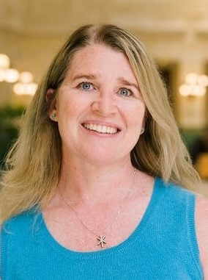 |  | sarah bohlen  Sound Transit  development manager for implementation planning
Profile  I am the Development Manager for Implementation Planning for Sound Transit. I oversee the business practices used during the project development phase of Sound Transit's system expansion projects.  I have been at Sound Transit for 9 years; my prior experience includes 6 years of project planning and management work at a structural engineering firm, 8 years of land use and transportation planning at the City of Shoreline and research positions at the Washington State Association of Counties and the American Planning Association starting. Throughout my career I have been interested in the implementation of large-scale public infrastructure projects.  Contact  PHONE:  (206) 398-5319  CELL PHONE:  (206) 335-7274  EMAIL:  sarah.bohlen@soundtransit.org |  | department  Planning, Environmental, and Project Development  position description  Project management oversight, develop, track, monitor strategies to implement capital projects, third party negotiations, intra-agency coordination and decision-making, project oversight policy development.  business project  Improve process for internal decision-making, documenting decisions, change management guidance.  I hope to use the EnoMAX opportunity to investigate how our peer agencies document and manage internal concurrence or decisions over the lifecycle of a project or system and use that information to propose a process that can be used at Sound Transit. This process would document decisions, their level of detail, make various points during project development or planning, describe the assumptions and intent in making those decisions, include guidance for revisiting decisions as appropriate, and recommend how and where to memorialize this information.

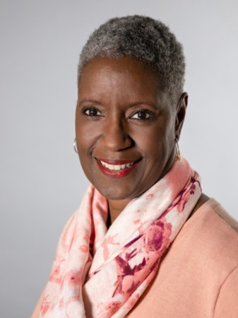 |  | Rhonda dixon  Sound Transit  Community Outreach Specialist II
Profile  I have worked for Sound Transit (ST) for the past 14 years as a Community Outreach Specialist. In this position I am the liaison between ST and communities around the region, elected officials, property owners and our construction contractors.  The highlight of my career is being a part of an organization that is building a system that will benefit the region for years to come. I still love my job to this very day after 14 years. I love being a problem solver and helping people.  Outside of work, I belong to a 12-step program, I roller skate once to twice a week at a skating rink, I do soul line dancing and a dance style called Chicago Stepping. I also love to travel and shop.  Contact  PHONE:  (206) 370-5569  CELL PHONE:  (425) 652-0577  EMAIL:  rhonda.dixon@soundtransit.org |  | department  Communications & External Affairs  position description  - Investigate public property and construction inquiries/complaints.  - Assist in the creation and implementation of special Sound Transit public events.  - Brief Sound Transit staff on matters of public interest and concern.  - Respond to emergency public and community inquires as needed.  - Organize, attend and present at community, neighborhood and individual homeowner meetings regarding the project status, its impacts and intended mitigations.  - Co-facilitates project learning organization consolidating lessons learned in the area of on-going construction, systems breakdown, and business mitigations.  business project  Although we do a lot of work to engage historically hard to reach communities, we would like to see an improvement in participation from these groups. As an EnoMAX participant, I would like to learn from other agencies around the country to help us create more inclusive outreach strategies and programs.  I am interested in how other agencies work to engage historically hard to reach communities. I have chosen to focus my project on traditionally hard to reach communities that deal with potential barriers such as language, technology, and mobility. ST as an agency would like to improve how we engage with these communities and how we integrate their feedback into our projects.

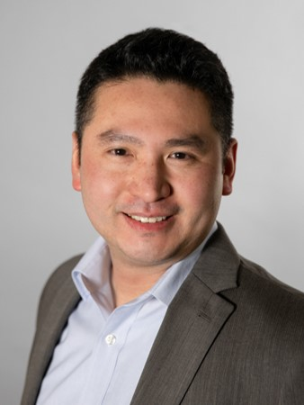 |  |  | Akarawit “Wit” Ekman  Sound Transit  Manager, Project Controls
Profile  Wit has over 20 years of increasingly responsible Project Management and Construction Management experience on a variety of heavy civil and industrial capital projects, in both the public and private sectors.  In Wit's current role as Manager of Project Controls at Sound Transit, he provides direct oversight, coaching, training and performance feedback to staff and multiple consultant teams. Wit ensures that proper and comprehensive project controls systems for management and delivery of scope, schedule, budget, risks and cost estimating are implemented across projects. He ensures that policies and procedures are applied effectively.  Wit oversees multiple concurrent contracts; directs consultant activities, prepares contract documents and evaluates proposals. He provides inputs and guidance to senior management in support of their decision-making. Wit also assisted the project team in the development and negotiation of inter-local agreements, and regularly coordinated work with inter-agency work teams and external stakeholders.  Contact  PHONE:  (206) 398-5486  CELL PHONE:  (206) 484-1734  EMAIL:  wit.ekman@soundtransit.org |  |  | DEPARTMENT  Design, Engineering and Construction Management  Position Description  Wit provides direct oversight, coaching, training and performance feedback to staff and multiple consultant teams. Wit ensures that proper and comprehensive project controls systems for management and delivery of scope, schedule, budget, costs and risks are implemented across projects. He ensures that policies and procedures are applied effectively. Wit oversees multiple concurrent contracts; directs consultant activities, prepares contract documents and evaluates proposals. He provides inputs and guidance to senior management in support of their decision-making. Wit also assisted the project team in the development and negotiation of inter-local agreements, and regularly coordinated work with inter-agency work teams and external stakeholders.  Business Project  Sound Transit (ST) is a regional transit authority that operates within the jurisdiction of local cities, counties and the state.  ST's capital program has finite financial capacity and timeline for delivery. The cost of delivering a capital project in the entire Puget Sound region is already facing pressure due to an unprecedented increase in real estate and construction costs. Scope creep and lengthy permitting processes lead to unnecessary added cost and lost time, which makes it more difficult to deliver capital programs on time and within budget. As a Project Controls Manager for the Central Corridor which is going to be the largest project that the region has ever undertaken, I see controlling scope creeps and streamlining permitting processes as keys to successful project delivery. A 1% cost growth in the $35 Billion ST3 Program could results in $350,000,000 of avoidable cost.  The knowledge and experience that I will acquire from the EnoMAX Program through collaboration, inter-agency networking and the sharing of best-practices with other mature public transportation agencies will provides insights into the issue and potential strategies to work with local jurisdictions having authority to control scope and optimize permitting process, which could be put to immediate use on the Central Corridor and potentially the rest of ST3 Program.

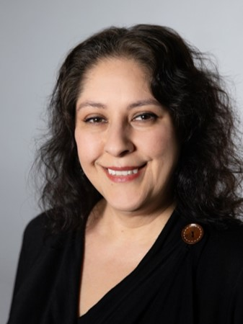 |  | melissa gomez  Sound Transit  Operations Project Control Supervisor
Profile  Project Control Supervisor with 18 years of increasing project control experience, 10 years in Construction and the last 8 years in Operations.  I successfully implemented the pre-procurement process currently in place when I first started working for the Facilities division. Recently, I was moved to Operations Business to support Operations.  I enjoy taking photos and nature walks.  Contact  PHONE:  (206) 398-5391  CELL PHONE:  (425) 443-1255  EMAIL:  melissa.gomez@soundtransit.org |  | department  Operations  position description  Prepare operating expense and State of Good Repair budgets, support project delivery (from initiation to close-put), track and report on related project costs, contract management and process improvement.  business project  I am interested in how other agencies support the delivery of Operations (OPS) state of good repair (SOGR) projects, and the types of controls in place over realistic budget planning, practical scheduling, and performance monitoring. This knowledge will be used to assist with mapping out a more efficient process that will span across the department. A recent internal audit on our current Operations Small Capital Project process assessed the controls in place over realistic budget planning, practical scheduling, and adequate performance monitoring are not adequate. Internal audit recommends our process should be strengthened.  My MAX business project will focus on exploring what types of controls are in place at other agencies for realistic budget planning, the delivery of state of good repair work in an efficient and timely manner and how project controls assist with the delivery. My project will include identifying the technology and staff organization that are employed by the other agencies to track project life-cycle (identified need to close-out) and is the technology used flexible to adapt to a growing department. As Sound Transit begins to shift from building systems to full operations, I'd like to implement and document an efficient budgeting, delivery and monitoring process for our Operations Department.

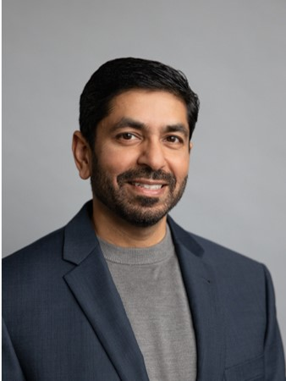 |  | ahmed idrees  Sound Transit  SCADA & Controls Systems Engineer Supervisor
Profile  Ahmed Idrees is a SCADA and Control Systems Engineer Supervisor at ST Operations Technology and Engineering. His focus is primarily on the Link Light Rail SCADA and Industrial Control System. He collaborates across departments including ST IT, King County Metro, Contractors, and Design Engineering and Construction Management group in engineering and design of the Link Light Rail expansion.  Ahmed has strong expertise in SCADA & Control System Design Engineering and Field implementation as well as SCADA PLC & HMI programming. He has extensive background in network design and implementation including field start-up and testing of control systems.  Ahmed is the Vice-Chair in the APTA Control & Communications Security Working Group, a committee of transit professionals working with TSA to publish best practice recommendations around securing our crucial transit related systems, the goals of which are to add security features based on cyber and intrusion vulnerabilities to the controls and auxiliary systems of the light rail and bus transit systems.  Contact  PHONE:  (206) 903-7449  CELL PHONE:  (206) 288-9124  EMAIL:  Ahmed.Idrees@SoundTransit.org |  | department  OPS - Operations Technology, SCADA Engineering  position description  - Leads the SCADA Engineering team responsible for the 24x7 operational management of the Link Light Rail SCADA application including configuration, programming, change and configuration management, testing, and troubleshooting.  - Oversee the design, development, implementation, testing and maintenance support of SCADA systems for monitoring and control of: train signaling, traction power, fire/life safety and building management systems.  - Develops and maintain standards in coordination with other agency technology groups.  - Collaborates with IT infrastructure team to architect the SCADA system, design, network, installation and testing of servers, storage and data centers in production and test environments.  - Develop and maintain standards and enhancements in coordination with the other agency technology and engineering groups.  business project  Sound Transit's OPS group focuses on the Link Light rail industrial control systems and various contractors install these systems which must be integrated into a common headend. We have begun implementing a few hardware integration and implementation standards but identifying precise requirements from operations and engineering for data retention, standard reporting, data management, backup management, and version control has been challenging. I would like to identify other agencies’ best practices, industry standards on configuration management, software requirements, and configuration and programming of systems including:  - SCADA Building Management System, Emergency Ventilation System, and Train Control System and Subsystems within each  - Phone systems  - CCTV and Access Control  - PA/VMS  - Industrial Networking  I would like to refine and implement standards at ST with a focused effort of what has worked well and what to avoid including ideas on how SCADA is used, what data is utilized, and how to best leverage data.

rahul nagalkar
Sound Transit

Value Engineering Program Manager
Profile  I am the Value Management Program Manager for Sound Transit. I conduct independent reviews of Sound Transit's products, projects and processes using the value management methodology including Value Analysis, Constructability Reviews, and Risk Assessment/Analysis workshops.  - Advocate for Value Management (VM)/ Value Engineering (VE) process as a problem-solving tool to build consensus among stakeholders, increase stewardship, improve customer service with our partners, solve difficult transportation problems, and improve project quality.  - Promote VE internally to facilitate overall ST management objectives of streamlining operations, improving performance, reliability, quality, safety and reducing life-cycle costs.  - Train ST staff in Policy and Procedures as they relate to Value Engineering and Risk Management.  - Liaison with FTA/ PMOC for Value Engineering and Risk Management activities.  Contact  PHONE:  (206) 398-5255  CELL PHONE:  (206) 953-1768  EMAIL:  rahul.nagalkar@soundtransit.org |  | department  Design, Engineering and Construction Management  position description  - Conduct independent reviews of agency product, project and processes using the value management methodology (includes Value Analysis, Constructability Reviews and Risk Assessment/ Analysis workshops)  - Advocate for Value Management (VM)/ Value Engineering (VE) process as a problem-solving tool to build consensus among stakeholders, increase stewardship, improve customer service with our partners, solve difficult transportation problems, and improve project quality.  - Promote VE internally to facilitate overall ST management objectives of streamlining operations, improving performance, reliability, quality, safety and reducing life-cycle costs.  - Train ST staff in Policy and Procedures as they relate to Value Engineering and Risk Management  - Liaison with FTA/ PMOC for Value Engineering and Risk Management  business project  I would like to develop a comprehensive agency strategy and centralized management approach of how we engage with Third Parties in our capital project planning, design and construction phases.  I am primarily interested in how other agencies strategize their dealings with jurisdictions having permitting authority and external stakeholders -Authorities Having Jurisdiction (AHJ). Does each agency project team deal with AHJ's on their own or is there a centralized management and strategy to deal with AHJ's?  One approach for ST is to pursue a state legislature approval that will grant a legal self-permitting authority. However, this may be a big lift. Instead ST could use several strategies that can minimize the effects on ST projects relative to schedule and cost impacts. For example, AHJ requirements and ST design criteria manual requirements for stations, facilities often conflict. There is an opportunity to develop a mutually beneficial plan that can minimize risks for project and build stakeholder engagement. These are issues that are not new to ST and I want to use my time at EnoMAX to understand how other transit agencies have developed strategies that foster partnerships with major AHJ's.

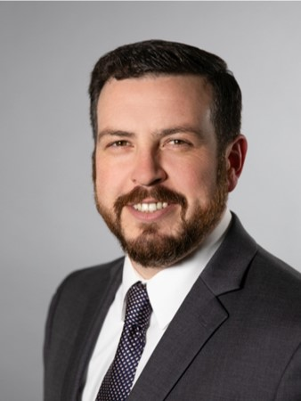 |  | Gabe rukeyser  Sound Transit  Link Transportation Manager
Profile  Gabe Rukeyser is the Link Transportation Manager for Sound Transit's Link Light Rail System. Before joining Sound Transit, Gabe worked for several transit agencies including King County Metro Rail, San Francisco Muni and the Hudson Bergen Light Rail system in New Jersey. Gabe began his rail career in freight railroads, working as a Car Inspector and Yardmaster for CSX in New York City. Prior to his rail transportation career, Gabe served in the US Navy for seven years.  When not working, Gabe enjoys spending time with his two daughters.  Contact  PHONE:  (206) 903-7411  CELL PHONE:  (206) 255-2901  EMAIL:  gabe.rukeyser@soundtransit.org |  | department  Operations  position description  - Manages and coordinates oversight of Agency contractor operator for Central Link light rail train service  - Develops, manages and audits annual operating budget  - Responsible for operational design criteria and requirements for systems and civil designs  - Establishes train service requirements and schedules  - Reviews design submittals for system safety elements coordinating with internal and external stakeholders and systems interfaces for operational functionality  - Develops Operations and Fleet Management Plans for existing and future lines  - Provides leadership to the division in support of department/division goals, policies, and procedures  business project  I am interested in how other transit agencies collect and disseminate daily operational data. At Sound Transit, much of the daily operational data is collected and documented by the control center, staffed by King County Metro, the contractor tasked with operations and maintenance of the rail system. The current system relies on individual controllers documenting events in a CSR (Controller Service Report) or a daily communication log. There is a high degree of variance in how and when CSRs and log entries are generated - although guidelines do exist. Because of this variability, it is difficult to analyze data to identify trends or trouble spots on the railroad. Sound Transit's SCADA system collects volumes of data but harvesting this data in a useable way has proved difficult.  In learning more about how other agencies collect, document and disseminate operational data, I would like to develop some industry best practices to bring back to Sound Transit. I believe that collecting daily operational data will allow the operations team to analyze it and develop strategies for improving the performance of our system.

Candace toth
Sound Transit

Program Manager - Capital Signage
PROFILE  Candace Toth joined Sound Transit in 2012 after 6 years of as a Project Manager for a nationally recognized east coast public artist. Her responsibilities included evolving the artwork from concept through design, engineering, fabrication, on-site construction and installation. She utilizes her experience managing design and fabrication for ST's Capital Signage program, which involves the standards, design, and implementation of the Agency's wayfinding, ADA, and customer information signage at new facilities throughout multiple transportation modes. Candace closely coordinates with various departments, operating partners, municipal jurisdictions, and signage fabrication and installation contractors. In 2017 Candace earned her Project Management Professional (PMP) certification and participated in ST’s Management Excellence Program. Prior to that, she was awarded Mass Transit Magazine's "Top 40 Under 40" in 2016.  She is a Brown University alumni and Ivy League Fastpitch Softball Champion. When not focused on signage and wayfinding, she enjoys bike camping throughout the Pacific Northwest, and making and sharing good food with good friends. She is a maker, baker, biker and obsessed knitter.  CONTACT  PHONE:  (206) 903-7513  CELL PHONE:  (425) 922-5129  EMAIL:  Candace.Toth@soundtransit.org |  | department  Design Engineering Construction Management / Architecture & Art Division  position description  - DECM Customer Signage Project Manager. Manage Sound Transit's Capital Signage Program. Manage scope, schedule, budget for multiple simultaneous capital projects and overlapping contracts (primarily static customer signage). Manage procurement and project implementation strategy for static signage. Oversee staff and consultants.  - Manage sign standards, manuals, guide specs and related documents. Oversee required updates. Develop new standards and processes when needed for both static signage and dynamic signage.  - Design Manager for Capital customer signage at new facilities. Direct consultants, generate IFC ready drawings, collaborate with Communications & External Affairs to develop production-ready graphics and protect brand.  - Construction Manager for Capital customer signage at new facilities. Manage on-site installation work of 3rd party vendors, while coordinating with civil contracts. Oversee permitting/site access, creative problem-solving in the field, change orders, inspections and punch lists through Link revenue service and contract closure.  - Collaborate with all project stakeholders to incorporate best practices and UX user-centered design approach into signage research, studies, and design standards for static and dynamic signage. Co-Chair of Signage Governance Team (SGT), interdepartmental committee ensuring agency-wide programmatic approach to signage management.  business project  I am interested in learning about other agency's signage standards for static signage and dynamic signage (both in stations and on vehicles). My focus is primarily rail; however, bus, intermodal, and BRT standards would also be useful. I will be updating our agency's signage manual this year and would like that effort informed by best practices gleaned from EnoMAX. In addition, I will be updating a number of signs at existing stations each time we open an expansion of our Link light rail system, or BRT system-these are excellent opportunities to implement improvements, which could also stem from recommendations gleaned from EnoMAX.  How do we design a signage system to be flexible and future-proof?

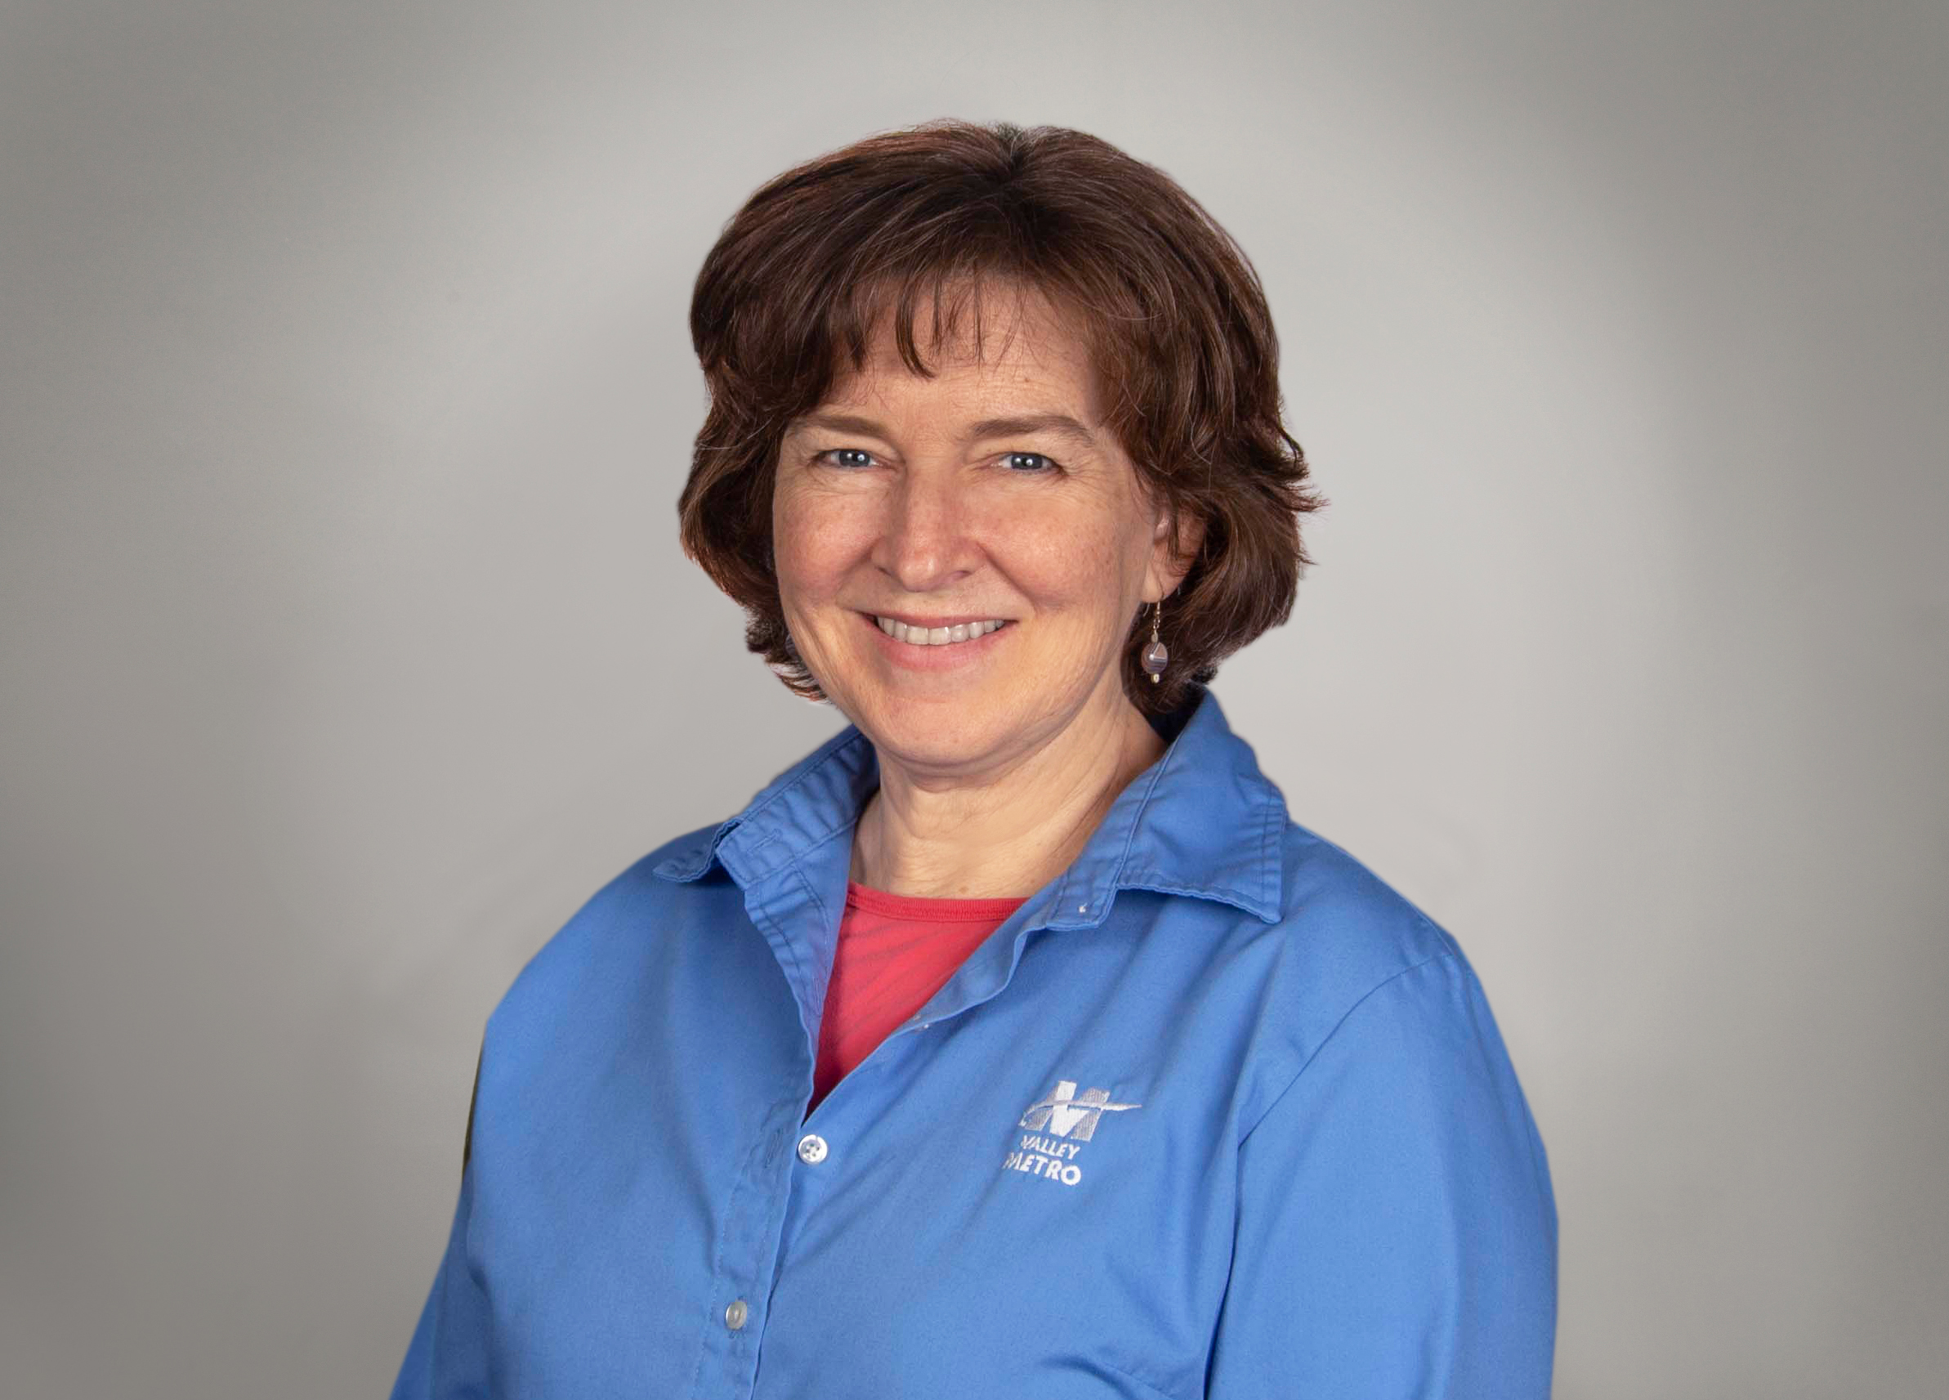 |  | MB Finnerty  Valley Metro  Public arts administrator
PROFILE  I am the Public Art Administrator for Valley Metro where I have headed the program for over 17 years. I have also worked in public art at the city of Mesa. I have a Bachelor of Arts from the University of Arizona and a Master of Arts from the University of Texas, Austin - specializing in Medieval Art History.  I was born in Bangkok, Thailand and taught English in Himeji, Japan. My hobbies include painting, ceramics and costuming. My husband and I also enjoy travelling and camping.  Contact  PHONE:  (602) 322-4471  CELL PHONE:  (602) 317-4514  EMAIL:  mfinnerty@valleymetro.org |  | department  Capital and Service Development Division  position description  Manage the public art program for Valley Metro streetcar and light rail.  business project  I would like to learn how other agencies organize their public art maintenance programs and how they connect to, or interact with, their general rail maintenance and operations groups.  Our art program has been growing steadily and is now over 10 years old. While we have completed repairs on various, individual projects, our collection as a whole needs conservation and an overall assessment and our data management system is inadequate. Our maintenance group conducts daily cleaning as well as alerting us to troubles in the field, which mean that we need to work within their maintenance framework, but we need flexibility to address issues of conservation that are unique to public art.  For my MAX business project, I will be studying how other agencies coordinate between the two groups. I would also like to learn more about best practices for public art maintenance and collections management that I can incorporate at Valley Metro.

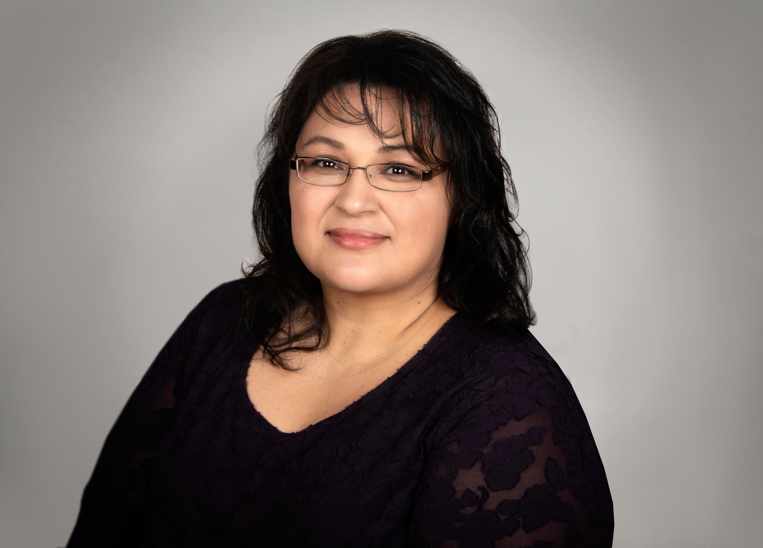 |  | susanna hernandez  Valley Metro  Senior Contracts Administrator
PROFILE  I have 25 years' experience with public procurement practices and procedures. A majority of those 25 years have been spent with transit agencies starting with the Arizona Department of Transportation where I earned my professional procurement certification and focused on complex procurements such as heavy equipment and non-road construction. Hired at Valley Metro in 2015, I was instrumental in reviewing and creating new solicitation templates including terms and conditions along with completing procurements for all light rail extension construction including A/E services. Also, in 2017, I introduced comprehensive digital procurement concepts to issue, evaluate and award solicitations through an e-procurement website. This was announced at our first annual Procurement Open House, an idea I brought forward to leadership in order to present educational procurement topics to the agency in a fun and interactive manner.  I am avid reader and traveler...primarily to Disneyland as I and various family members have won 15 hotel and ticket prize packages from Phoenix radio stations.  Contact  PHONE:  (602) 495-8218  CELL PHONE:  (602) 361-2895  EMAIL:  shernandez@valleymetro.org |  | department  Contracts & Procurement  position description  Responsible for the acquisition of goods and services by means of advanced level work for solicitations and contracts including negotiating, awarding, monitoring and administering local, state and federal contract compliance requirements.  Administers procurements in all areas including: Construction, architectural and engineering services, supplies, and equipment and consulting services.  business project  As we have all come to know, shift happens. Valley Metro must be ready to shift from a heavy capital/project-based arena to a responsive and proactive operationally focused Agency. When construction stops the next shift will see our focus change to how do we maintain the same or greater level of service for our customers and encourage more people to ride public transit.  While we can't predict the future here are things we can see: aging vehicles that will need to be maintained and updated to match the greatness of our new vehicles; changes in how we market our services; and while we may not be designing and constructing miles of new extensions, we will design, construct and maintain changes to what we have already built.  I work in Contracts and Procurement, one of the many internal service divisions in our Agency. We, like IT, HR, and other divisions work behind the scenes to keep the Agency moving forward. We must be as equally prepared for change. A plan of action will be required to better serve all Divisions in order to maintain the light rail system at full functionality.  Valley Metro is not alone in this shift as other transit agencies experience the same growing pains. I want to be a part of planning for what comes next and I want our internal service divisions to take an active role in preparing our Agency for change. The focus of my project will be to conduct an in-depth analysis of other service divisions to determine how to better service Valley Metro as a whole.

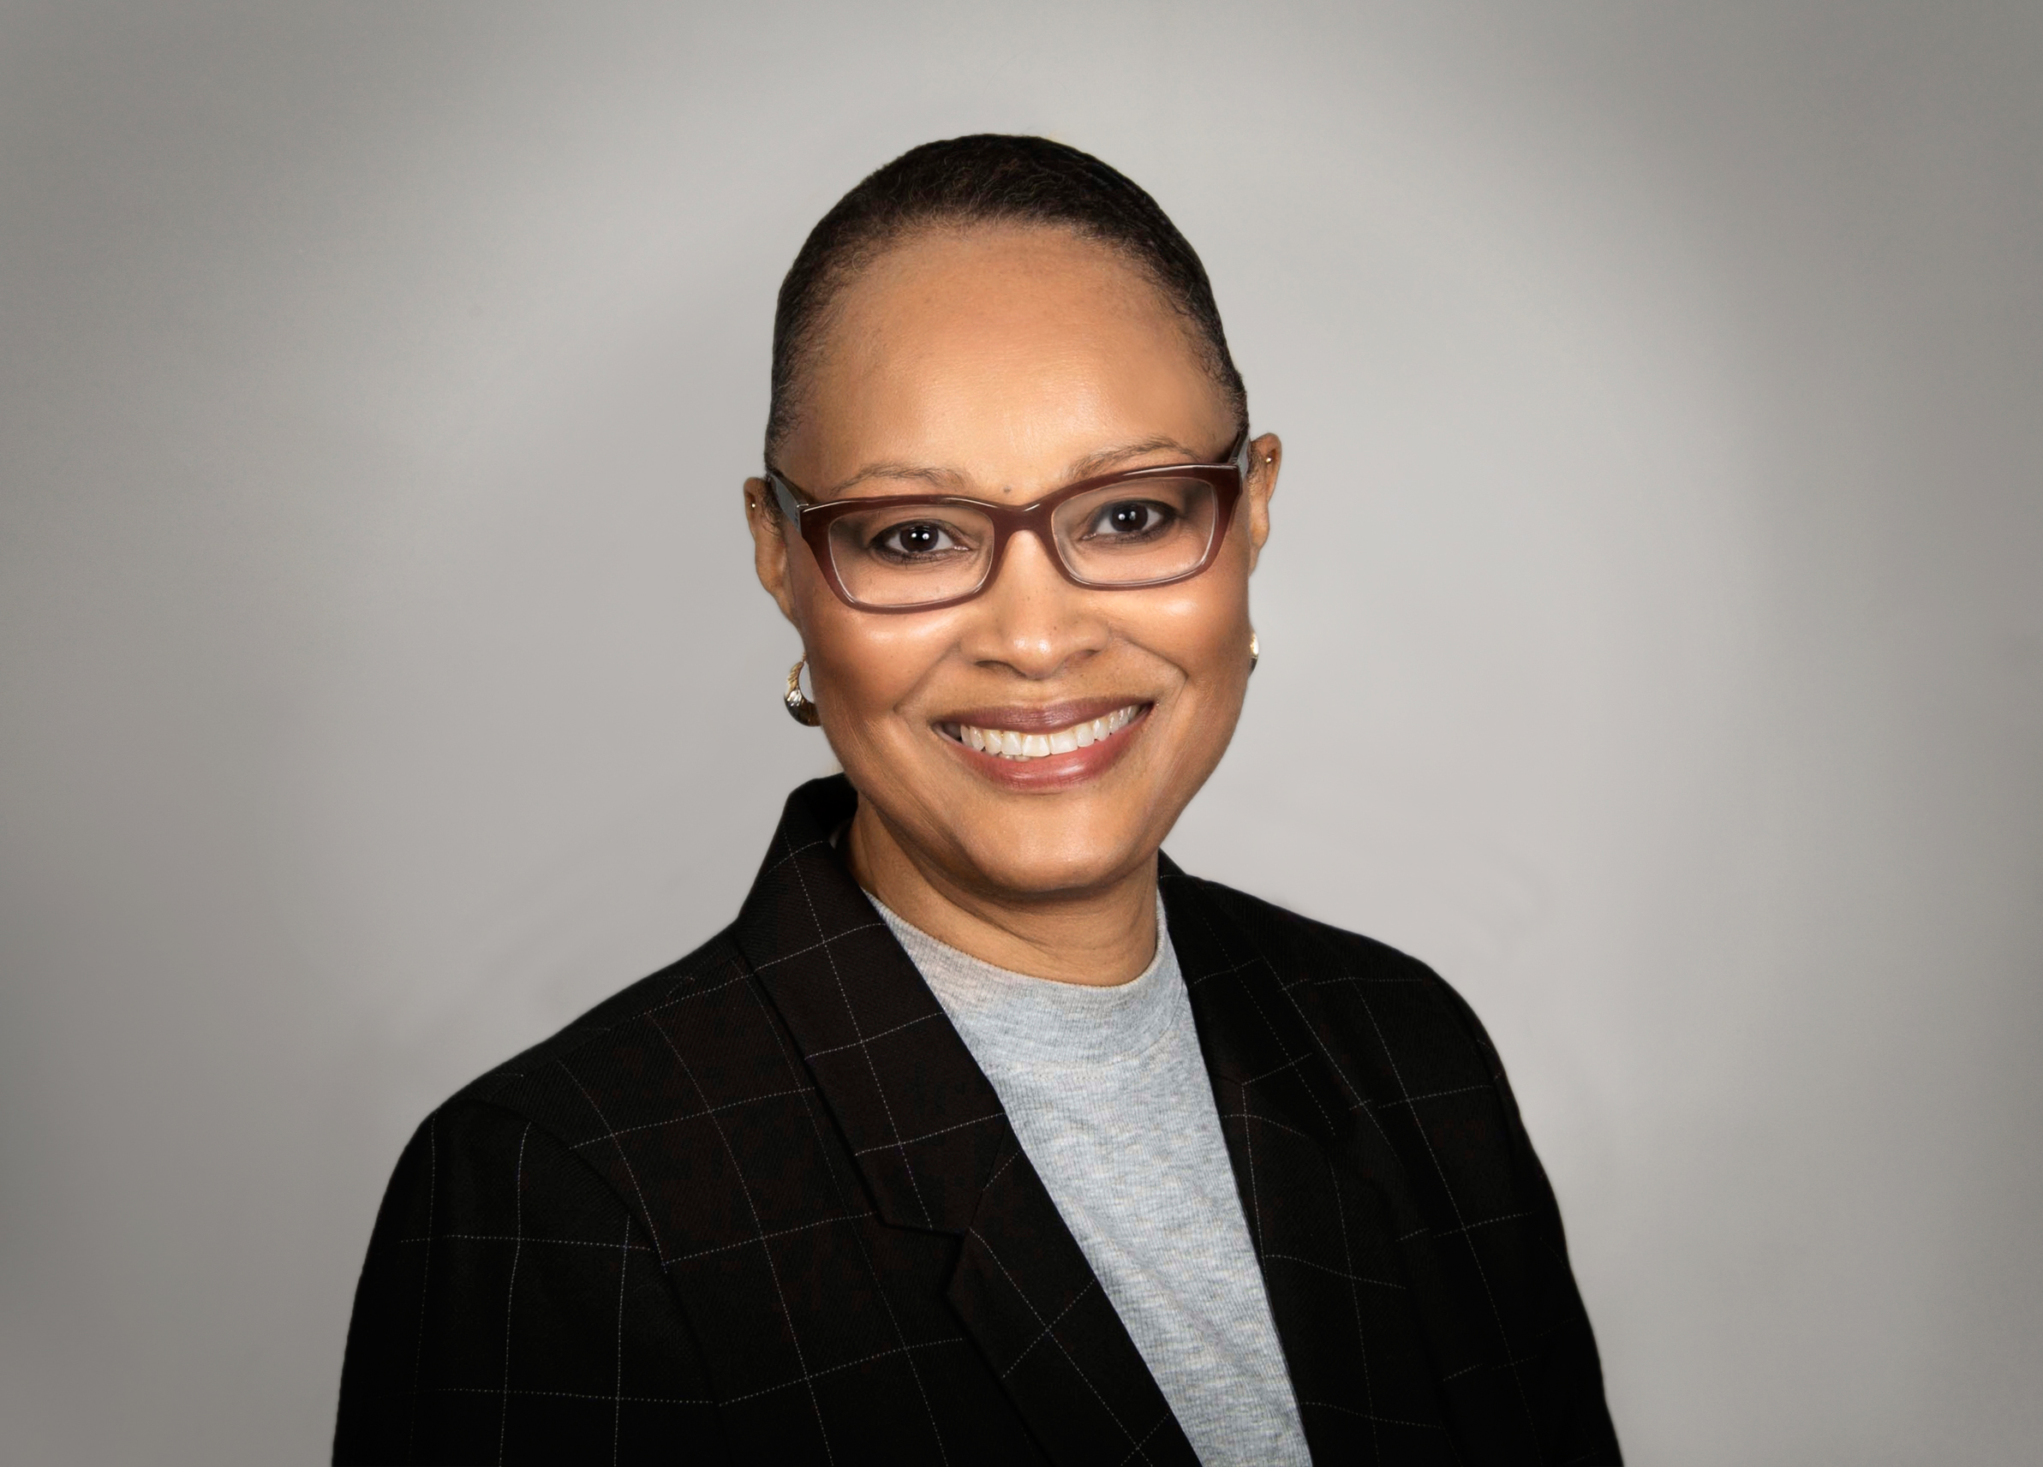 |  | willie marks-pearson  Valley Metro  Customer Service Supervisor
PROFILE  My name is Willie Marie Marks-Pearson. I am a Customer Service Supervisor at the Valley Metro Regional Call Center. I supervise with a group of 8 - 10 Customer Support Agents and work with six Customer Support Leads along with three other Customer Service Supervisors and our Customer Service Manager.  I am from Chicago, Illinois and moved to Phoenix, AZ in 1989. My husband and I have three adult children and a Shih Tzu. My husband and I enjoy going to movies, taking family excursions and having family time.  Contact  PHONE:  (602) 251-2029  CELL PHONE:  (480) 414-6506  EMAIL:  wmarks@valleymetro.org |  | department  Customer Service Regional Call Center  position description  - Work with and supervise a team of 1-10 Customer Support Agents  - Assist with escalations  - Complete evaluations  - Work with a team of 1-6 Customer Support Leads  - Train Customer Support Agents on transit policies and procedures to assist customers with documenting their feedback into our Customer Assistance System (CAS)  - Train and work with transit route providers with assigning and providing credentials access to the CAS for them to investigate customer complaints and document their results and action taken  - Assign and distribute customer feedback to appropriate route providers and agencies  - Create quarterly complaint overview reports  business project  To create Valley Metro Customer Satisfaction goals and establish tracking methods.  I am interested in how other call centers are meeting and improving customer satisfaction goals. Customer Service at Valley Metro responds to customer calls and emails regarding transit related information as well as complaint information. We track monthly call volume and complaint volume as well as complaint categories to identify lower customer satisfaction and opportunities to improve.  For my MAX Business Project, I will be studying how other call centers, including paratransit call centers, measure customer satisfaction. I hope to bring back information that will support our efforts to create customer satisfaction goals and focus on improving our customer satisfaction.

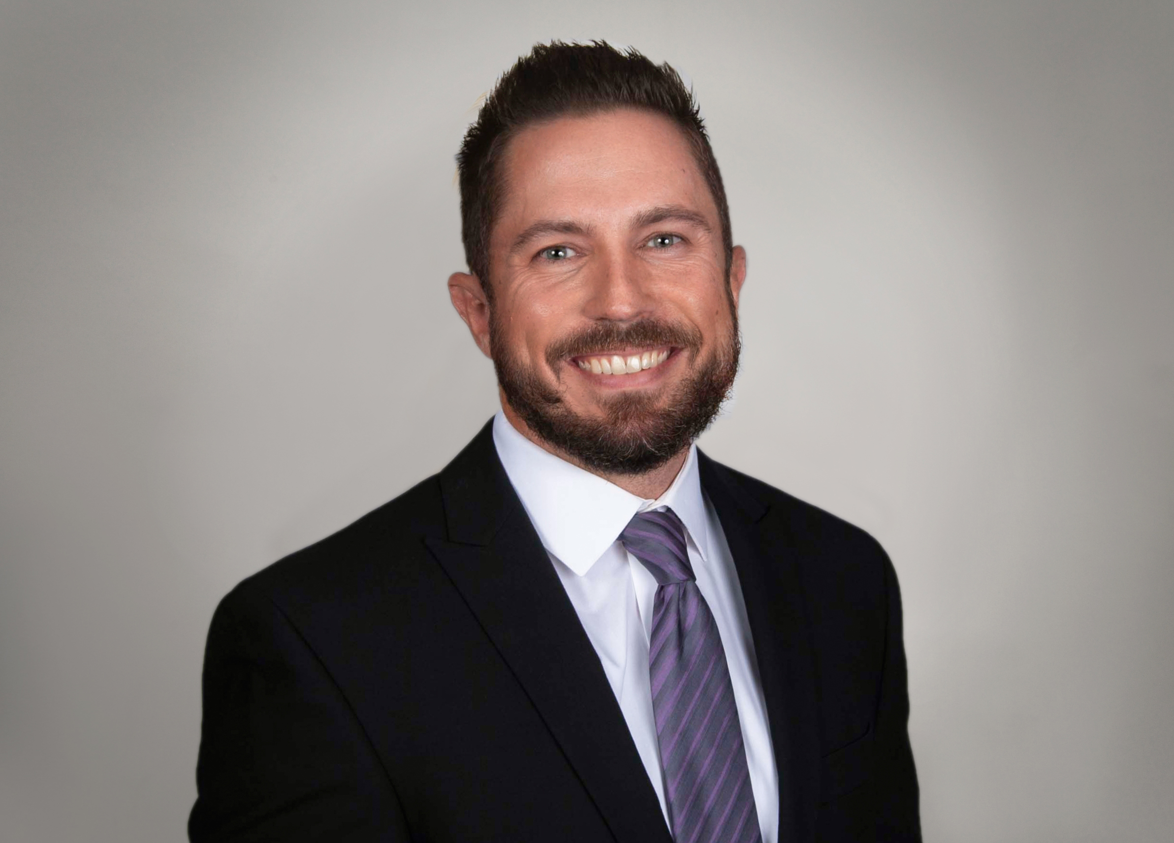 |  | tyler olson  Valley Metro  Budget and Operations Financial Controls Manager
PROFILE  I'm a public transit professional with over 10 years of experience at Valley Metro in the Finance Division. I currently manage a high performing team of five and report to the Chief Financial Officer. I'm responsible for managing the annual budget, 5-year forecast development process, revenue servicing and reconciling of fare revenues, and work closely with operations to develop sustainable operations and maintenance budgets for current and future service. My team also tests financial controls by conducting audits of cashboxes, fare revenue rooms, and parts inventories. I have expertise in the areas of budgeting, forecasting, operations financial analysis, and fare collection.  When I'm not working, I enjoy traveling, riding motorcycles, and being outdoors.  Contact  PHONE:  (602) 322-4485  CELL PHONE:  (480) 332-3382  EMAIL:  tolson@valleymetro.org |  | department  Budget and Operations Financial Controls  position description  - Manage the annual and 5-year budget development process, publications and presentations to committees and boards for both Valley Metro Rail and RPTA.  - Manage fare revenue collection and support the fare collection network from a financial perspective.  - Ensure service and financial information is reported accurately and on-time to FTA (NTD).  - Manage audits performed on parts inventory and bus fareboxes, ensure sound controls are in place.  business project  Budget planning and monitoring isn't the easiest or most exciting task for some people. Tools and software can make a big difference in assisting team members to better understand their budget, key performance metrics, and annual expenses that they are tasked to manage.  For my business project, I will propose we implement a cloud-based budget tracking and monitoring software solution that would provide a budget dashboard view of their Division. The software will provide close to real-time financial transactions, via an automated daily or weekly upload from our financial system. Key features of this software give the user the ability to view at the overall health of their budget at the highest level all the way to the line item detail, combined with powerful visuals, prior year comparisons, and the ability to customize each dashboard based on the customer needs.  I selected this project since our agency has a goal to provide great customer service, be accountable, and fiscally responsible. Our current financial system doesn't provide this level of access and report are very simply formatted and can be difficult to run if you are not a daily user of the system. In speaking with some of my coworkers who recently completed the MAX program, they expressed great interest in RTD's budget process so I'm very excited to kick off our first trip with that agency. I hope to learn much more about their process and identify some best practices that I can bring back to Valley Metro.

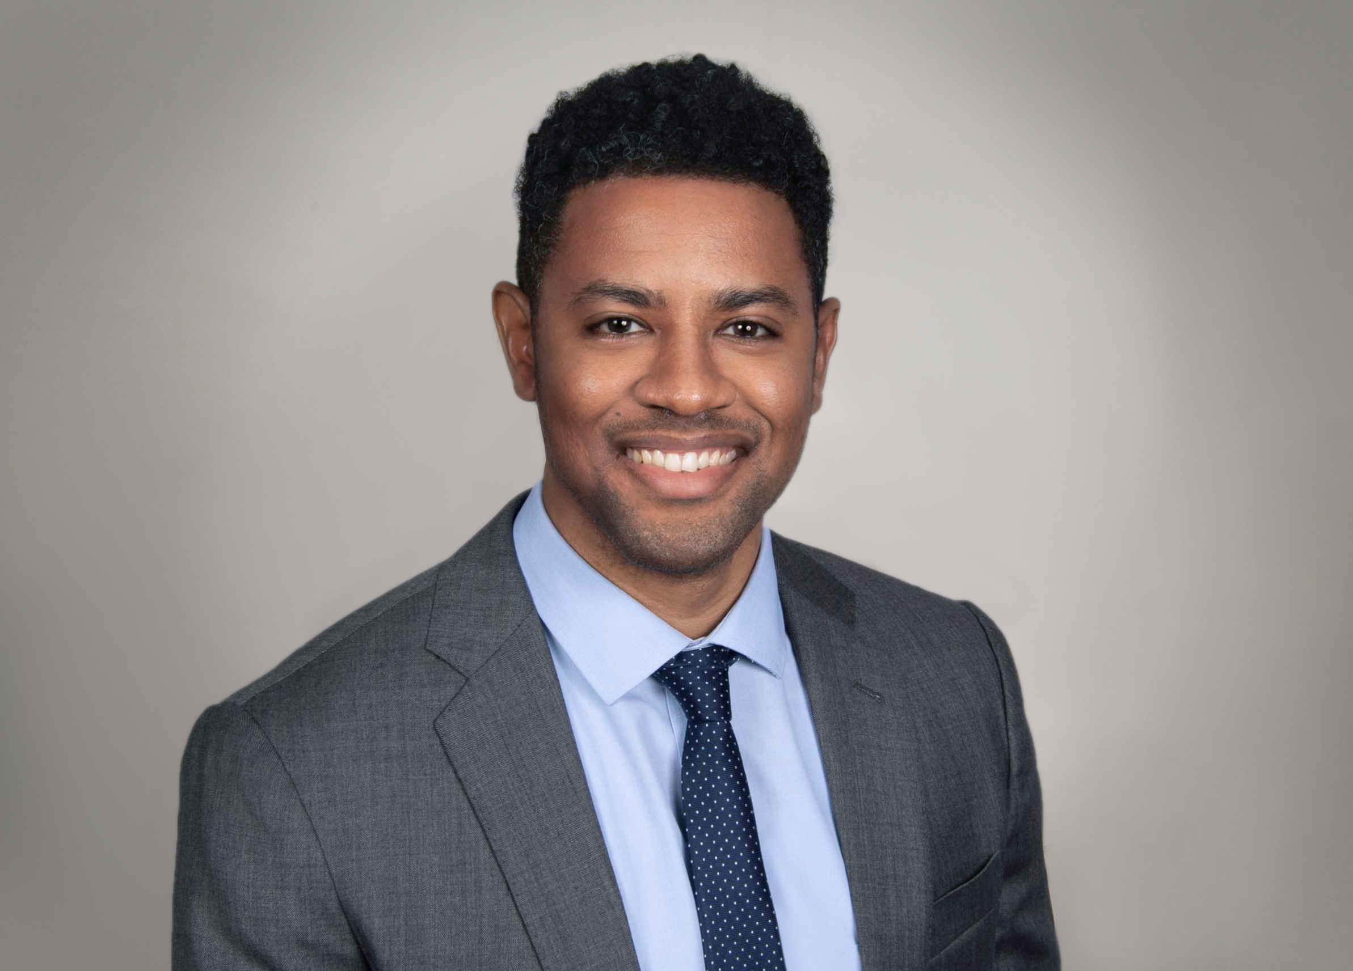 |  | omar peters  Valley Metro  planner iii
PROFILE  I have over seven years of multi-modal transportation planning experience. The first four years were as Regional Transportation Planner at the metropolitan planning organization (MPO) for Dayton, Ohio. Following that tenure, I moved to Phoenix, Arizona and have been with Valley Metro as a Capital Transit Planner for the past three years.  I'm an alumnus of the University of Delaware and the State University of New York at Albany. Although I've lived in many parts of the U.S. (Brooklyn, NY; Newark, DE; Albany, NY; Dayton, OH; and Phoenix, AZ), I'm originally from a small Caribbean island called Grenada. With the 300+ days of sunshine in Phoenix, I'm usually out enjoying the weather and commuting by bicycle. When not outside, I'm usually playing video games. I credit the video game, SimCity, for getting me into this career.  Contact  PHONE:  (602) 744-5557  CELL PHONE:  (302) 690-0792  EMAIL:  opeters@valleymetro.org |  | department  Capital and Service Development  position description  - Managing capital projects to study and construct new park-and-ride facilities in Phoenix West Valley.  - Providing support and technical analyses for various bus and high-capacity transit studies.  - Supervising consultant deliverables on transit studies and data collection projects for quality control.  - Collaborating with local and federal agencies to develop regional transit service improvements.  - Applying for Federal Transit Administration and United States Department of Transportation grants.  - Synthesizing transit ridership trends and survey data for input into transportation planning efforts.  business project  I am interested in how other agencies coordinate with the cities in which they operate to make meaningful improvements to bicycle and pedestrian connections to transit. Over ninety percent of trips to access the Valley Metro transit system are done by people walking/using mobility device (88%) or by bicycling (5%) to a bus stop or light rail station. It is imperative for the operation and future development of the Valley Metro transit system to ensure safe and accessible conditions for people bicycling and walking. However, Valley Metro does not have jurisdiction on the streets which our passengers use, therefore there is a disconnect over the level of improvements that we can make for bicycle and pedestrian safety.  I will be studying how other agencies are planning and prioritizing bicycle and pedestrian improvements within existing bus and rail stop areas, how they are including bicycle and pedestrian facilities into new transit projects, and how they fund those improvements. I hope to get takeaways from other agencies to recommend a bicycle and pedestrian connections to transit program for Valley Metro.

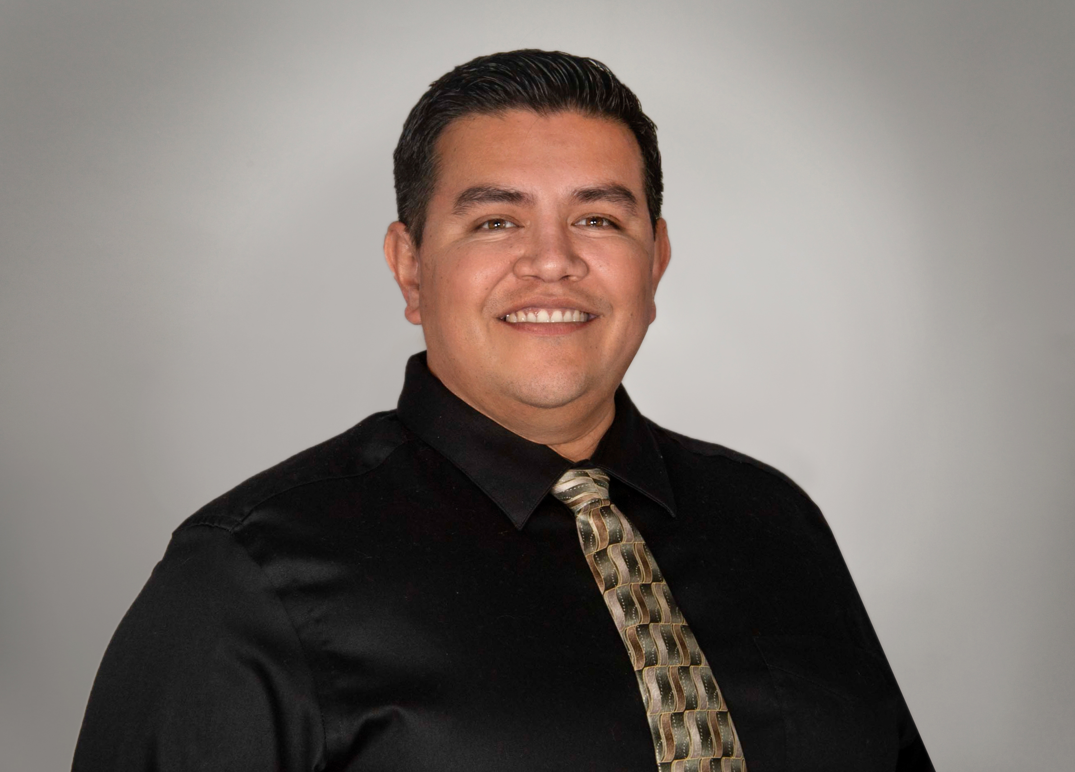 |  | jose rodriguez  Valley Metro  Maintenance of Way Supervisor
PROFILE  I've been with Valley Metro Rail for over 10 years. I began as a signals & communications maintainer and for the last year I have been one of 3 Maintenance of Way Supervisors. Mainly overlooking the signal & communication department.  I was also an active duty Marine for 8 years prior to working at Valley Metro. I did Multi-channel microwave emitting radio communications for about 5 of those years and was a fire arms instructor for the other 3.  Contact  PHONE:  (602) 652-5034  CELL PHONE:  (623) 824-1411  EMAIL:  jrodriguez@valleymetro.org |  | department  Maintenance of Way  position description  Oversee the Maintenance of Way departments (Signal & Comm/Traction Power/Track Maintenance) in their day to day activities. Plan, organize, assign, supervise, review, and evaluates the work of staff maintaining the light rail system elements, facilities and equipment.  business project  I am interested in how other agencies departmentalize their signals and their communications department. As of now, Valley Metro combines signals & communications together into one department. Because signals & communications are two disciplines very different from each other, it makes it difficult to hire employees that have experience in both fields. We end up having to choose between someone who can do signals or communications & attempt to teach them the other discipline that they do not know.  I would like to separate the two departments. Have Communications as its own separate department & combine the signals department with the traction power department, if need be. From what I understand, most agencies have it set up in this manner. I believe it will facilitate the hiring process. I also believe that it will make employees more proficient in in their trade since they are not having to learn two different disciplines.

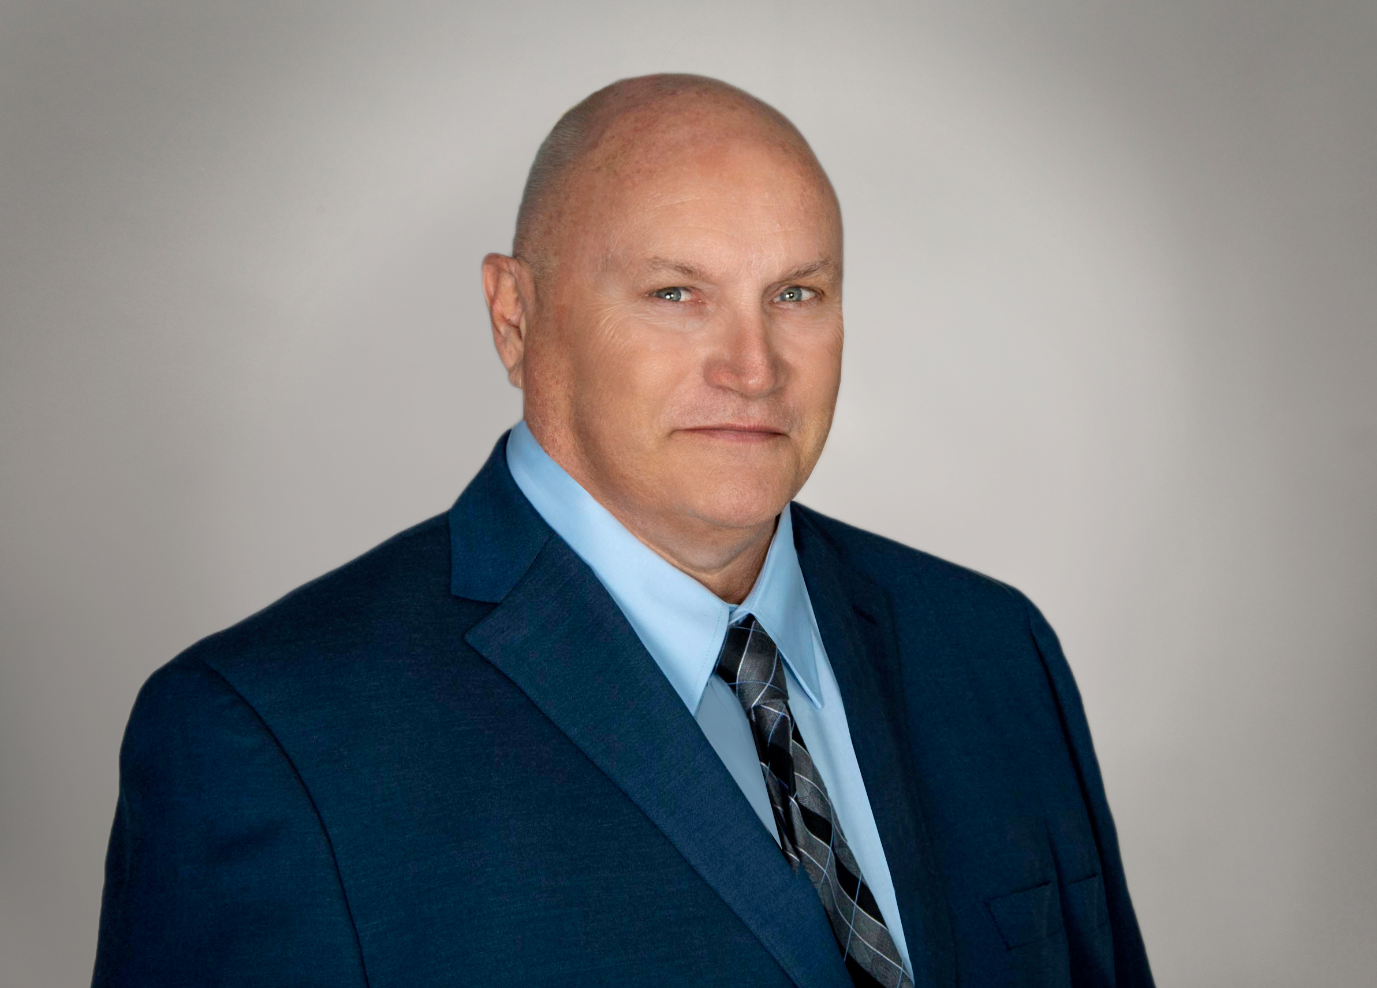 |  | joe scholz  Valley Metro  Technical Trainer. Maintenance of Way
PROFILE  Started with Valley Metro Rail in 12/2008 as a Signals & Communications Maintainer. In 10 years, I have been promoted to Technician, then Supervisor, interim SCADA administrator, and finally as Technical Trainer.  Glendale Community College for Electronics, Phoenix Community College for Mass Communications.  I play golf, bowling, and watch most sports.  Contact  PHONE:  (602) 652-5039  CELL PHONE:  (602) 628-4100  EMAIL:  jscholz@valleymetro.org |  | department  Maintenance of Way Technical Training  position description  Technical Training for Maintenance of Way departments (Signals & Communications, Traction Power, and Tracks). Training includes electronic, electrical, computer servers. and networking.  business project  When Valley Metro Rail first started 10 years ago, technical training for Maintenance of Way personnel was primarily the responsibility of the contractors for each system. Diagnosis and repair for signaling, radio and telephone communication, Train tracking and control (SCADA), fare collection systems and the CCTV (cameras) were all classes conducted by representatives for each company.  Later when new employees were hired, the veteran technicians and supervisors took on the task of training for each area they were well versed in.  Today with current and future expansions in progress and diversity of new equipment and technologies, the need for an organized thorough training program is obvious.  For my business project I would like to build a training program that covers the following:  - Assessing technical knowledge and troubleshooting skills of existing and new maintainers and technicians.  - Creating a training program for each system to conform with existing work schedules.  - Working with equipment manufacturers and distributors that offer training programs.  - Involve Valley Metro's safety department to ensure compliance in training practices.  The valuable information learned from working with other agencies will have a great impact in developing a comprehensive technical training program.

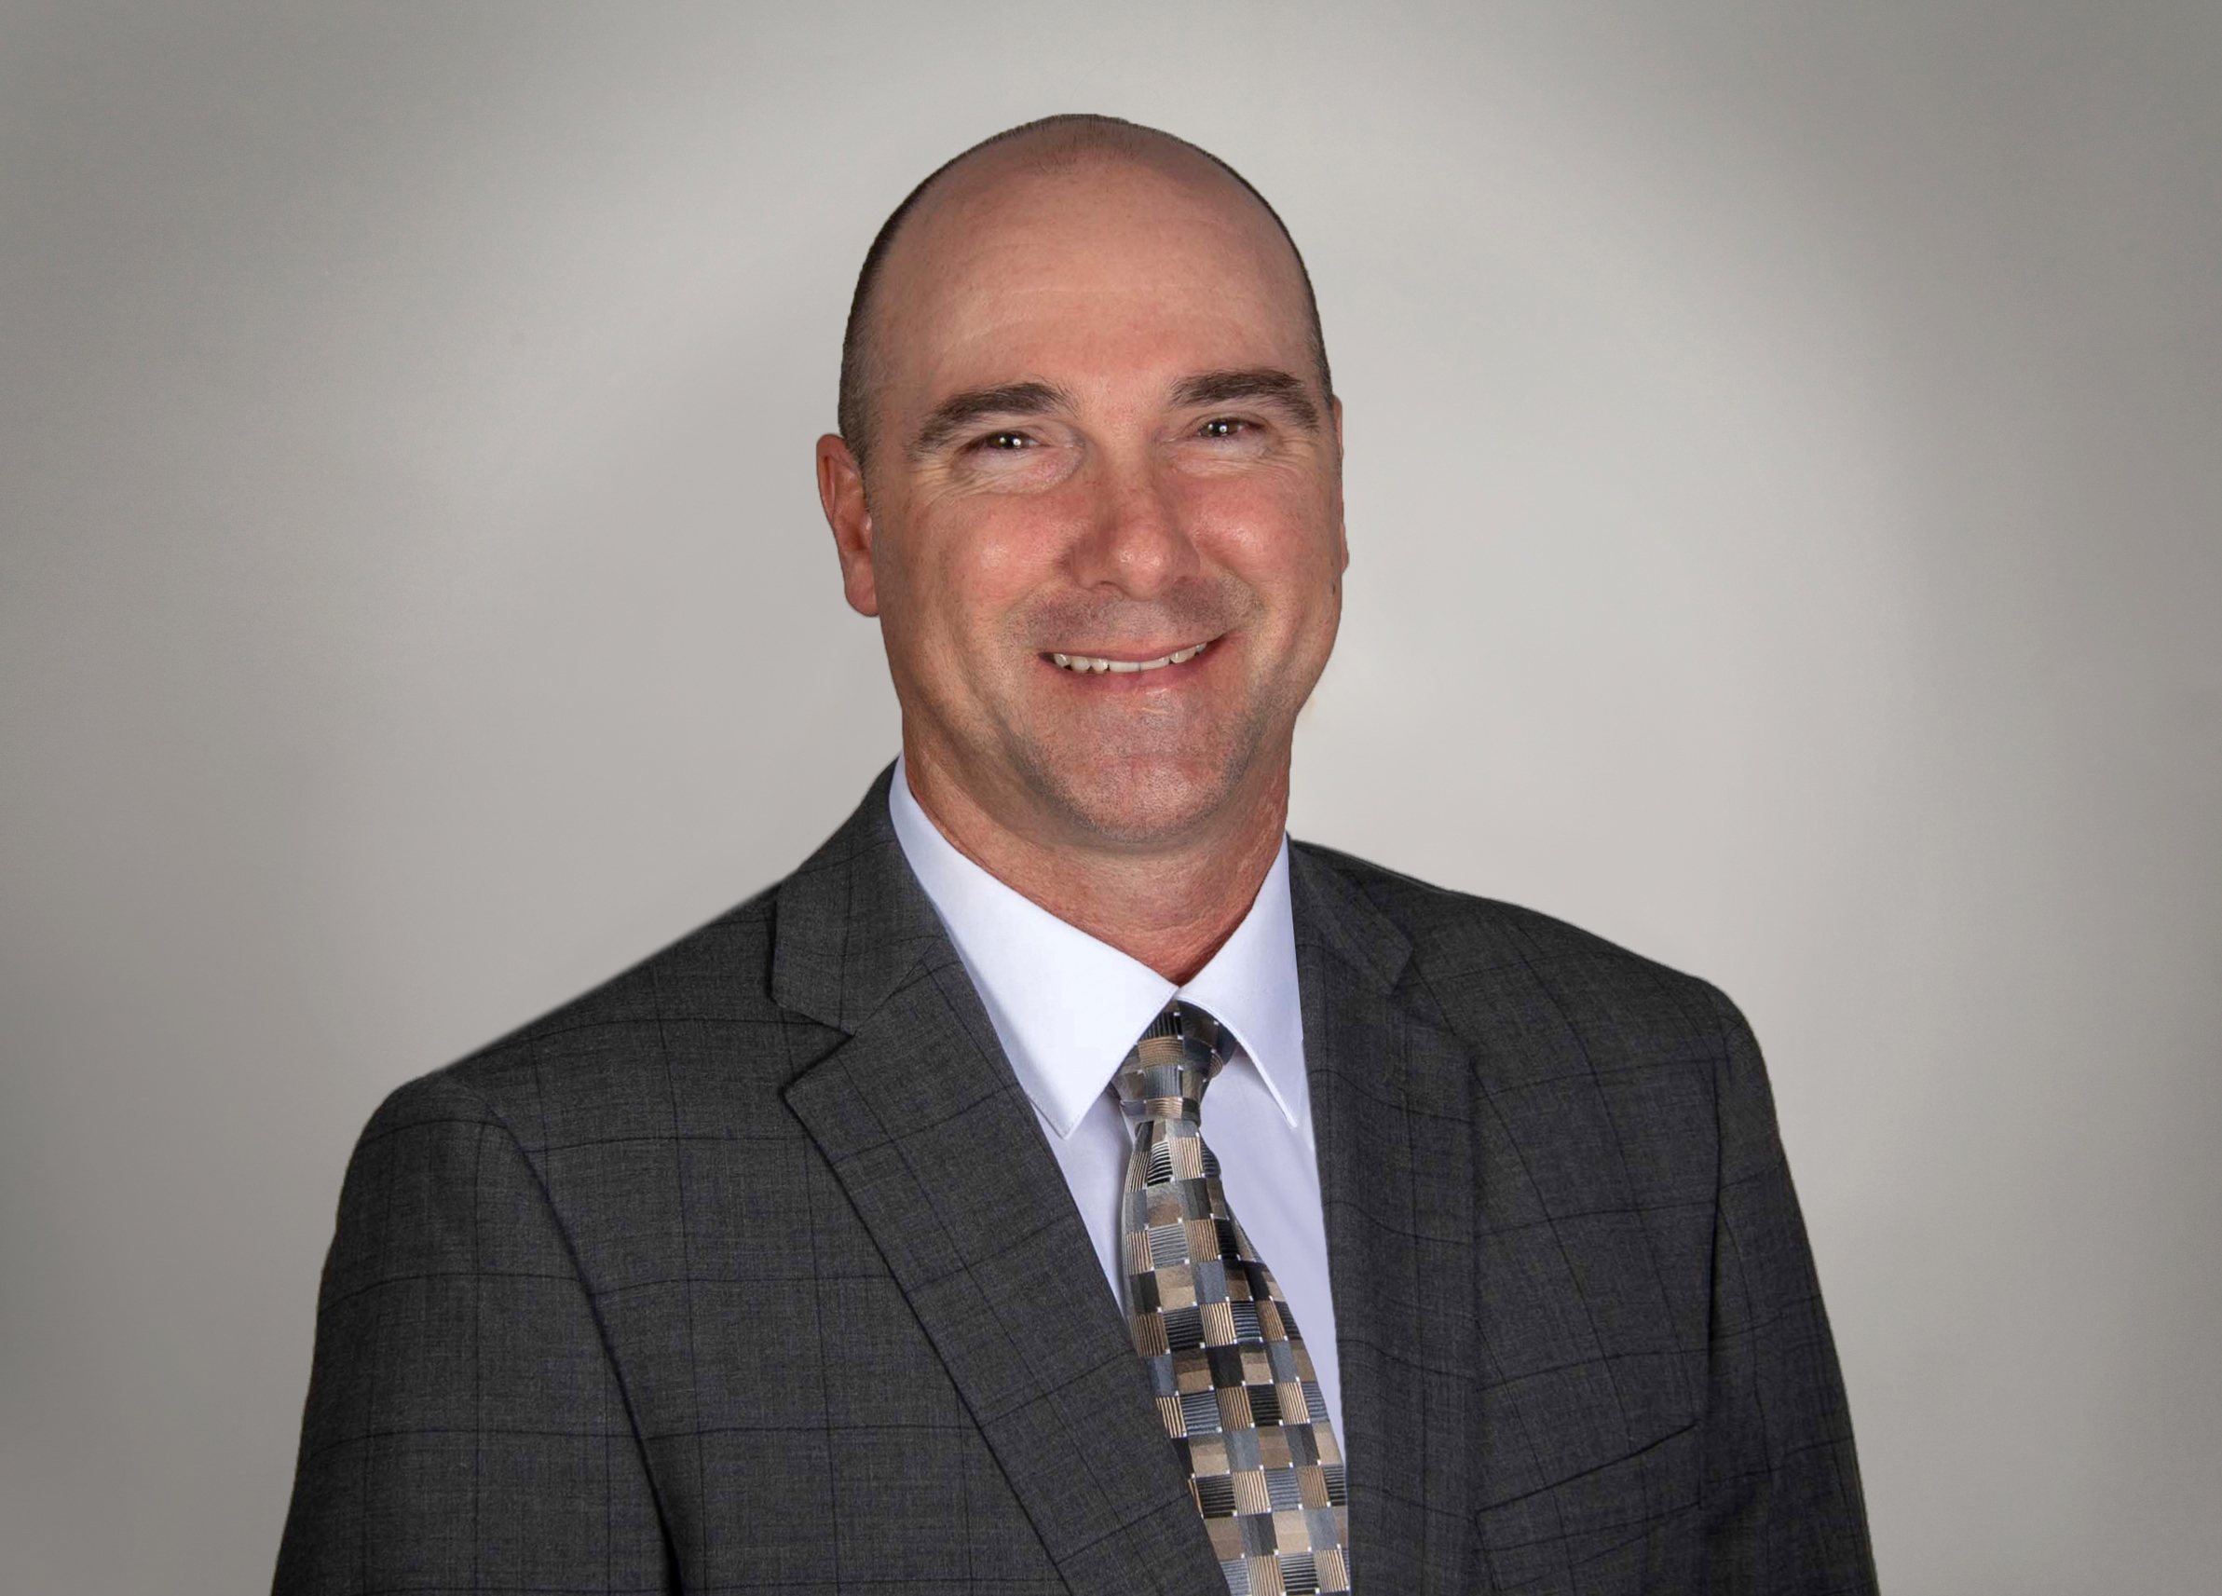 |  | john williams  Valley Metro  Facilities Maintenance Coordinator
PROFILE  I started my career in transportation over 10 years ago with the first 20 miles of light rail in Phoenix. I was a Traction Power Systems Technician for 8 years prior to promoting to Facilities Maintenance Coordinator. As I thought about my promotion, my father and his years at NASA came to mind, then I thought of my brother who is a Commercial Airline Pilot. It dawned on me that transportation was in my blood. My Dad helped put the first man on the moon, my brother delivers people all over the world, and I handle the ground work with the trains.  I look forward to enjoying each host city’s cultural and social amenities. As a homebrewer I’m eager to sample the local food and craft beer. I also enjoy architecture, museums and learning about local history. When we visit Denver, I might jump on a shuttle to Keystone for some snowboarding if my aging body can handle it and my wife approves it of course.  I am looking forward to the MAX program and will absorb everything it has to offer.  Contact  PHONE:  (602) 652-5040  CELL PHONE:  (623) 205-1236  EMAIL:  jwilliams@valleymetro.org |  | department  Facilities Maintenance  position description  The Facilities Maintenance Coordinator is responsible for planning, prioritizing, monitoring and inspecting the work of maintenance staff and contracted vendors in the construction, modification, maintenance and repair of Valley Metro buildings, facilities, light rail system and equipment, including building cleanliness. Typical duties include: assist with the preventive maintenance program, cost estimates/bids, and coordination of repairs and maintenance work items.  business project  Currently the Facilities Maintenance Department relies on various methods of communication from staff, contractors and the public to inform the various team members of facility issues needing resolution. It is absolutely critical that proper channels are followed accurately with so many properties involved and being spread out over 26 miles across three cities. Millions of riders have used the light rail over the years and the facilities, passenger stations, lighting fixtures, walkways and many other elements are all common conduits that safely connect our riders to the vast communities across the Valley.  When an issue is identified it will typically get passed along to several staff members until it finds its way to the proper team member who will respond. Miscommunication is more prevalent with multiple staff members involved. The more the information changes hands the greater possibility it will get altered or critical details will get left out. A unified reporting system will greatly improve and expedite system critical repairs that will benefit all parties involved. A telephone call, email, text, or possibly a mobile application will start the process automatically routing to the proper team member for resolution. An automatic reply will also be generated giving reassurance the issue will get resolved. The originator of the repair request is also automatically notified of resolution. Many software programs can do this automatically with little or no margin for error.  Valley Metro currently uses a similar communication method for IT issues and something similar can be used by Facilities Maintenance Department. Site visits and discussions with other agencies will offer an opportunity to compare and critique this proposed business plan to accurately report and resolve facility maintenance issues.

