How To Access your MAX Membership Documents

Step One: Go to https://www.enotrans.org

Step Two: Hover your mouse over learning and hit Student and Alumni Resources

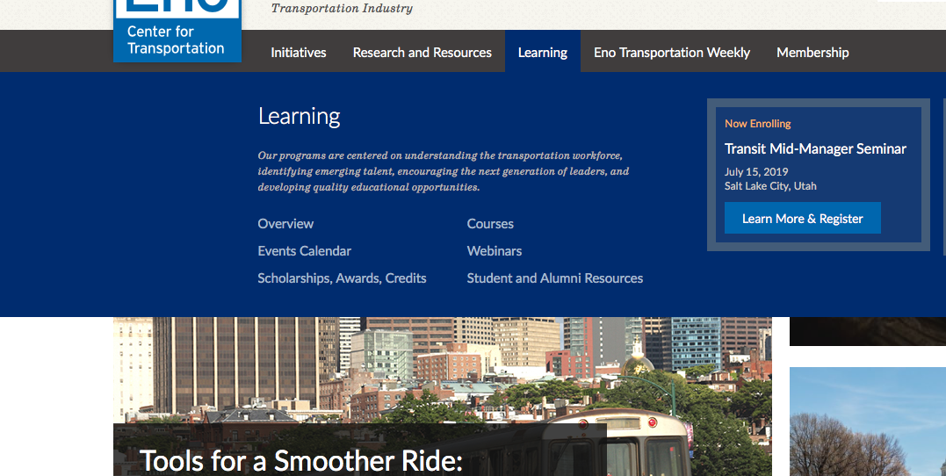

Step Three: Hit the photo that says Current Students

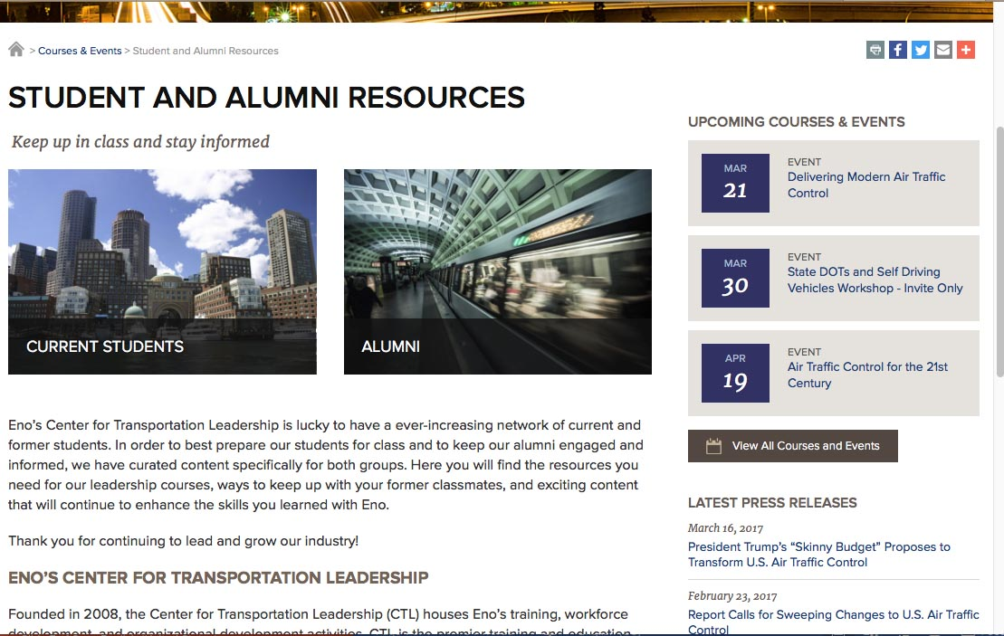

Step Four: Login into the current student webpage
- Your username and password have been created for you. Your facilitators have your logon but the format is first initial last name. (EX: Jane Doe would be jdoe)
- Change your password when you first enter the website.

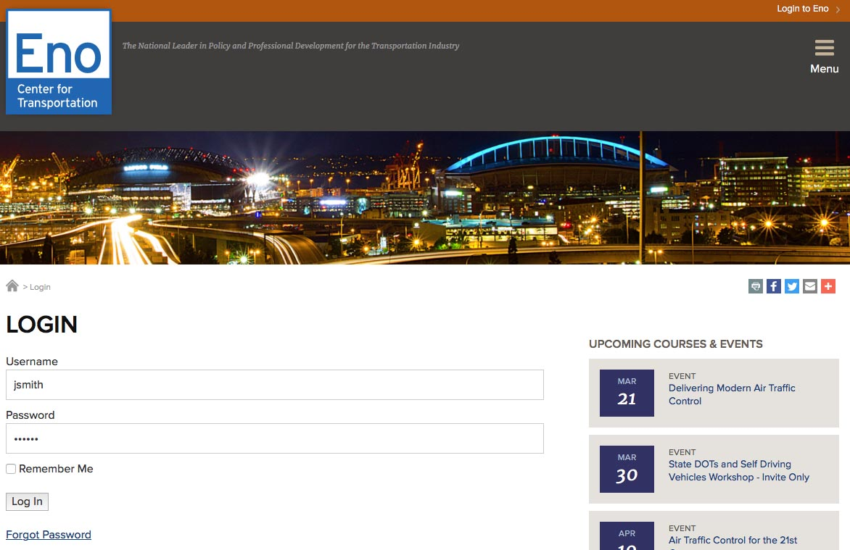

Step Five: Select the current class – Eno MAX

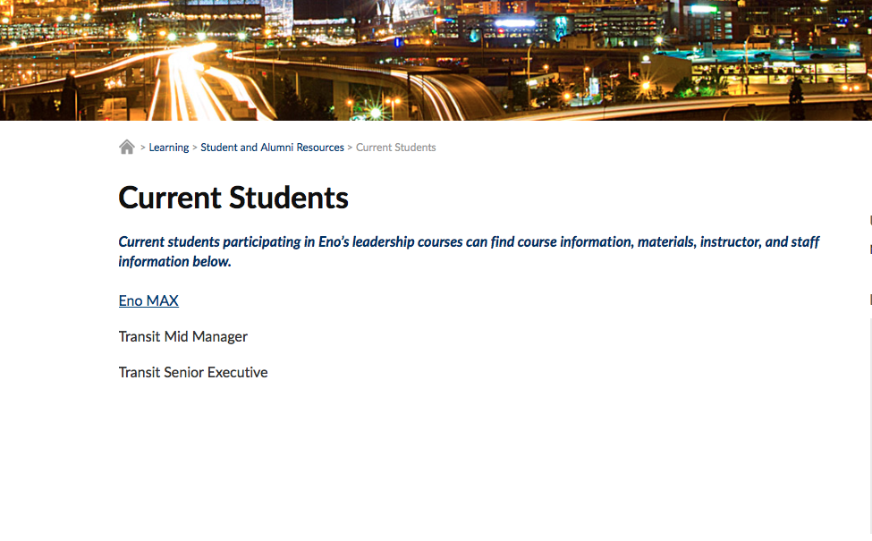

Step Six: Access materials on webpage by clicking any of the links

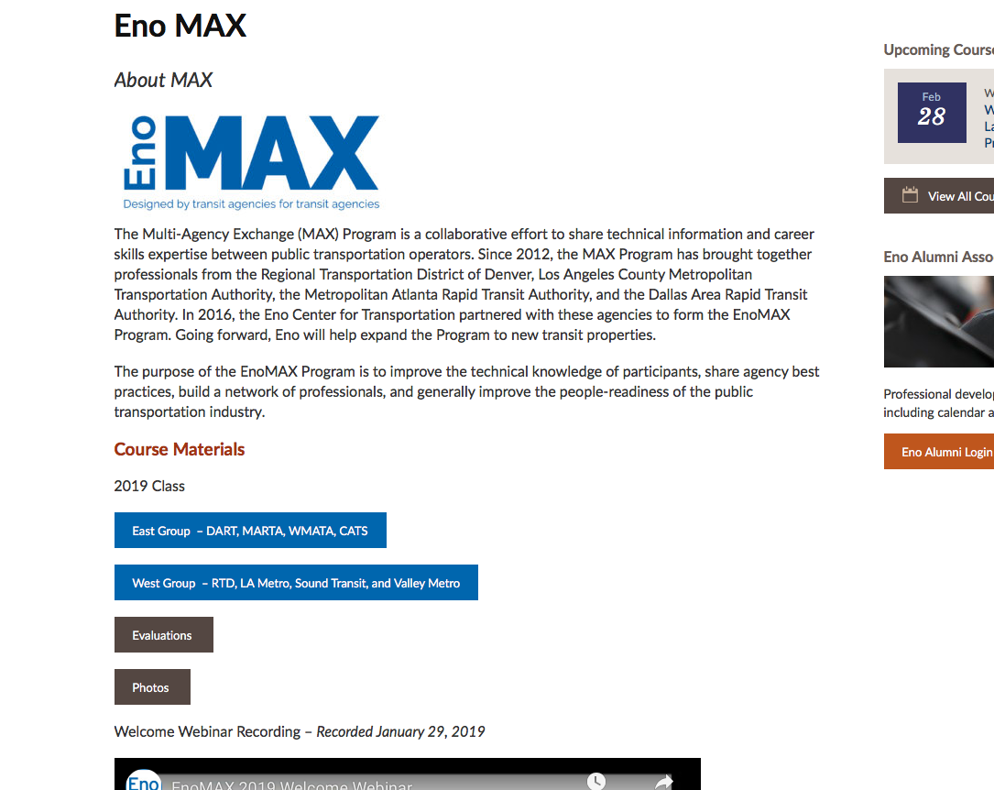

How To Access your MAX Membership Documents as Alumni

Step One: Go to https://www.enotrans.org

Step Two: Hover your mouse over learning and hit Student and Alumni Resources

Step Three: Hit the photo that says Alumni

Step Four: Login into the alumni webpage
- Your username and password are the same as your MAX logins.

Step Five: Access materials on webpage by clicking any of the links. To access your specific call information, hit Course Specific Resources.

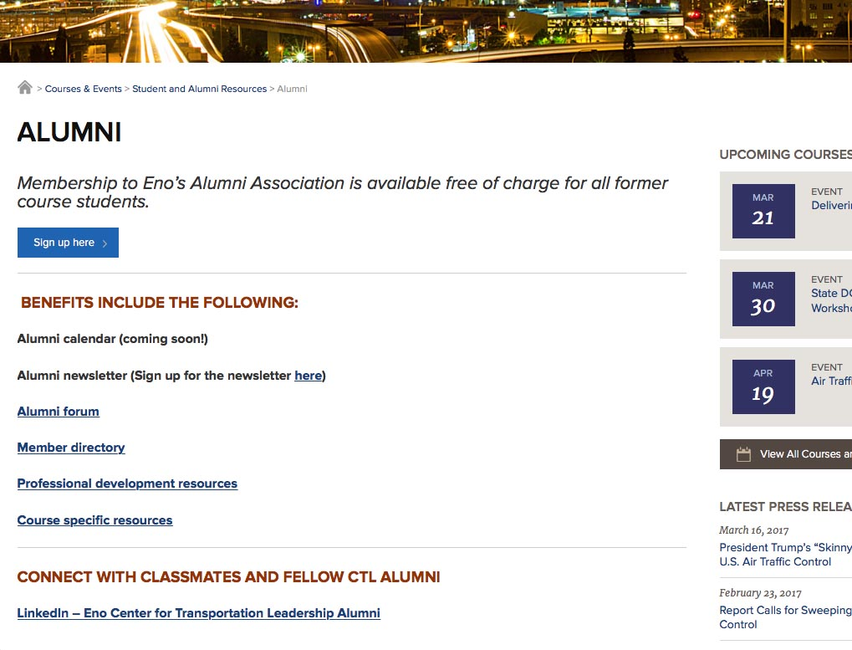

Step Five: Hit the link for your specific class

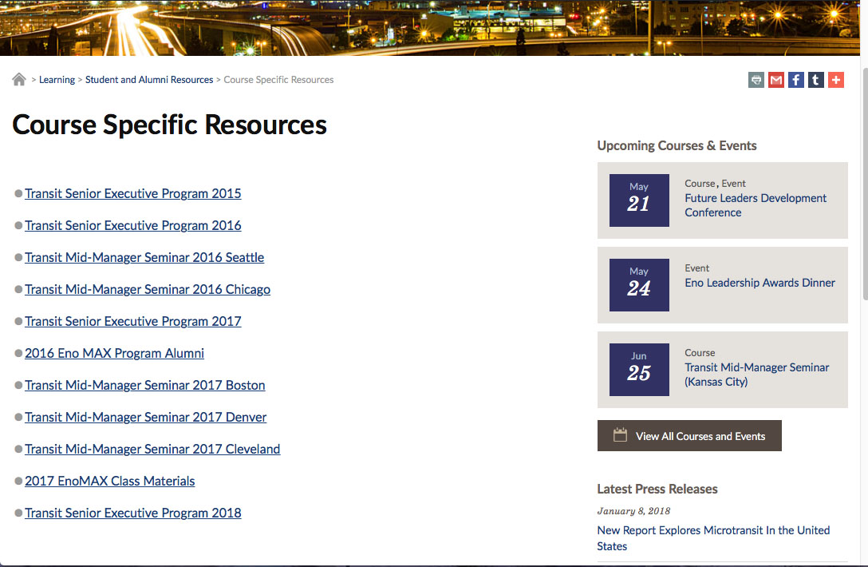

What To Do if you Forgot Your Password/How to Reset Your Password

Step One: Hit the login to Eno button on the top right of the screen

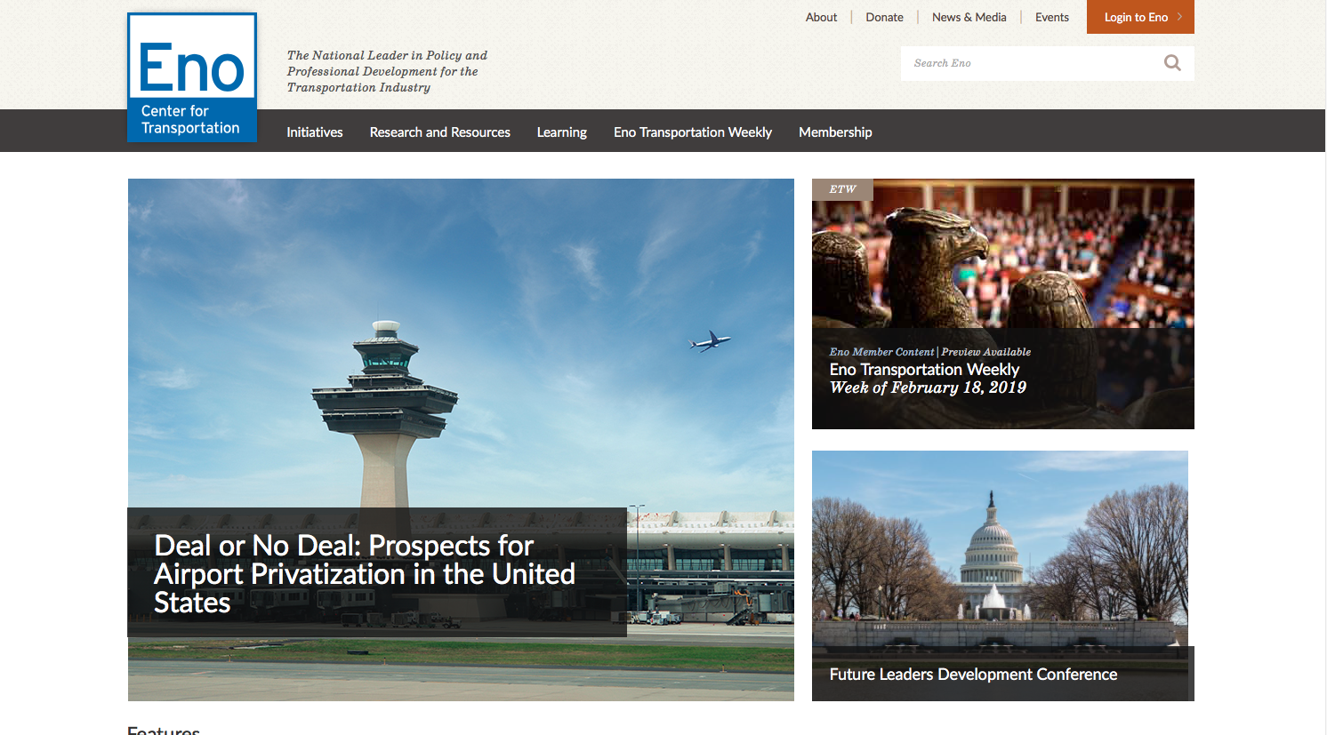

Step Two: Below the login there is a forgot password link

Step Three: Enter your Username or MAX email address to request to reset
