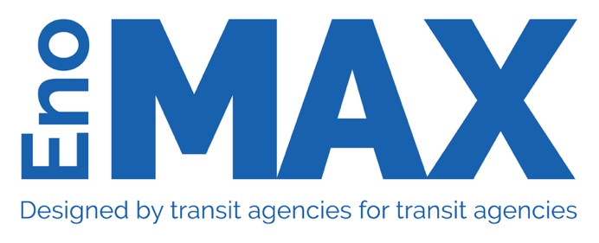

MAX Style Guide

Brand Style Guide
Since its formation in 2012, the Multi-Agency Exchange Program (MAX) has built a reputation as a highly reputable peer-to-peer exchange program. For brand awareness and perception, it is important to use care and consistency with the MAX name and visual usage of the program’s logo and brand. The following guidelines ensure consistency and quality wherever the program’s name or logo appears.

About the Eno/MAX Program:
MAX is a collaborative program to share technical information and career skills expertise between public transportation operators. MAX improves the technical knowledge of participants, provides a forum to share agency best practices, enables continuous learning and building a network of professionals in similar roles.

In 2012, leaders at the Regional Transportation District of Denver, the Dallas Area Rapid Transit Authority, and Los Angeles County Metropolitan Transportation Authority realized they shared similar challenges at their agencies and began to discuss how they could learn and collaborate with each other. Together with the Metropolitan Atlanta Rapid Transit Authority, these leaders created the first Multi-Agency Exchange. The program brought front-line managers to visit their counterparts in the other agencies for this collaborative best-practice sharing program. In 2017, these agencies began collaborating with Eno to expand the leadership development and networking and alumni programming. Since its inception, the MAX Program has brought together over 250 professionals and saved participating agencies millions of dollars.

In 2018, Valley Metro (Phoenix) and Sound Transit (Seattle) joined the program and in 2019, WMATA (DC) and CATS (Charlotte) came on board. Together with the participating agencies, Eno is looking to continue to incrementally expand the program to include additional transit agencies. This program will provide critically needed training for first-level supervisors, help build a network of professionals, and improve people readiness of the industry.

Logo
The following logo represents MAX and should be the only logo used to represent the program:

One acceptable variation excludes the tagline, which can be used when needed (for example, when the logo will appear too small to discern the text of the tagline):

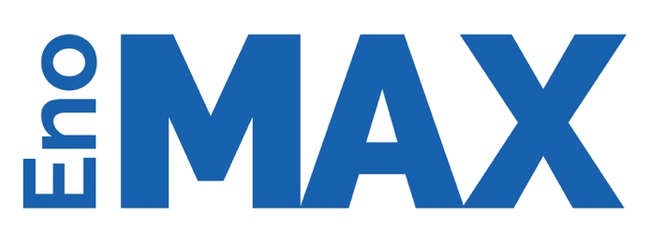

Name
The official name of the program is the Multi-Agency Exchange Program. This can be shortened to the MAX Program, or simply MAX, after the first reference in a document. Eno’s Multi-Agency Exchange Program, shortened to Eno’s MAX, are also appropriate. EnoMAX or MAX/Eno will no longer be used.

Font
Titles/Chapters/Headers: Raleway Bold/Raleway
Body Text: Century Schoolbook

When using a platform (such as Mailchimp or Visme) that does not have these fonts, the font should be as close as possible. Lato is one good substitute for Raleway; Merriweather or Adobe Caslon Pro are good substitutes for Century Schoolbook.

Colors
The main color, which is used in the logo, is Hex #0060b1:

Secondary colors that can be used are:

Hex #00325c Hex #d5d9dd

Occasionally you might use a tertiary color, Hex #e29324, for call-outs and other special purposes:

