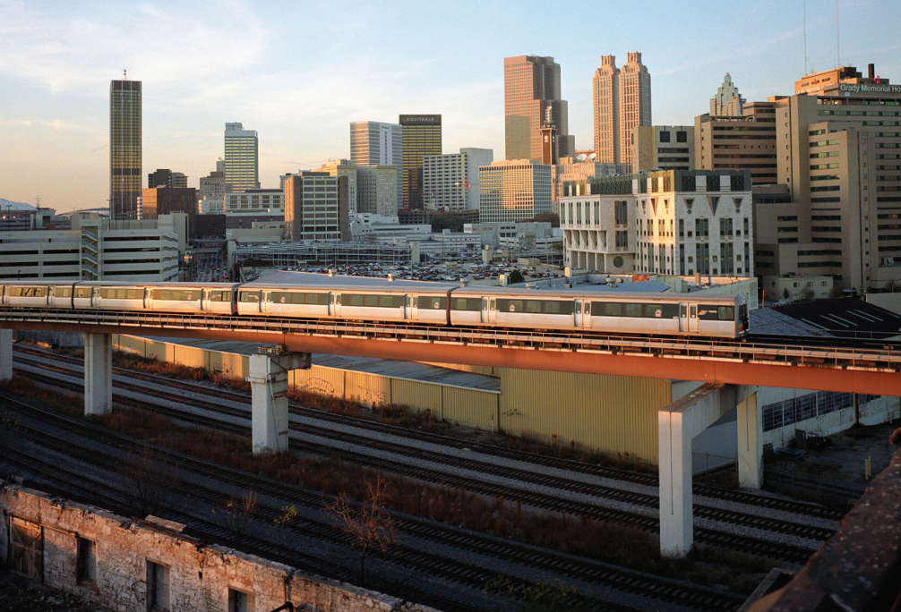

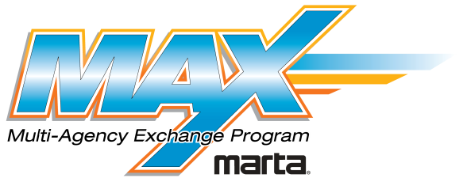
MARTA MAX Program 2019
Welcome Packet
MARTA MAX Program 2019 Welcome Packet

Welcome to Atlanta!
We’re happy to have you all (feel free to say ya’ll) here. We’ve loaded the week with MAX programming, but there’s a lot more to Atlanta than just MARTA. To help you navigate and to give you a taste of our fair city, we’ve compiled some notes for you here.

A Little Bit About Atlanta
- Transportation is in the city’s blood. Atlanta was founded around a railroad terminus in 1837, and the world’s busiest airport is a major regional economic driver.
- Change is part of our civic identity. Atlanta has redeveloped and reinvented itself frequently, from the Civil War to the past several years. It’s evident in gentrifying neighborhoods, a booming population, and an eclectic mix of architectural styles.
- We’re the 9th largest metro area in America, with over 5 million residents.
- Home to Coca-Cola, Delta Air Lines, and Home Depot, Atlanta brands are everywhere.
- Though Atlanta has a reputation for being a late suburban sprawler, we have a rich and diverse history with deep roots in the Civil Rights Movement.
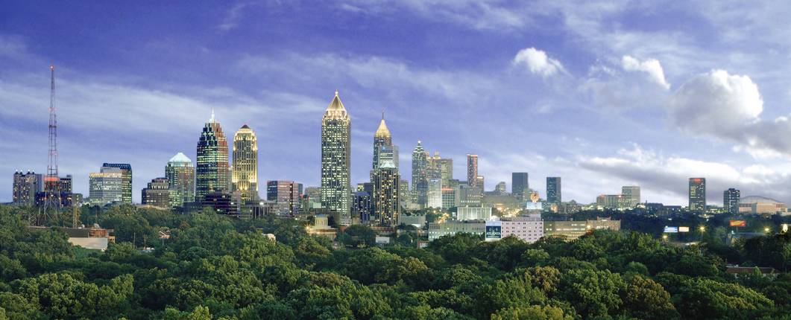
- It’s not true that every street is named Peachtree (really, it’s just most of them). Our region has over 70 streets with “Peachtree” in the name.
- Common nicknames include “Hotlanta,” “The A,” and “The ATL.”
- Our region spans more than 10,000 square miles, 28 counties, and over 50 municipalities.
- MARTA serves the region’s center– City of Atlanta, Fulton County, DeKalb County, and Clayton County.

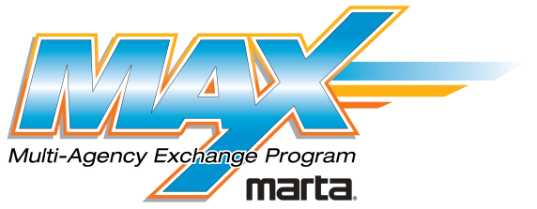

Contents
Welcome 1
MARTA rapid rail directions 2
Atlanta transit travel tips 3
Near your hotel 4
Things to do 5
Food and drink 7

MARTA Rapid Rail Directions
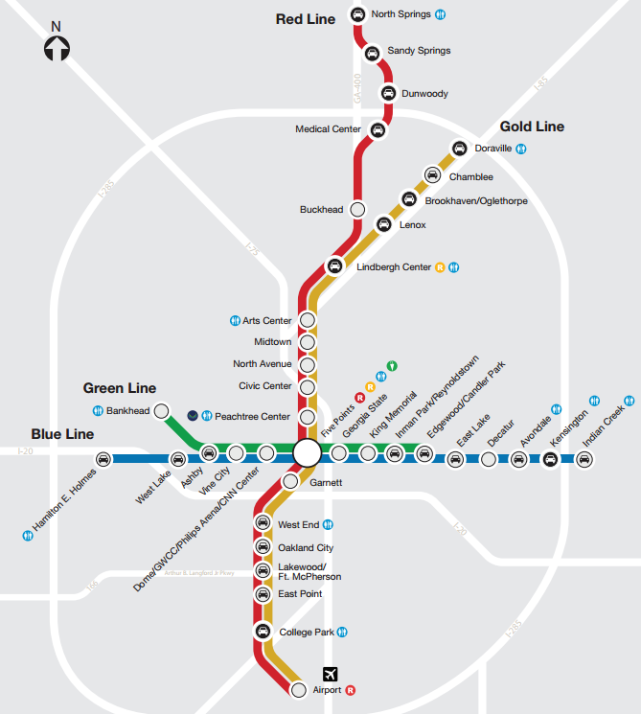

To the hotel from the Airport Station:
- Catch a northbound Gold Line train northbound towards Doraville.
- Exit the train at Lenox Station (14 stops from Airport Station).
- Walk towards the rear of the train, following signs to Lenox Mall. Take the large escalators up to street level.
- Go through the fare gates to the intersection of East Paces Ferry Rd and Lenox Rd. You’ll see the JW Marriott across the street.

To MARTA Headquarters from the hotel:
- Catch a Gold Line train south towards the Airport. Board towards the rear of the train if possible, but spread out to avoid crowding.
- Exit the train at Lindbergh Center Station (1 stop from Lenox Station).
- Walk towards the rear of the train and follow signs upstairs to MARTA Headquarters.
Atlanta Transit Travel Tips

Hours of Service
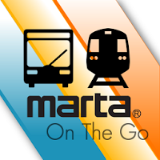
MARTA’s rapid rail system operates from approximately 4:45 AM to 1:00 AM on weekdays. Trains on each line operate every 10 minutes during rush hours, every 12 during mid-day, and every 20 at night. On weekends, the system operates from approximately 6:00 AM to 1:00 AM, with trains on each line operating every 20 minutes. Hours of service and headways on bus routes vary, so check schedules for details.

Night Service
At night, the Red and Green Lines short-turn and operate shorter routes. The Red Line only operates between the North Springs and Lindbergh Center Stations; transfers with the Gold Line are required for further travel. The Green Line only operates between Vine City and Bankhead Stations; passengers must transfer at Ashby or Vine City to the Blue Line.

Tap to Exit Faregates
MARTA is a closed system, requiring entry and exit through faregates. To enter the system, you must tap your Breeze card on the blue target on the faregate. You also have to tap to exit – this will open the gates to exit and automatically load your card with a bus transfer.

Local Terminology
Here are a few lingo tips to help you navigate the system and talk to our riders:
- Our system uses cardinal directions for all rail lines and bus routes (Northbound, Southbound, Eastbound, and Westbound). Look for these on signs, maps, and schedules.
- Bus routes are typically referenced by number rather than street. You’d take “Route 39” instead of the “Buford Hwy bus.” Route 110 – “The Peach” (Peachtree St) is an exception.
- Faregates, cards, ticket vending machines are part of the “Breeze” automated fare collection system, known to most simply as “Breeze.”

Mobile Apps
Get real-time train and bus arrival times on your phone! Check out these great transit apps while you visit:

MARTA On The Go
The Authority’s official iPhone and Android application. Includes real-time train arrival times, bus schedules, and system alerts. A great choice for frequent rail riders like you’ll be for the week!
Transit App
A great alternative iPhone and Android application. Includes real-time train and bus arrivals in a map-based interface.

Near Your Hotel

Coffee & Snacks
You’re staying in one of the city’s largest business districts, and your hotel is attached to one of the city’s favorite malls. There’s no shortage of caffeine!
- Starbucks Coffee – Two locations in the Lenox Mall. The location in Macy’s is open from 6:30 PM to 8:00 or 9:00 PM, and the kiosk location is open from 7:00 AM to 9:00 PM.
- Revelator Coffee – located in the Lenox Mall. Open from 10:00 AM to 9:00 PM.
- Corner Bakery – located in the Lenox Mall. Open from 8:00 AM to 9:00 PM.
- SIP The Experience – located at the Lindbergh Center Station, by the north bus loop. Open from 7:00 AM to 6:00 PM weekdays; weekend hours vary.
- Dunkin Donuts – two blocks from MARTA headquarters on the TOD at Main St & Piedmont Rd.
- Sweet Hut – bubble tea and bakery, located in the Lenox Mall. 10:00 AM – 9:00 PM.

Convenience & Grocery
Forget something? Random produce craving? Late-night snack run? You’re in luck.
- CVS/Pharmacy – located a short walk or bus ride away. Take a 15-minute walk or walk through the mall to Peachtree St and catch Route 110 northbound. Open daily from 7:00 AM to 11:00 PM. 3221 Peachtree Rd NE.
- Target – two locations nearby. One is at the Lindbergh Plaza Shopping Center two blocks from MARTA headquarters; the other is a 15-minute walk from your hotel at the Lenox Marketplace Shopping Center. Both open from 8:00 AM to 11:00 PM, except Sundays, when closing is at 10:00 PM. Lindbergh Plaza location: 2539 Piedmont Rd NE. Lenox Marketplace location: 3535 Peachtree Rd NE.
- Kroger – located across Piedmont Road from the MARTA headquarters building.
- Publix – located a short walk or bus ride away in the Lenox Marketplace Shopping Center. Take a 15-minute walk or walk through the mall to Peachtree St and catch Route 110 northbound. Open daily from 7:00 AM to 11:00 PM. 3535 Peachtree Rd NE.

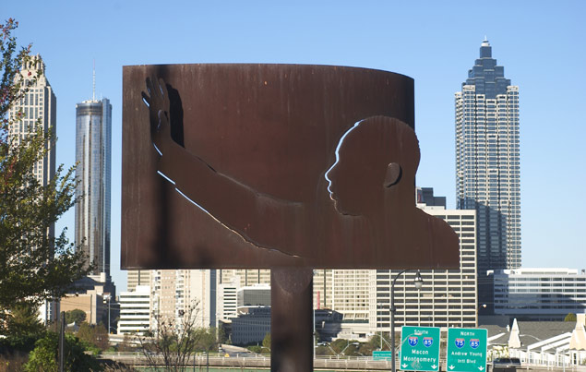

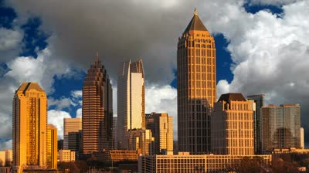

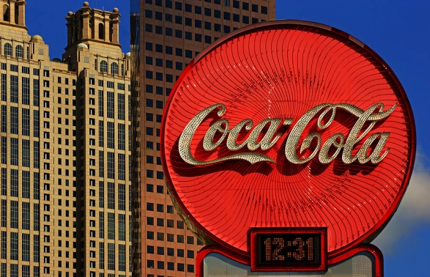
Things to Do Around Atlanta

Downtown Attractions
Downtown Atlanta has a number of destinations and activities within walking distance of MARTA stops! Get maps, more information, and more ideas at www.atlantadowntown.com.
- APEX Museum – interpreting and presenting history from an African-American perspective, and presenting African-American contributions to America and the world.
135 Auburn Ave, Atlanta GA 30303. Near the Auburn at Piedmont streetcar stop.
- Centennial Olympic Park – downtown’s “urban oasis,” Centennial Olympic Park features the world’s largest interactive fountain, events, and spaces for recreation and relaxation.
Centennial Olympic Park Dr between Baker St and Marietta St
- Fox Theatre – a restored, opulent 1920s theatre with ballet, concerts, movies, and more. 660 W Peachtree St NW, Atlanta GA, 30308. Near MARTA’s North Ave Station.
Georgia Aquarium – 10 million gallon aquarium facility with over 500 species, including whale sharks, beluga whales, bottlenose dolphins, and manta rays. 225 Baker St NW, Atlanta GA 30313
- Georgia State Capitol – the Classical state capitol building, built in 1889, and featuring a dome plated in Georgia gold leaf. 206 Capitol Ave, Atlanta GA 30334
- Martin Luther King Jr National Historic Site – home to Martin Luther King’s birth home, tomb, Ebenezer Baptist Church, and the King Center and museum. Take the Atlanta Streetcar to the King Historic District stop.
- National Center for Civil & Human Rights – a museum dedicated to exploring the American Civil Rights Movement and today’s Global Human Rights Movements. 100 Ivan Allen Jr Blvd, Atlanta GA, 30313-1807
- Skyview Atlanta – Atlanta’s new 20-story ferris wheel, featuring climate-controlled gondolas and unique place in the downtown skyline. Centennial Olympic Park Dr and Luckie St.
- World of Coca-Cola – museum dedicated to the history of Coca-Cola and its ubiquitous advertising. Features an international tasting room. 121 Baker St NW, Atlanta GA 30313

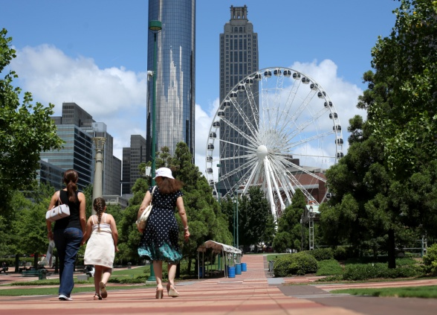
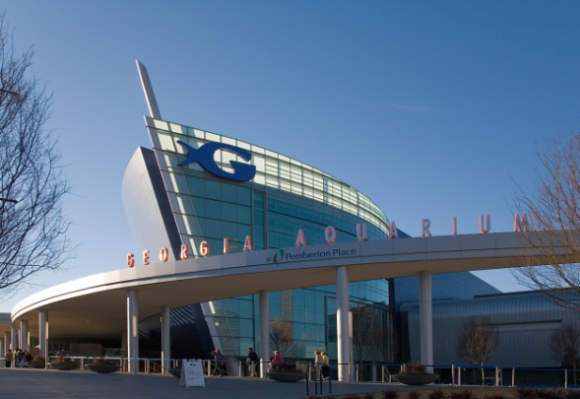
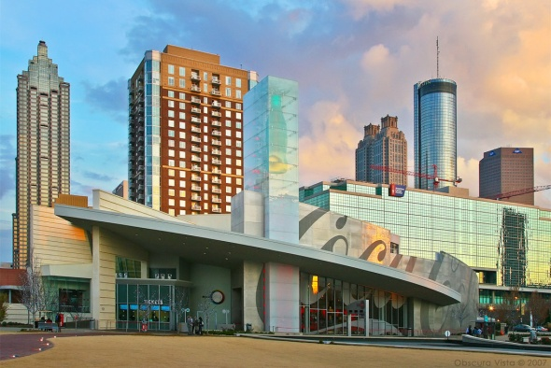
Things to do around Atlanta

Other Attractions & Neighborhoods
Atlanta’s known both as a city of neighborhoods and a city of trees. Check out some other areas with easy MARTA access while you’re in town! For more ideas, visit www.atlanta.net.
- Atlanta Beltline Eastside Trail – a 2 mile multi-use trail on a former railroad alignment, with connections to other major trails in Atlanta’s bicycle network. Midtown Station, accessible from Piedmont Park - bike rentals, bike share, and scooters are everywhere
- Atlanta Streetcar– A ride along the 2.1-mile streetcar alignment provides a view of Peachtree Center, the historic Fairlie-Poplar district, Edgewood Ave, and the revitalizing Sweet Auburn. Connect at the Peachtree Center Station
- Decatur – Atlanta’s next-door neighbor, the Decatur has a walkable historic downtown centered around the MARTA station. Lots of dining and retail options. Decatur Station
- Little Five Points – a historic commercial district and focal point for Atlanta alternative culture, featuring a variety of shops, restaurants, and a lively street scene. Short walk or ride on the #6 bus from the Inman Park Station
- Living Walls – a collection of large, bright murals and street art focused in downtown and surrounding neighborhoods (several are visible along the streetcar alignment). Visit www.livingwallsatl.com for more info, or ride the Atlanta Streetcar
- Midtown Atlanta – a booming residential, office, and commercial district home to some of the city’s hippest restaurants and active park spaces. Midtown Station
- Piedmont Park – the city’s famed and beloved 189-acre urban park, featuring a lake, walking trails, and a unique modernist playground. Walk via Piedmont Ave, 10th St, and 14th St – a short walk from Midtown or Arts Center Stations or ride on the #27 or 36 buses
- Ponce City Market - one of the hottest spots in Atlanta, this massive renovated Sears & Roebuck warehouse offers upscale retail and a large food hall. On the Beltline Eastside Trail. Walk or bike along the Beltline, or a 10 minute ride on the #2 or 102 buses
- West Midtown – a newly-revitalized urban neighborhood, home to some of the city’s trendiest high-end restaurants, design shops, and art spaces. A short ride on the #12 bus from Midtown Station or the #14 bus from Arts Center Station

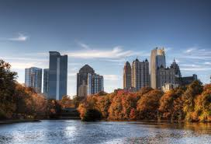
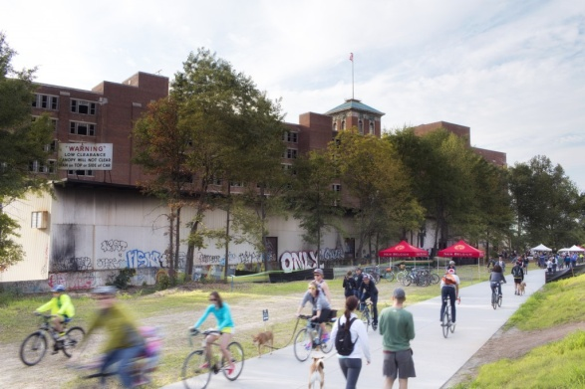
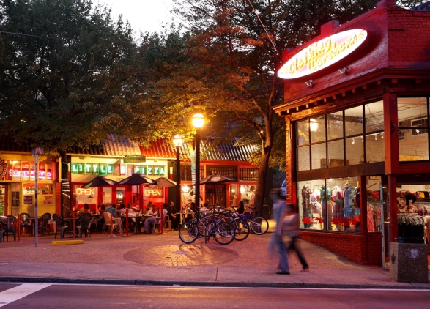
Things to do Around Atlanta

Events & Happenings
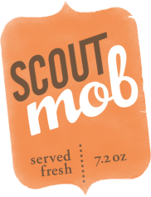
In addition to the regular attractions, there are a few special events and exhibitions going on.
- Imaginary Worlds: Alice’s Wonderland at the Atlanta Botanical Garden – a collection of giant topiary-like plant sculptures scattered throughout the beautiful grounds of the Atlanta Botanical Gardens. $21.95. Tues-Sat, to 7:00 PM. Walk from Arts Center Station or the #27 bus from Midtown Station.
- Imagination Nights at the Georgia Aquarium – discounted night admission to all six galleries for $26.95+tax. Mon-Sat after 4:00 PM. Walk from Peachtree Center Station.
Food & Drink

Around Lenox
- Lenox Mall – Lenox Mall has a wide variety of options in the food court. Other restaurants in the mall include California Pizza Kitchen, Cheesecake Factory, Zinburger Wine & Burgers, and Prime Steakhouse.
- Katana Teppenyaki & Sushi – sushi, sashimi, and more. Across the street from your hotel.

On Route 110 – Peachtree St
Route 110 offers frequent service to dozens, if not hundreds, of dinner options along Atlanta’s famous Peachtree St. Catch the #110 on Peachtree St – just walk through the mall and look for the bus stops on Peachtree.
- Fellini’s Pizza – local low-key pizza chain. 2809 Peachtree Rd NE.
- Imperial Fez – elaborate Moroccan restaurant with floor seating and belly dancing. 2813 Peachtree Rd NE.
- McKinnon’s Louisiane – serving southern and creole food in Buckhead for 45 years. 3209 Maple Drive NE.
- Lots, lots more – just check Google

Coupons & Discounts
Hand-Picked Atlanta
An Atlanta-based startup, Hand-Picked Atlanta is a website that provides serious discounts on drinks, dinners, and local experiences. Check out www.handpickedatlanta.com to see what’s available.
Atlanta CityPass
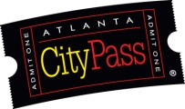
Bundled admission to numerous major tourist attractions (World of Coke, Georgia Aquarium, Inside CNN, Zoo Atlanta, Atlanta History Center, Fernbank Natural History Museum, High Museum of Art). At $74, it’s a 46% savings over individually purchased admissions. A great way to hit the big-name tourist attractions around town.
Food & Drink, cont’d

Around the City
Atlanta’s southern roots and growing foodie culture provide variety and quality all over town. If you feel like getting out of Downtown, check out these great places, all readily accessible on MARTA. Ask us if you want more recommendations!
- Crescent Ave – A wide variety of restaurants spanning roughly a three-block stretch in Midtown. From sushi to southern comfort food, Italian to an Irish pub, Crescent Ave is home to great food from just about everywhere. $$-$$$$. Crescent Ave, between 11th St and 14th St. Roughly 3 blocks from the Midtown MARTA Station.
- Edgewood Avenue – Edgewood Avenue has experienced a boom and commercial revitalization, bolstered by the Atlanta Streetcar. Among other establishments, check out Joystick, a bar/arcade and Church (It’s a Bar!), an irreverent chapel for drink and ping-pong. $$. Edgewood Ave, between Fort St and Jackson St. Take the Atlanta Streetcar!
- Food Truck Park – the Thursday night hangout spot for many of the city’s new food trucks, usually with live music. $$. 1850 Howell Mill Rd. #12 bus from Midtown Station.
- Fox Brothers BBQ – Acclaimed local BBQ, as featured on Good Day Atlanta and The Food Network. $$. 1238 DeKalb Ave NE. 3 blocks west of Edgewood/Candler Park Station.
- Mary Mac’s Tea Room – Serving southern cooking since 1945, Mary Mac’s is a true Atlanta institution. $$. 224 Ponce de Leon Ave NE. 4 blocks east of North Avenue Station.
- Six Feet Under – Seafood and craft beer rooftop skyline views. Two locations on transit. $$. 685 11th St NW - #12 bus from Midtown; 437 Memorial Dr SE - #21 bus from Five Points or #107 bus from Georgia State, or a short walk from King Memorial Station.
- The Varsity – Open since 1928, The Varsity serves classic fast food – burgers, chili dogs, onion rings, and shakes. $. 61 North Ave NW. 2 blocks west of North Avenue Station.
- The Vortex – Legendary local sandwiches and burgers, featuring a variety of extremely unhealthy (but tasty) Bypass Burgers. The Midtown location is good, but the Little Five Points location has a front door worth seeing. $$. Midtown – 878 Peachtree St NE; walk from the Midtown Station. Little Five Points – 438 Moreland Ave; walk or take the #6 bus from Inman Park/Reynoldstown or Lindbergh Center Stations.

