Lost at Sea

You have been a guest on a private yacht in the South Pacific. In the early afternoon you mentioned to the other passengers that it would be a great time for a siesta. They agreed and you departed for your cabin. You placed your wallet (or purse), phone and watch in a drawer with your other valuables; and without undressing, you stretched out on your bunk.

You were not sure how long you had been sleeping when you heard someone yell, “Fire!” You bounded out of bed, then just before opening the door, you stopped. You felt the door and, realizing it was not hot, left your cabin to investigate the yelling. The flames and billowing smoke on the top deck confirmed that the vessel was in trouble. Quickly ascertaining that all the crew and passengers were present, you pitched in and helped to fight the blaze.

Unfortunately, the fire spread quickly. It was not subdued until the charred bow had broken off and was sinking. By this time, the stern was dangerously tilted, and you know it would not be long before it, too, would be sinking.

On the positive side, the crew salvaged the rubber life raft and oars without damage. The raft was large enough to carry all the passengers, including the crew. The group was able to save only a few items from destruction, and there was also room on the raft for these items.

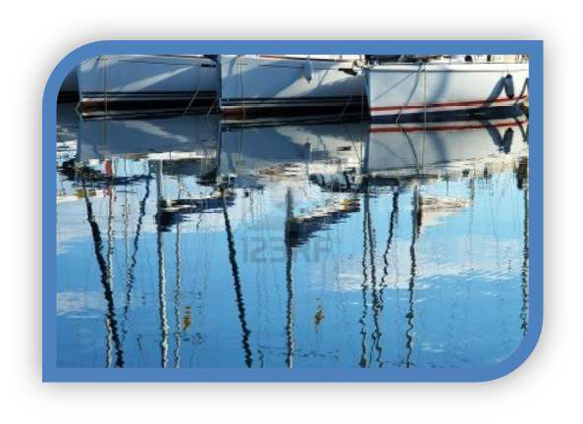
You are now on the raft. Because the navigational equipment was destroyed, plus the fact that everyone was distracted by the fire, your location is unclear. Your best estimate is that you are approximately one thousand miles south-southwest of the nearest land. Because of the cloud cover and the heavy smoke you are not sure what time of day it is. Two people are wearing watches, but the timepieces do not agree. You presume night will be falling shortly. When the passengers emptied their pockets, only a package of cigarettes, several books of matches, and five one-dollar bills were produced.

You have survived the fire. Your next concern is to try and survive the sea.

Lost at Sea Ranking Chart

Items | Step 1 | Step 2 | Step 3 | Step 4 | Step 5
 | Your individual ranking | Your team ranking | Coast Guard ranking | Difference between Step 1 & 3 | Difference between Step 2 & 3
A sextant
A shaving mirror
A quantity of mosquito netting
A 25 liter container of water
A case of army rations
Maps of the Atlantic Ocean
A floating seat cushion
A 10 liter can of oil/petrol mixture
A small transistor radio
20 square feet of opaque plastic sheeting
A can of shark repellent
One bottle of 160 proof rum
15 feet of nylon rope
2 boxes of chocolate bars
An ocean fishing kit & pole
 |  |  | Totals | Your score | Team score
Lowest Individual Score:
Average Individual Score:

